Dotnet Architectural Principles

You should architect and design software solutions with maintainability in mind. These principles will guide you towards building applications out of discrete components that are not tightly coupled to other parts of your application, but rather communicate through explicit interfaces or messaging systems.

# Common design principles

## Separation of concerns

A guiding principle when developing is separation of concerns. This principle asserts that software should be separated based on the kinds of work it performs. For instance, consider an application that includes logic for identifying noteworthy items to display to the user, and which formats such items in a particular way to make them more noticeable. The behaviour responsible for choosing which items to format should be kept separate from the behaviour responsible for formatting the items, since these behaviours are separate concerns that are only coincidentally related to one another.

Architecturally, applications can be logically built to follow this principle by separating core business behaviour from infrastructure and user interface logic. Ideally, business rules and logic should reside in a separate project, which should not depend on other projects in the application. This separation helps ensure that the business model is easy to test and can evolve without being tightly coupled to low level implementation details (it also helps if infrastructure concerns depend on abstractions defined in the business layer). Separation of concerns is a key consideration behind the use of layers in application architectures.

Encapsulation

Different parts of an application should use encapsulation to insulate them from other parts of the application. Application components and layers should be able to adjust their internal implementation without breaking their collaborators if external contracts are not violated. Proper use of encapsulation helps achieve loose coupling and modularity in application designs, since objects and packages can be replaced with alternative implementations if the same interface is maintained.

In classes, encapsulation is achieved by limiting outside access to the classes internal state. If an outside actor wants to manipulate the state of the object, it should do so through a well-defined function (or property setter), rather than having direct access to the private state of the object. Likewise, application components and applications themselves should expose well-defined interfaces for their collaborators to use, rather than allowing their state to be modified directly. This approach frees the applications internal design to evolve over time without worrying that doing so will break collaborators, so if the public contracts are maintained.

Mutable global state is antithetical to encapsulation. A value fetched from mutable global state in one function cannot be relied upon to have the same value in another function (or even further in the same function). Understanding concerns with mutable global state is one of the reasons programming languages like C# have support for different scoping rules, which are used everywhere from statements to methods to classes. It’s worth noting that data driven architectures which rely on a central database for integration within and between applications are, themselves, choosing to depend on the mutable global state represented by the database. A key consideration in domain driven design and clean architecture is how to encapsulate access to data, and how to ensure application state is not made invalid by direct access to its persistence format.

## Dependency Inversion

The direction of dependency within the application should be in the direction of abstraction, not implementation details. Most applications are written such that compile-time dependency flows in the direction of runtime execution, producing a direct dependency graph. That is, if class A calls a method of class B and class B calls a method of class C, then at compile time class A will depend on class B, and class B will depend on class C, as shown:  
  
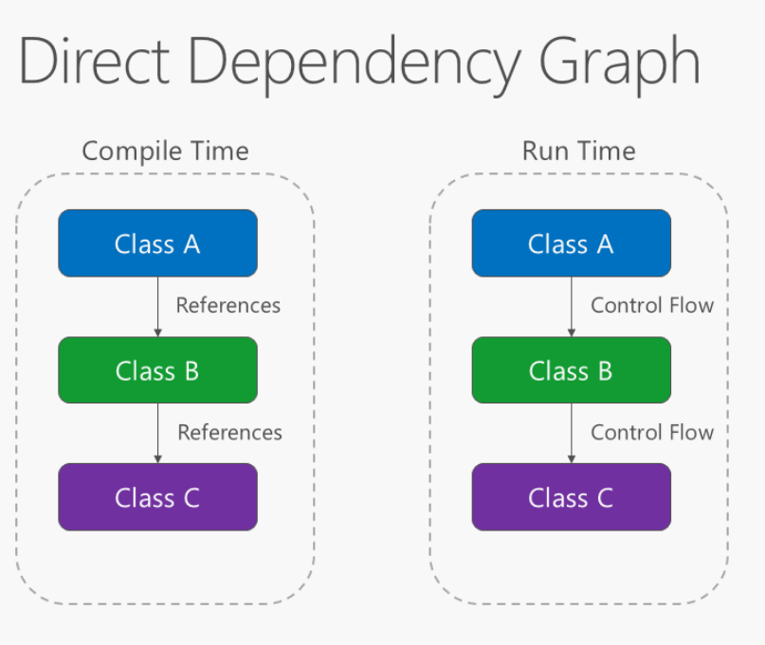

Applying the dependency inversion principle allows A to call methods on an abstraction that B implements, making it possible for A to call B at run time, but for B to depend on an interface controlled by A at compile time (thus *inverting* the typical compile-time dependency). At run time, the flow of program execution remains unchanged, but the introduction of interfaces means that different implementations of these interfaces can easily be plugged in. Inverted dependency graph:

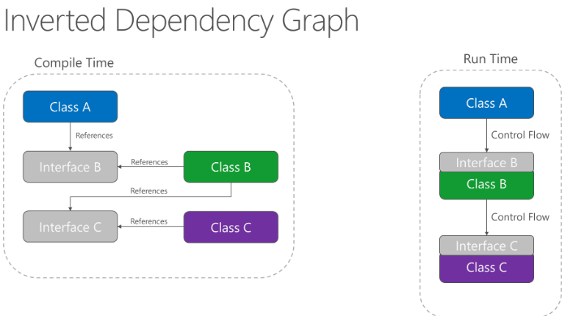

Dependency inversion is a key part of building loosely coupled applications, since implementation details can be written to depend on and implement higher-level abstractions, rather than the other way around. The resulting applications are more testable, modular and maintainable as a result. The practice of dependency injection is made possible by following the dependency inversion principle.

## Explicit dependencies

Methods and classes should explicitly require any collaborating objects they need in order to function correctly. It is called the ‘*Explicit Dependencies Principle*’. Class constructors provide an opportunity for classes to identify the things they need in order to be in a valid state and to function properly. If you define classes that can be constructed and called, but that will only function properly if certain global or infrastructure components are in place, these classes are being dishonest with their clients. The constructor contract is telling the client that it only needs the things specified (possibly nothing if the class is just using a parameter less constructor), but then at runtime it turns out the object really did need something else.

By following the explicit dependencies principle, your classes and methods are being honest with their clients about what they need in order to function. Following the principle makes your code more self-documenting and your coding contracts more user friendly, since users will come to trust that if they provide what’s required in the form of method or constructor parameters, the objects they’re working with will behave correctly at run time.

## Single responsibility

The single responsibility principle applies to object-oriented design but can also be considered as an architectural principle similar to separation of concerns. It states that objects should have only one responsibility and that they should have only one reason to change. Specifically, the only situation in which the object should change is if the manner in which it performs its one responsibility must be updated. Following this principle helps to produce more loosely coupled and modular systems, since many kinds of new behaviour can be implemented as new classes, rather than by adding additional responsibility to existing classes. Adding new classes is always safer than changing existing classes, since no code yet depends on the new classes.

In a monolithic application, we can apply the single responsibility principle at a high level to the layers in the application. Presentation responsibility should remain in the UI project, while data access responsibility should be kept within an infrastructure project. Business logic should be kept in the application core project, where it can be easily tested and can evolve independently from other responsibilities.

When this principle is applied to application architecture and taken to its logical endpoint, you get microservices. A given microservice should have a single responsibility. If you need to extend the behaviour of a system, it’s usually better to do it by adding additional microservices, rather than by adding responsibility to an existing one.

## Don’t repeat yourself (DRY)

The application should avoid specifying behaviour related to a particular concept in multiple places as this practice is a frequent source of errors. At some point a change in requirements will require changing this behaviour. It’s likely that at least one instance of the behaviour will fail to be updated, and the system will behave inconsistently.

Rather than duplicating logic, encapsulate it in a programming construct. Make this construct the single authority over this behaviour and have any other part of the application that requires this behaviour use the new construct.

**Note:** avoid binding together behaviour that is only coincidentally repetitive. For example, just because two constants have the same value, that doesn’t mean you should have only one constant, if conceptually they’re referring to different things. Duplication is always preferable to coupling to the wrong abstraction.

## Bounded contexts

Bounded contexts are a central pattern in domain driven design. They provide a way of tackling complexity in large applications or organisations by breaking it up into separate conceptual modules. Each conceptual module then represents a context that is separated from other contexts (hence, bounded), and can evolve independently. Each bounded context should ideally be free to choose its own names for concepts within it and should have exclusive access to its own persistence store.

At minimum, individual web applications should strive to be their own bounded context, with their own persistence store for their business model, rather than sharing a database with other applications. Communication between bounded contexts occurs through programmatic interfaces, rather than through a shared database, which allows for business logic and events to take place in response to changes that take place. Bounded contexts map closely to microservices, which also are ideally implemented as their own bounded contexts.

## Architectural Agility

This principle highlights the importance of designing software architectures that can adapt to changing requirements and conditions. Architects should consider using techniques such as modular design, microservices or other architectural patterns that promote flexibility and adaptability.

The principle of architectural agility, while not as widely recognized as some other principles, is an important concept in modern software architecture. It emphasizes the need to design software architectures that can adapt to changing requirements, conditions or technologies. The term “Architectural Agility” is more of a philosophy that encompasses several practices and pattens that enable a system to evolve more easily. Although the term itself might not be as widely referenced, the underlying idea is echoed in various architectural styles, methodologies and literature. The concepts of architectural agility is closely related to agile software development methodologies, which prioritize flexibility and adaptability in software projects.

Other areas of software development that support architectural agility include:

* Agile Software development, whose methodologies focus on iterative development and adapting to change, often allowing for ongoing architectural agility.
* Microservices Architecture, which is designed to break systems into small, loosely coupled services that can be developed, deployed and scaled independently. Each microservice can evolve without requiring the entire system to be impacted.
* Continuous delivery and DevOps practices that emphasize close collaboration between development and operations teams, and promote rapid, frequent reliable delivery of software.

## Interface Segregation Principle

The interface segregation principle (ISP) states that clients should not be forced to depend on methods that they do not use. Interfaces should belong to clients, not to libraries or hierarchies. Application developers should favour thin, focused interfaces to “fat” interfaces that offer more functionality than a particular class or method needs.

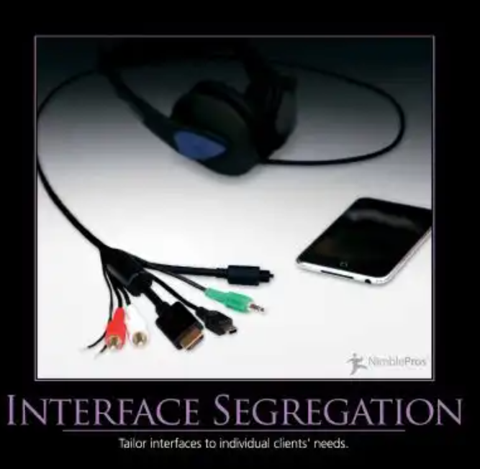

In many languages, such as C# interfaces can inherit from multiple other interfaces. Thus if you need a larger interface in some parts of the application, but not in others, you may be able to compose it from two or more other interfaces. This is also a good approach to keep in mind if you find yourself refactoring a legacy codebase, which already has large interfaces that you can’t break. Consider an interface like this one:

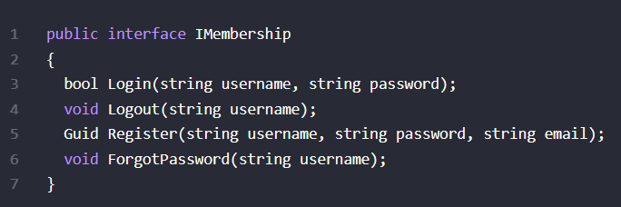

It’s easy to imagine such an interface growing completely out of control and having more functionality than any one class would ever require. To keep, say a login form from having more methods on it than it needs, you could create a login-specific interface and have the existing interface extend from it:

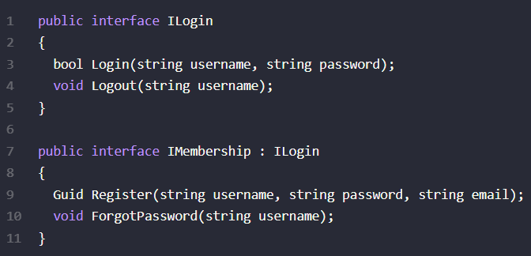

You could extend this further, as required, perhaps ending up with an original “fat” interface that only exists for legacy reasons, and is totally composed of other interfaces:

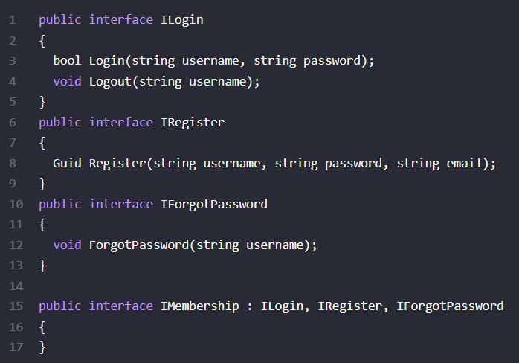

Ideally your thin interface should be cohesive, meaning they have groups of operations that logically belong together. This will prevent you from ending up with one interface per method most of the time in real world systems (as opposed to the above trivial example).

Another benefit of smaller interfaces is that they are easier to implement fully. They also provide greater flexibility in how you implement functionality, since parts of a larger interface can be implemented in different ways. Consider the repository pattern, which usually includes methods for reading as well as writing. A common performance pattern for database reads it so add a caching layer, but this generally only makes sense for read operations. Likewise, scalability can often be improved by queuing commands (like write operations) rather than executing them immediately, but you wouldn’t queue queries. Thus having an IRepository interface composed of an IReadOnlyRepository and an IWriteRepository would allow base implementations that go against a data store and separate implementations that employ caching and queuing as well.

## SOLID

The SOLID principles of object-oriented design include these five principles:

* SRP – single responsibility principle
* OCP – Open/Closed Principle
* LSP – Liskov Substitution principle
* ISP – Interface Segregation Principle
* DIP – Dependency Inversion Principle

Generally, software should be written as simply as possible in order to produce the desired result. However once updating the software becomes painful, the software’s design should be adjusted to eliminate the pain. Often, these principles, in addition to the more general ‘Don’t repeat yourself principle’ can be used as a guide while refactoring the software into a better design.

## Inheritance vs Composition

The relationship among classes is one of the fundamental activities of software design. There are two ways to relate classes: inheritance and composition.

**Inheritance**

Inheritance enables us to create a new class that reuses and extends behaviour from another class called a base class or superclass and the newly created class is called the derived class. When we inherit a class from any other class, the derived class implicitly gains all the members of the base class except the constructors and destructor. So, the derived class can reuse a base class method and property without re-implementing it. In other words we can say, using inheritance, a derived class extends the base class functionality. The main advantage of inheritance is the reusability of the code. The other main advantages of class inheritance are, it makes it easy to modify the current implementation of the base class by just overriding an operation within the derived class. The limitation with inheritance is, we cannot change the implementation of the base class at run time.

Inheritance is a hierarchical relationship between classes. Inheritance can denote a “is – a” relationship between classes.

Inheritance is sometimes said to provide “weak encapsulation”, because if you have code that directly uses a derived class then that code can be broken by changes to a base class.

An inheritance relationship between base classes is often said to be fragile, because small changes done in the base class can ripple out and might require changes in many places within an application.

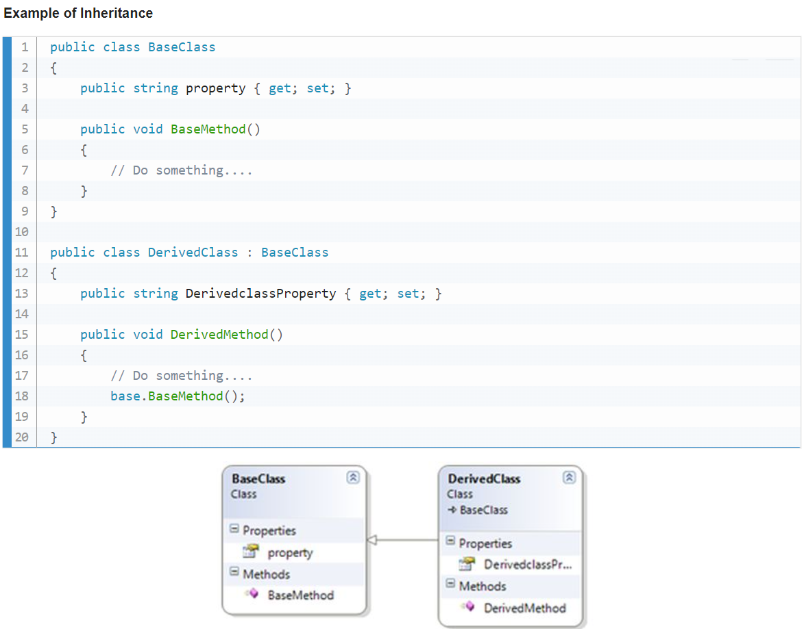

**Composition**

Composition is the most commonly used relation in a class diagram. In general terms, composition allows a class to contain an object instance of another class. Composition can be denoted as being an “as a part” or a “has a” relationship between classes.

In the composition approach, the derived class becomes the front-end class and the base class becomes the back-end class. The composition approach provides stronger encapsulation than inheritance because a change to a back-end class does not necessarily break any code that relies on the front-end class. The main advantages of composition is, with carefully designed interfaces we can change references of back end classes at runtime.

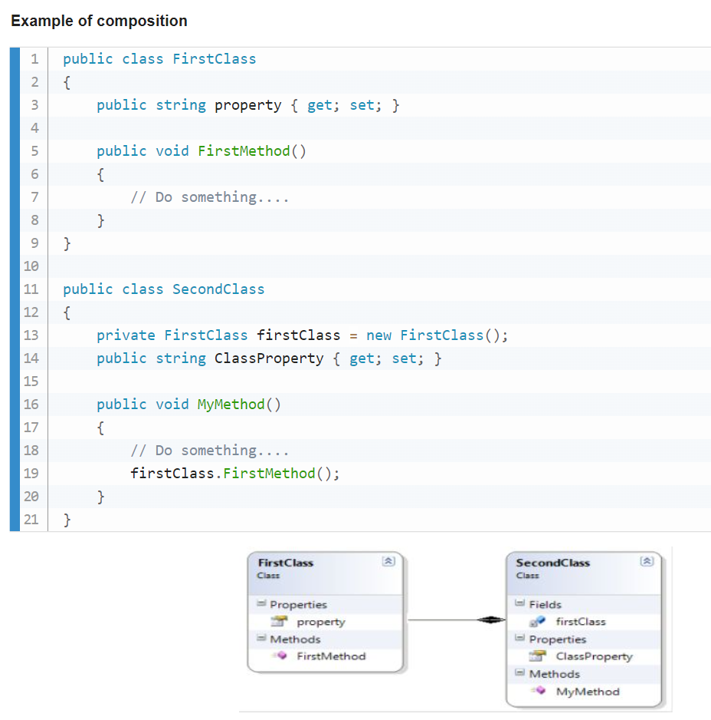In this example SecondClass (also called the front-end class) is related to FirstClass (also called the back end class) by composition. SecondClass has an instance variable that holds a reference to a FirstClass object. In the composition, the front-end class holds the reference of the back end class as an instance variable.

**Inheritance vs Composition**

|  |  |
| --- | --- |
| **Inheritance** | **Composition** |
| In inheritance, there is an image of the base class in the derived class object, so the image of the base class is created when the derived class object is created. | Composition allows late creation of the backend class object until and unless they are not really required. |
| Base class remains a part of the derived class object throughout the life of the derived class. | In composition, life of the backend class is independent, and we can change backend object dynamically. |
| Inheritance is static binding (compile time binding) | Composition is dynamic binding (run time binding) |
| Inheritance can denote an “is – a” relationship between classes. | Composition can be denoted as being an “as a part” or “has a” relationship between classes. |
| Inheritance comes with polymorphism. | NA |
| In inheritance, it is not required to implement all base class methods within the derived class. | In composition, all methods provided by composed classes must be implemented in the front-end class. |
| The derived class and base class interfaces are tightly coupled. | The front-end and back-end interfaces are loosely coupled. |

It is easier to add new derived classes in inheritance than to add new front-end class in composition.

**Conclusion**

The inheritance model is denoted as being an “is – a” relationship and composition is denoted as being a “has – a” relationship between classes. The developer is always confused, choosing between inheritance and composition. Do not use inheritance just for code reuse. If there is no is-a relationship between classes, then use composition. Do not use inheritance to get polymorphism. We can use inheritance to express differences in behaviour and fields to express variations in state in a state design pattern.

## Composition vs Inheritance explained again

Composition and Inheritance are programming techniques to establish relationships between different classes. When working with an object-oriented language like C#, it is natural that we come across classes and objects. These classes, more than often, need to interact with each other if we are creating any meaningful application. Both composition and inheritance are tools to implement these interactions.

**Inheritance**

Inheritance is one of the critical characteristics of object-oriented programming. It is a mechanism of a class deriving its implementation from a base class. To put it simply, when a derived class inherits from a base class, it acquires properties and behaviours of the base class. Some of the most common types of inheritance are:

* Single Inheritance, where the derived class has a single base class.
* Hierarchical inheritance, where a base class has multiple derived classes.
* Multi-level inheritance, where a derived class acts as a base for another derived class.

C# does not allow multiple class inheritance. We overcome this by using interfaces. **We use inheritance to achieve an *is-a* relationship between classes.**

To see how inheritance works, lets start by creating a base House class:

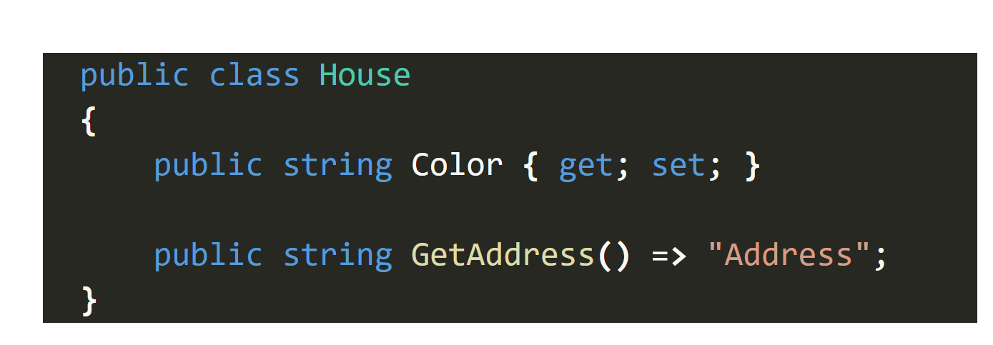

Now lets create a BrickHouse class that inherits from the House class:

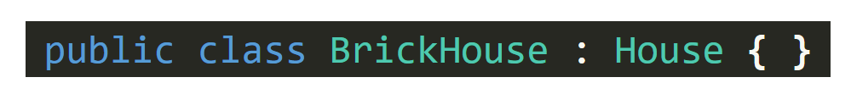

And a new GlassHouse class:

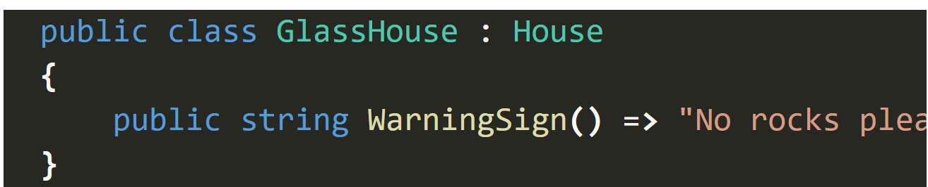

Finally we can modify the Program class:

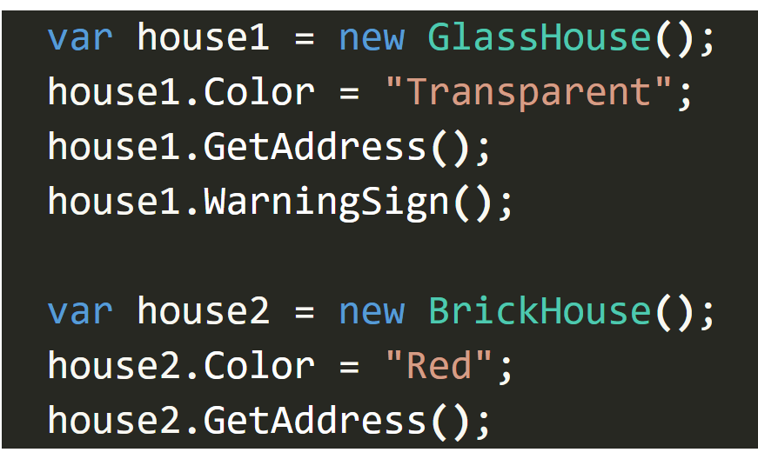We have two derived (or child) classes, GlassHouse and BrickHouse. The properties and methods of the base (or parent) class are accessible from the objects of derived classes. These classes can also have additional properties and methods like the WarningSign() method in GlassHouse.

**Composition**

**We use composition to create a *has-a* relationship between classes.**

A combination of component objects creates a composite object. Here, the composite class contains the object of component classes as members. In other words, every composite ***has-a*** component. Let’s continue with the example we used earlier. A House can be seen as a combination of several components like Ceiling, Floor, etc:

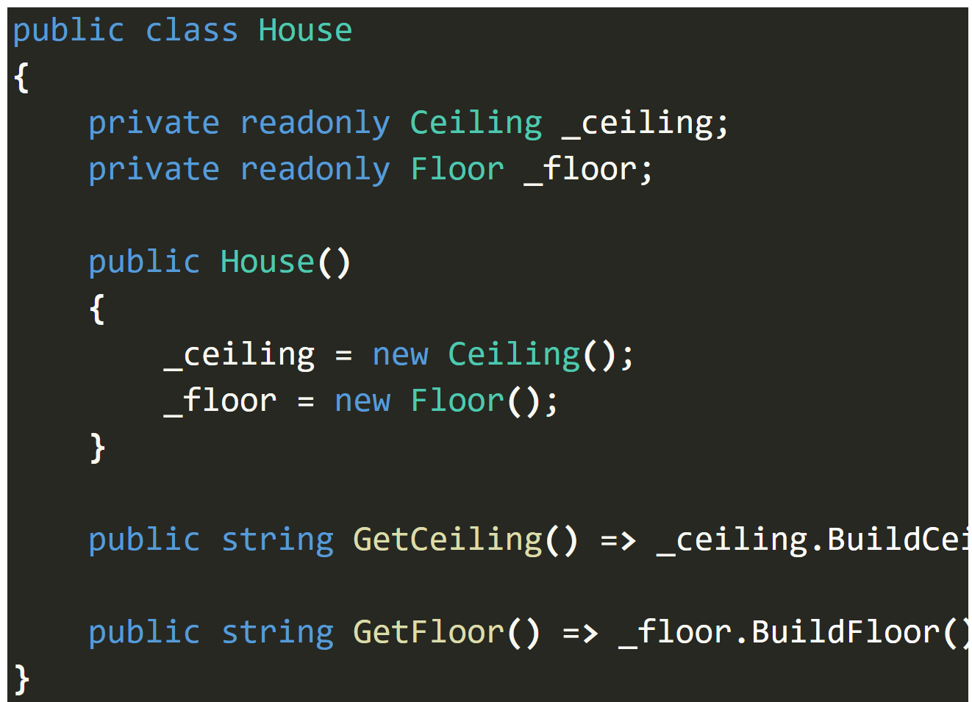

Here, we can represent the composition of a House using Ceiling and Floor class references.

With composition, we can choose the functionalities we want to implement in the composite class based on the components unlike inheritance, where the derived class automatically has access to all the base class methods.

**What is the Difference between Inheritance and Composition?**

Inheritance is all about specialization of a general concept. The derived class is a specialized version of the base class and promotes code reuse. It implicitly inherits all non-private members of its base classes, whether direct or indirect. It can also hide or override the inherited members.

On the other hand, the composition is about the association of objects of different classes. It enables code reuse by adding a reference to another object instead of inheriting the complete implementation.

On the other hand, the composition is about the association of objects of different classes. It enables code reuse by adding a reference to another object instead of inheriting the complete implementation.

With inheritance, we get a tight coupling of code, and changes in the base class ripple down the hierarchy to derived classes. Whereas, a coupling created through composition is a loose one. It helps us achieve greater flexibility. We can add another component to accommodate any future change instead of restructuring the inheritance hierarchy.

One of the major advantages of inheritance is that we implicitly get all the base class methods in the derived class and there is no extra performance cost of invocation.

On the contrary, with composition, we are creating a composite object by plugging in the component objects. These component objects should not be exposed directly as they exist only within the composite context. We need to have a corresponding implementation of the component class methods in the composite class like GetCeiling() and GetFloor() in the House class to invoke BuildCeiling() and BuildFloor() methods respectively. This delegation of the method invocation may have a performance cost in addition to having to write extra code.

**Composition Over Inheritance**

So, we have established that both composition and inheritance, are essential object-oriented programming techniques. Both of them promote code reuse. What is that about?

The main problem with inheritance is that it may lead to a deep hierarchy of classes. This hierarchy is fragile, and the implementation of derived classes can break or be forced to change with any change at the top of the hierarchy.

Let’s continue with our House example and say we want to introduce another type of House which is a Caravan. This leads to a problem because a caravan doesn’t have a fixed address. The hierarchy now needs to change and introduce for example MovableHouse and FixedHouse classes.

However, it’s not viable to re-write the complete code on introducing a change once it’s deployed.

This also leads to another common problem we face with inheritance. A derived class is exposed to all the functionalities of its base class. While good in terms of code reuse, this isn’t always beneficial as the derived class might not need all the functionalities.

For example, we can fix the problem of introducing a Caravan class by making the GetAddress() method as a virtual one in the House class:

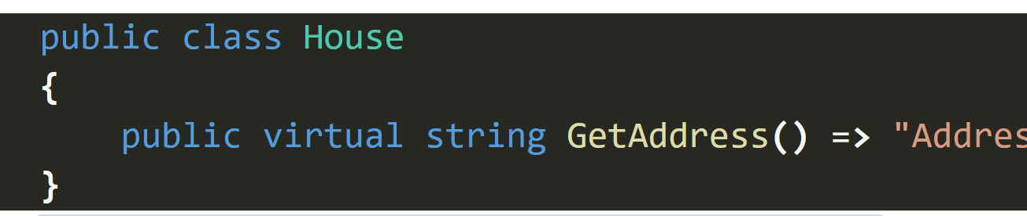

Now in the Caravan class:

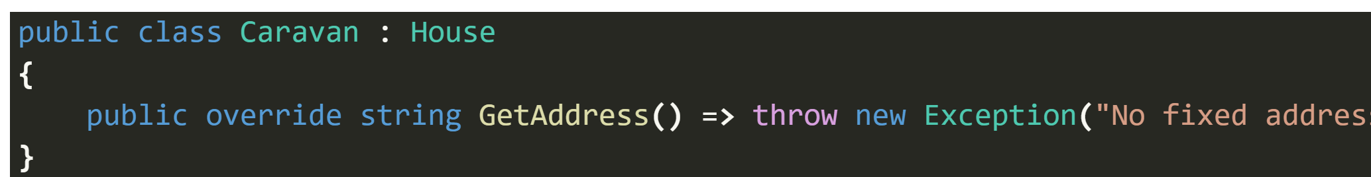

As we don’t want our Caravan class to have a fixed address, we can override the GetAddress() method and throw an exception.

This takes care of our fragile base class problem at the moment. However, this isn’t ideal. The Caravan class should not have access to the functionality it does not support.

We can address this problem by using composition. We can treat Address as a separate component and move the GetAddress() method there:

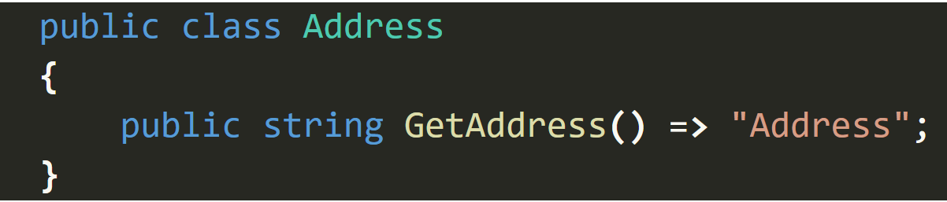

Now, the BrickHouse class can have Address as its component:

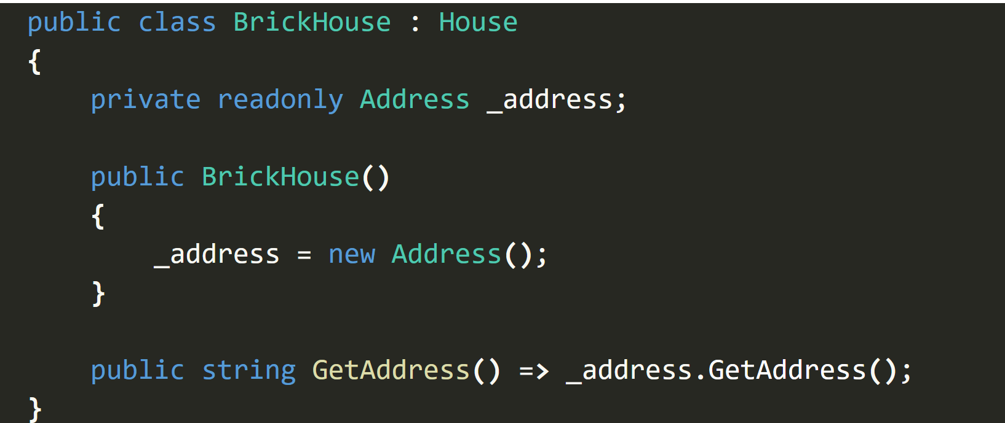

Whereas the Caravan class does not need to implement the same:



**Is Composition better than Inheritance?**

This question doesn’t have a clear yes-no answer like everything else in software design. We need to understand the trade-offs when we make our decisions. “Composition over inheritance” is, after all, a guideline that we need to consider and does not mean we choose composition as a silver bullet.

For example, with inheritance, we get straightforward code reuse i.e. the derived class can use the methods from the base class. Whereas, with composition, we need to rewrite the code for every method in the component, even if just for delegation. It’s also easier in inheritance to extend or modify a base functionality by overriding it in the derived class.

Nevertheless, it is often preferable to use composition over inheritance. Even when we can use inheritance, it doesn’t mean we should use inheritance

One test to decide whether we should use inheritance is establishing an “is-a” relationship between the classes. If X is Y, class X can inherit from class Y.

This test alone might not be helpful every time. It may lead to the classic Circle-Ellipse problem where a circle is a type of ellipse but doesn’t share all its implementations, for example, stretching on one of the axes.

Thus, along with our previous criteria, we need to consider the Liskov Substituion principle which says the base class objects should be replaceable with the derived class objects and this replacement should not break the application.

So, we should use inheritance if:

* There is an “is-a” relationship between classes (X is a Y)
* The derived class can have all the functionality of the base class

For all other instances, the composition is the preferred choice.

## Access Modifiers

All type members have an accessibility level. The accessibility level controls whether they can be used from other code in your assembly or other assemblies. An assembly is a .dll or .exe created by compiling one or more .cs files in a single compilation. Use the following access modifiers to specify the accessibility of a type or member when you declare it:

**Public:** The type or member can be accessed by any other code in the same assembly or another assembly that references it. The accessibility level of public members of a type is controlled by the accessibility level of the type itself.

**Private:** The type or member can be accessed only by code in the same class or struct.

**Protected:** The type or member can be accessed only by code in the same class, or in a class that is derived from that class.

**Internal:** The type or member can be accessed by any code in the same assembly, but not from another assembly. In other words, internal types or members can be accessed from code that is part of the same compilation.

**Protected internal:** The type or member can be accessed by any code in the assembly in which its declared, or from within a derived class in another assembly.

**Private protected:** The type or member can be accessed by types derived from the class that are declared within its containing assembly.

The **readonly** keyword is a modifier that can be used in different contexts. In a field declaration, readonly indicates that assignment to the field can only occur as part of the declaration or in a constructor in the same class. A readonly field can be assigned and reassigned multiple times within the field declaration and constructor.

However, a **readonly** field can’t be assigned after the constructor exists.

## Other keywords

**Virtual:** The virtual keyword is used to modify a method, property, indexer, or event declaration and allow for it to be overridden in a derived class. For example, this method can be overridden by any class that inherits it:

**Abstract:** The abstract modifier indicates that the thing being modified has a missing or incomplete implementation. The abstract modifier can be used with classes, methods, properties, indexers, and events. Use the abstract modifier in a class declaration to indicate that c class is intended only to be a base class of other classes, not instantiated on its own. Members marked as abstract must be implemented by non-abstract classes that derive from the abstract class.

**Static:** use the static modifier to declare a static member, which belongs to the type itself rather than to a specific object. The static modifier can be used to declare static classes. In classes, interfaces, and structs, you may add the static modifier to fields, methods, properties, operators, events, and constructors. The static modifier can’t be used with indexers or finalizers.

**Sealed:** When applied to a class, the sealed modifier prevents other classes from inheriting from it. In the following example, class B inherits from class A, but no class can inherit from class B.

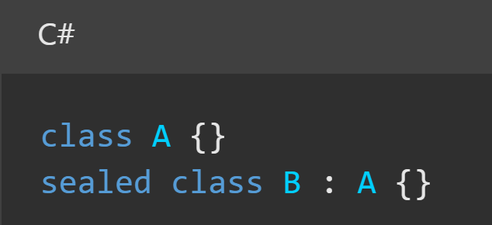

You can also use they sealed modifier on a method or property that overrides a virtual method or property in a base class. This enables you to allow classes to derive from your class and prevent them from overriding specific virtual methods or properties.

**Partial:**

# The OSI Model – Features, Principles and Layers

There are n numbers of users who use computer network and are located over the world. So to ensure, national and worldwide data communication, systems must be developed which are compatible to communicate with each other ISO has developed a standard. ISO stands for International organization of Standardization. This is called a model for Open System Interconnection (OSI) and is commonly known as OSI model.

The ISO-OSI model is a seven-layer architecture. It defines seven layers or levels in a complete communication system.

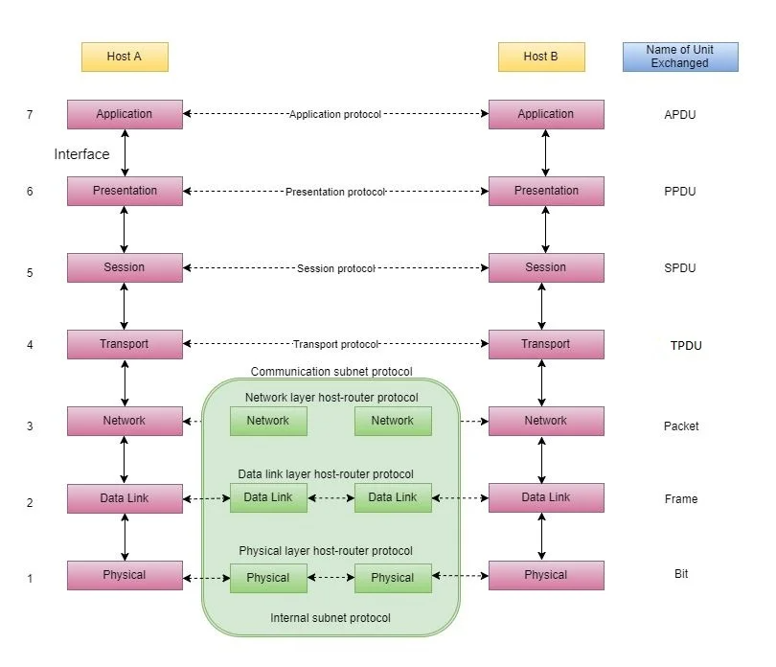

## Feature of OSI Model

* Big picture of communication over network is understandable through this OSI model.
* We see how hardware and software work together.
* We can understand new technologies as they are developed.
* Troubleshooting is easier by separate networks.
* Can be used to compare basic functional relationships on different networks.

## Principles of OSI Reference Model

The OSI reference model has 7 layers. The principles that were applied to arrive at the seven layers can be briefly summarized as follows:

1. A layer should be created where a different abstraction is needed.
2. Each layer should perform a well-defined function.
3. The function of each layer should be chosen with an eye toward defining internationally standardized protocols.
4. The layer boundaries should be chosen to minimize the information flow across the interfaces.
5. The number of layers should be large enough that distinct functions need not be thrown together in the same layer out of necessity and small enough that architecture does not become unwieldly.

## OSI Model Layer 1: The Physical Layer

Physical layer is the lowest layer of the OSI reference model. It is responsible for sending bits from one computer to another. This layer is not concerned with the meaning of the bits and deals with the setup of physical connection to the network and with transmission and reception of signals.

Following are the various functions performed by the physical layer of the OSI model:

1. Representation of Bits: data in this layer consists of a stream of bits. The bits must be encoded into signals for transmission. It defines the type of encoding i.e., how 0s are changed to signal.
2. Data Rate: this layer defines the rate of transmission which is the number of bits per second.
3. Synchronization: it deals with the synchronization of the transmitter and receiver. The sender and receiver are synchronized at bit level.
4. Interface: The physical layer defines the transmission interface between devices and transmission medium.
5. Line configuration: this layer connects devices with the medium; point to point configuration and multipoint configuration.
6. Topologies: Devices must be connected using the following topologies: Mesh, star, ring and bus.
7. Transmission modes: physical layer defines the direction of transmission between two devices: simplex, half duplex, full duplex.
8. Deals with baseband and broadband transmission.

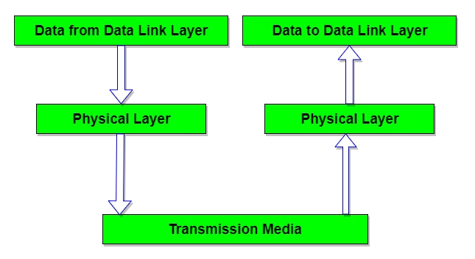

## Design issues with Physical Layer

* The physical layer is concerned with transmitting raw bits over a communication channel.
* The design issue has to do with making sure that when one side sends a 1 bit, it is received by the other side as a 1 bit and not as a 0 bit.

Typical questions here include:

* How many volts should be used to represent a 1 bit and how many for a 0?
* How many nanoseconds a bit lasts?
* Whether transmission may proceed simultaneously in both directions?
* How many pins the network connector has and what each pin is used for?

The design issues here largely deal with mechanical electrical and timing interfaces, and the physical transmission medium, which lies below the physical layer.

## Multipoint vs Point to Point

|  |  |
| --- | --- |
| Point to point communication | Multipoint Communication |
| Point to point communication means the channel is shared between two devices. | Multipoint communication means the channel is shared among multiple devices or nodes. |
| In this communication, there is dedicated link between nodes. | In this communication, link is provided at all times for sharing the connection among nodes. |
| In this communication the entire capacity is reserved between these connected two devices with the possibility of waste of network bandwidth/resources. | In this communication, the entire capacity isn’t reserved by any two nodes and the network bandwidth is maximally utilized. |
| In this communication there is one transmitter and one receiver | In this communication, there is one transmitter and many receivers. |
| In point-to-point connections the smallest distance is most important to reach the receiver. | In multi-point connections, the smallest distance is not important to reach the receiver. |
| Point to point communication provides security and privacy because communication channel is not shared. | Multipoint communication does not provide security and privacy because communication channel is shared |

### Point to point:

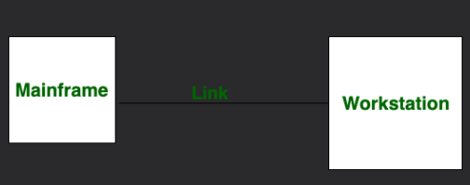

### Multipoint:

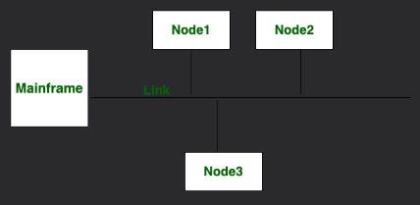

## Topologies

There are different types of topologies, like the following.

### Mesh Topology

In a mesh topology, every device is connected to another device via a particular channel. In Mesh Topology, the protocols used are AHCP (Ad Hoc Configuration Protocols), DHCP (Dynamic Host Configuration Protocol)

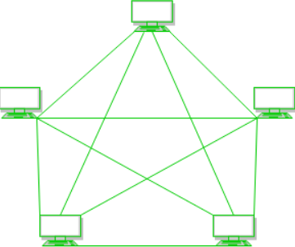

Every device is connected to another via dedicated channels. These channels are known as links.

* Suppose the N number of devices are connected with each other in a mesh topology, the total number of ports that are required by each device is N-1. In this figure above there are 5 devices connected to each other, hence the total number of ports required by each device is 4. The total number of ports required = N*N-1.
* Suppose, N number of devices are connected with each other in a mesh topology, then the number of dedicated links required to connect them is N(N-1)/2. In the figure there are 5 devices connected to each other, hence the total number of links required is 5* 4/2=10

### Advantages of Mesh Topology

* Communication is very fast between the nodes.
* Mesh Topology is robust.
* The fault is diagnosed easily. Data is reliable because data is transferred among the devices through dedicated channels or links.
* Provides security and privacy.

### Disadvantages of Mesh Topology

* Installation and configuration are difficult.
* The cost of cables is high as bulk wiring is required, hence suitable for a smaller number of devices.
* The cost of maintenance is high.

A common example of mesh topology is the internet backbone, where various internet service providers are connected to each other via dedicated channels. This topology is also used in military communication systems and aircraft navigation systems.

### Star Topology

In Star Topology, all the devices are connected to a single hub through a cable. This hub is the central node, and all other nodes are connected to the central node. The hub can be passive in nature i.e., not an intelligent hub such as broadcasting devices, at the same time the hub can be intelligent known as an active hub. Active hubs have repeaters in them. Coaxial cables or RJ-45 cables are used to connect the computers. In Star Topology, many popular Ethernet LAN protocols are used as CD (Collision Detection), CSMA (Carrier Sense Multiple Access).

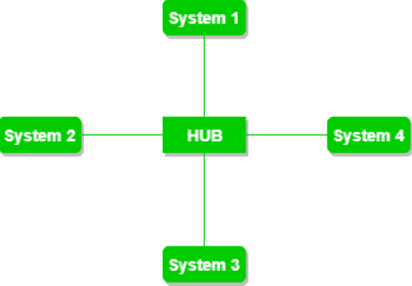

### Advantages of Star Topology

* If N devices are connected to each other in a star topology, then the number of cables required to connect them is N. So, it is easy to set up.
* Each device requires only 1 port i.e., to connect to the hub, therefore the total number of ports required is N.
* It is Robust. If one link fails only that link will be affected.
* Easy to identify and isolate fault.
* Star topology is cost effective as it uses inexpensive coaxial cable.

### Disadvantages of Star Topology

* If the concentrator (hub) on which the whole topology relies fails, the whole system will crash down.
* The cost of installation is high.
* Performance is based on the single concentrator i.e., hub.

A common example of star topology is a local area network (LAN) in an office where all computers are connected to a central hub. This topology is also used in wireless networks where all devices are connected to a wireless access point.

### Bus Topology

Bus Topology is a network type in which every computer and network device is connected to a single cable. It is bi-directional. It is a multi-point connection and a non-robust topology because if the backbone fails the topology crashes. In Bus Topology, various MAC (Media Access Control) protocols are followed by LAN ethernet connections like TDMA, Pure Aloha, CDMA, Slotted Aloha.

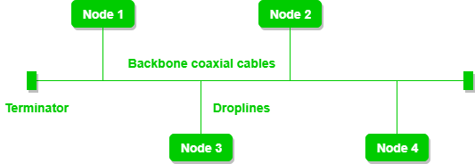

The figure above shows a bus topology with shared backbone cable. The nodes are connected to the channel via drop lines.

### Advantages of Star Topology

* If N devices are connected to each other in a bus topology, then the number of cables required to connect them is 1, known as the backbone cable, and N drop lines are required.
* Coaxial or twisted pair cables are mainly used in bus-based networks that support up to 10 Mbps.
* The cost of the cable is less compared to other topologies, but it is used to build small networks.
* Bus topology is familiar technology as installation and troubleshooting techniques are well known.
* CSMA is the most common method for this type of topology.

### Disadvantages of Star Topology

* A bus topology is quite simple, but still requires a lot of cabling.
* If the common cable fails, then the whole system will crash down.
* If the network traffic is heavy, it increases collisions in the network. To avoid this, various protocols are used in the MAC layer known as Pure Aloha, slotted aloha, CSMA/CD etc.
* Adding new devices to the network would slow down networks.
* Security is very low.

A common example of bus topology is the Ethernet LAN, where all devices are connected to a single coaxial cable or twisted pair cable. This topology is also used in television networks.

### Ring Topology

In a ring topology, it forms a ring connecting devices with exactly two neighbouring devices. A number of repeaters are used for Ring topology with a large number of nodes, because if someone wants to send some data to the last node in the ring topology with 100 nodes, then the data will have to pass through 99 nodes to reach the 100th node. Hence to prevent data loss repeaters are used in the network.

The data flows in one direction, i.e., it is unidirectional, but it can be made bidirectional by having 2 connections between each Network Node, it is called Dual Ring Topology. In-Ring Topology, the Token Ring Passing protocol is used by the workstations to transmit the data.

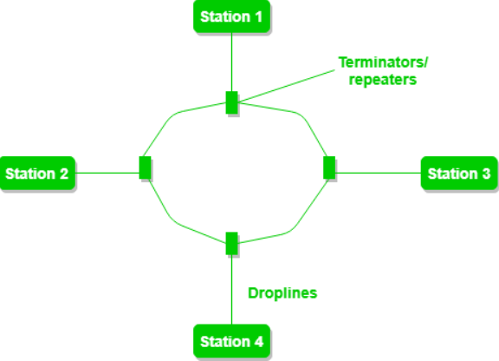

The figure above shows a ring topology comprising of 4 stations connected with each-other forming a ring. The most common access method of ring topology is token passing.

* Token passing: A network access method in which a token is passed from one node to another node.
* Token: A frame that circulates around the network.

### Operations of Ring Topology

1. One station is known as a monitor station which takes all the responsibility for performing the operations.
2. To transmit the data, the station has to hold the token. After the transmission is done, the token is to be released for other stations to use.
3. When no station is transmitting the data, then the token will circulate in the ring.
4. There are two types of token release techniques: Early token release releases the token just after transmitting the data and Delayed token release releases the token after the acknowledgment is received from the receiver.

### Advantages of Ring Topology

* The data transmission is high speed.
* The possibility of collision is minimum in this type of topology.
* Cheap to install and expand.
* It is less costly than a star topology.

### Disadvantages of Ring Topology

* The failure of a single node in the network can cause the entire network to fail.
* Troubleshooting is difficult in this topology.
* The addition of stations in between or the removal of stations can disturb the whole topology.
* Less secure.

### Hybrid Topology

This topological technology is the combination of all the various types of topologies we have studied above. Hybrid Topology is used when the nodes are free to take any form. It means these can be individuals such as Ring or Star Topology or can be a combination of various types of topologies seen already.

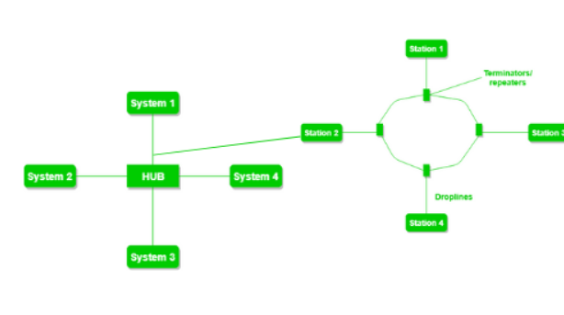

### Advantages of Hybrid Topology

* This topology is very flexible.
* The size of the network can be easily expanded by adding new devices.

### Disadvantages of Hybrid Topology

* It is challenging to design the architecture of the hybrid network.
* Hubs used in this topology are very expensive.
* The infrastructure cost is very high as a hybrid network requires a lot of cabling and network devices.

A common example of a hybrid topology is a university campus network. The network may have a backbone of a star topology, with each building connected to the backbone through a switch or router. Within each building there may be a bus or ring topology connecting the different rooms and offices. The wireless access points also create a mesh topology for wireless devices. This hybrid topology allows for efficient communication between different buildings while providing flexibility and redundancy within each building.

### Terms

### Coaxial Cables

Coaxial cables, sometimes known as coax cables are electrical cables that can transmit electrical signals from one point to another.

This technology has been around since the early 20th century, with these cables mainly used to connect satellite antenna facilities to homes and businesses thanks to their durability and ease of installation.

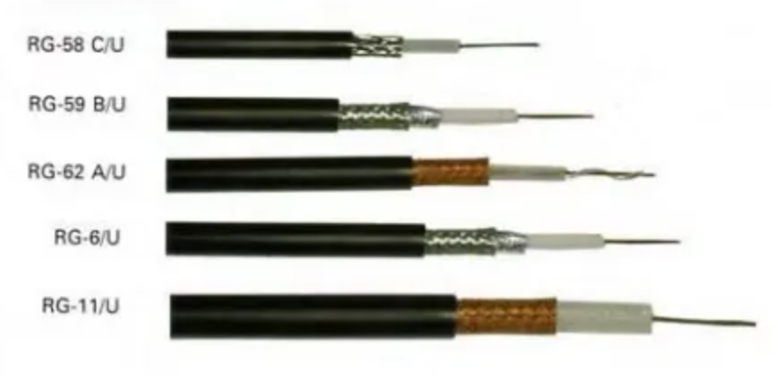

**What is RG cable?**

There are different types of coaxial cable, which vary by gauge and impedance. Gauge refers to the cables thickness and is measured by the radio guide measurement or RG number. The higher the RG number, the thinner the central conductor code is.

‘

**How do Coaxial Cables work?**

Coaxial cables are a popular choice because their shielded design allows the centre conductor to transmit data quickly while being protected from damage and interference.

Coaxial cables are mainly built up of these four different layers:

1. A centre conductor which is usually a copper wire, which data and video travels through.
2. Surrounding the copper wire is a dielectric plastic insulator.
3. A braided mesh made from copper then helps to shield the cable from electromagnetic interference (EMI).
4. The external layer is a plastic coating which protects the internal layers from damage.

Coaxial cable works by carrying data in the centre conductor, while the surrounding layers of shielding stop any signal loss (also called attenuation loss) and help reduce EMI.

The first layer, called the dielectric, provides distance between the core conductor and the outer layers, as well as some insulation. The next layers collectively referred to as the shield, keep electrical impulses and radio transmissions out. The different layers of a coaxial cable are shown in the image below:

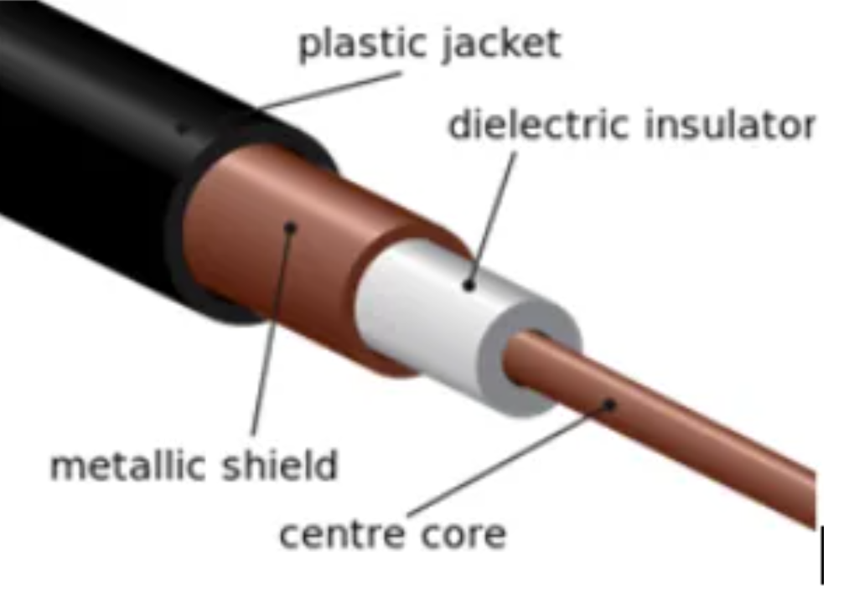

The transmission speed of a coaxial cable is 10Mbps (megabits per second).

**Advantages of coaxial cable**

* Inexpensive
* Easy to wire and install
* Easy to expand
* Good resistance to EMI
* Up to 10Mbps capacity
* Durable

Another benefit of coaxial cable is the electromagnetic field carrying the signal exists only in the space between the inner and outer conductors. This means coaxial cable can be installed next to metal objects without losing power, unlike other types of transmission lines.

**Disadvantages of coaxial cable**

The main disadvantage of using coaxial cable is that single cable failure can take down an entire network.

## Fibre Optic Cables

Fibre optics, or optical fibres are long, thin strands of carefully drawn glass about the diameter of human hair. These strands are arranged in bundles called fibre optic cables. We rely on them to transmit light signals over long distances.

Optical fibre cabling is used to transfer information via pulses of light, which pass along one or more transparent plastic or glass pipes. In some cases, this can be more than several hundred pipes. Each of these strands is little wider than an average hair and is normally surrounded by a further layer of cladding which is also in plastic or glass but constructed at a different density to the main inner strand. A sheath made up of several layers of insulated casing is also wrapped around the cladded fibers. This usually comprises of a protective wrapper, known as a buffer tube, followed by a final outer jacket designed to protect the entire multi-stranded cable.

**Optical Fibre Internet and Networking**

Fibre optic internet cable is increasingly popular. This is due to the higher speeds and bandwidth it can provide compared to standard ethernet or Wi-Fi signals delivered by coaxial or even copper wire from street level exchanges. This means that fibre networking is a far better choice where high speeds are advantageous or for particularly intensive data transfer needs. Much of this is also true for fibre optic phone lines.

## Difference between bandwidth and speed

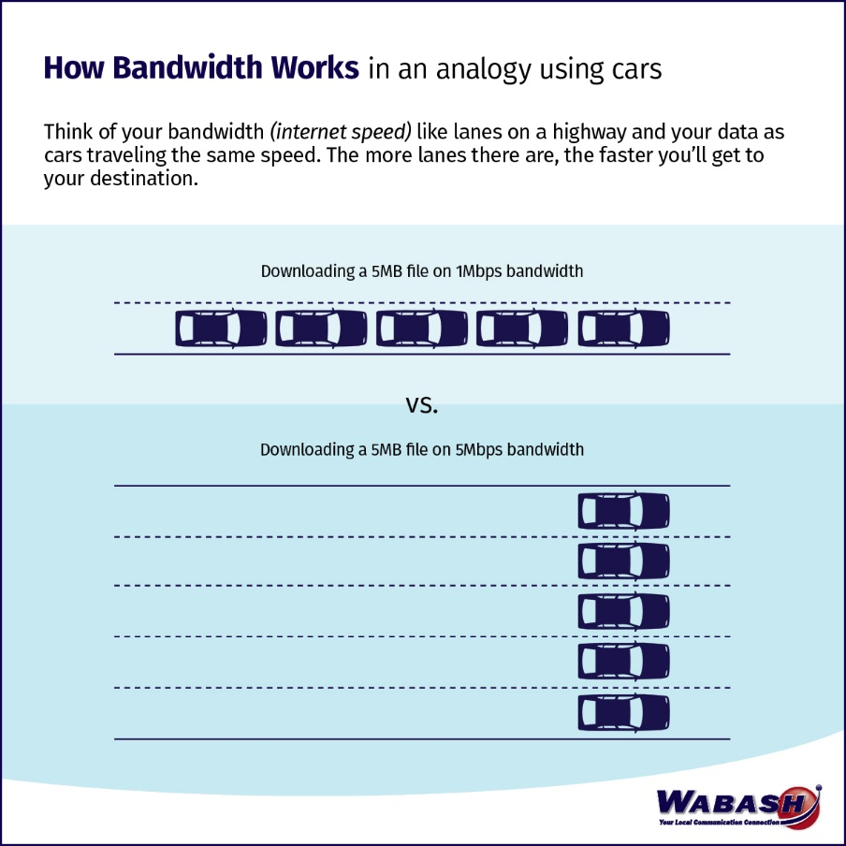

Bandwidth: the maximum amount of data your connection can handle at any moment

Speed: How fast data can travel on that bandwidth.

So, bandwidth refers to the capacity of your internet connection, typically measured in megabits per second (Mbps). It is like the number of lanes on a highway. The more bandwidth you have (more lanes), the more data you can transmit at the same time. Bandwidth is a measure of how much data can be transferred in a given period.

Speed on the other hand refers to how fast data can travel on that bandwidth. In the highway analogy, speed is how fast each car is moving. So, while bandwidth determines how much data can be sent or received at a time, speed determines how quickly that data travels. Speed is often measured in terms of data transfer rates, such as Mbps or Gbps.

To put it another way, imagine you have a 5-lane highway (5 Mbps of bandwidth). If the cars on that highway are moving at 1Mbps each it would take each car 5 seconds to reach their destination. So, bandwidth is like the number of lanes on the highway, and speed is how fast the individual cars (data packets) can travel on those lanes.

In practice the lanes in the analogy for bandwidth refer to the capacity for transmitting data over a network. Think of these lanes as the pathways through which digital information travels. Each lane represents a separate channel or a portion of the available capacity that data can flow through. The more lanes (higher bandwidth), the more data can be transmitted simultaneously.

In network infrastructure, these lanes can be realized in various ways, depending on the technology and medium used. For example:

1. Copper Wires (DSL): In digital subscriber line (DSL) internet connections, the lanes are different frequency channels on a copper telephone line. By splitting the available frequency spectrum into different channels, data can be transmitted simultaneously at different frequencies.
2. Fiber Optic Cables: In fiber optic connections, the “lanes” represent different wavelengths of light that carry data. Multiple wavelengths of light can be used to send data in parallel through the optical fibers.
3. Wireless (Wi-Fi, Cellular): In wireless networks, the “lanes” are different radio channels or frequency bands over which data can be transmitted. Different channels allow multiple devices to communicate simultaneously without interference.
4. Ethernet Cables: In wired Ethernet connections, the “lanes” refer to the number of twisted pairs in the cable, with each pair serving as a separate channel for data transmission.

So, the term “lanes” is a metaphorical way of describing the capacity to transmit data concurrently, and the actual implementation varies depending on the technology and medium used in a specific network or internet connection. So, a scenario with high speed but low bandwidth would result in a network or internet connection that can transmit data quickly but has limited capacity for simultaneous data transfer. This can have various effects on your internet experience.

**Multiple lanes for one file download?**

Multiple lanes (or higher bandwidth) can indeed be used for a single file download, but the extent to which they can be utilized depends on several factors, including the capabilities of your internet connection, the server’s capacity, and the specific technology being used.

In general, when you download a file, your computer or device will attempt to use as much available bandwidth as it can. If you have a high-bandwidth internet connection (e.g., a fiber optic connection with high Mbps). It can potentially use multiple lanes to download a file more quickly. However, there are limits to this:

1. Server Capacity: The server from which you’re downloading the file needs to have sufficient capacity and available bandwidth to match your download speed. If the server has lower bandwidth than your connection, it can become a bottleneck, and your download speed may be limited by the servers capacity.
2. File Splitting: Some download protocols and servers are designed to split a single file into multiple parts and download them in parallel, utilizing multiple lanes (or connections) to speed up the process. This is common with download managers or accelerators.
3. Concurrency: your computer or download client may be capable of opening multiple concurrent connections to the server, effectively using multiple lanes to download different parts of the file simultaneously.
4. Network Congestion: Even with a high bandwidth connection, network congestion or limitations along the data path (such as peering points and routing) can affect your download speed.

In practice, the degree to which multiple lanes are utilized for a single file download can vary. It is not uncommon for large file downloads to take advantage of multiple or connections when the server and your connection support it. However, for small files or in cases where server capacity is limited, the improvement in download speed may be less noticeable.

**Physical layer services:**

* Bit-by-bit or symbol-by-symbol delivery
* Modulation
* Line coding
* Bit synchronization
* Start-stop signalling.
* Circuit switching
* Multiplexing
* Carrier sense and collision detection
* Physical network topology, like bus, ring, mesh or star network

## OSI Model Layer 2: Data Link Layer

Data link layer performs the most reliable node to node delivery of data. It forms frames from the packets that are received from the network layer and gives them to the physical layer. It also synchronizes the information which is to be transmitted over the data. Error controlling is easily done. The encoded data are then passed to physical.

Error detection bits are used by the data link layer. It also corrects the errors. Outgoing messages are assembled into frames. Then the system waits for the acknowledgements to be received after the transmission. It is reliable to send message.

The main task of the data link layer is to transform a raw transmission facility into a line that appears free of undetected transmission errors to the network layer. It accomplishes this task by having the sender break up the input data into data frames (typically a few hundred or few thousand bytes) and transmit the frames sequentially. If the service is reliable, the receiver confirms correct receipt for each frame by sending back and acknowledgement frame.

### Functions of Data Link Layer

1. **Framing**: Frames are the streams of bits received from the network layer into manageable data units. This division of stream of bits is done by Data Link Layer.
2. **Physical Addressing:** The Data Link layer adds a header to the frame in order to define physical address of the sender or receiver of the frame, if the frames are to be distributed to different systems on the network.
3. **Flow Control:**  A flow control mechanism to avoid a fast transmitter from running a slow receiver by buffering the extra bit is provided by flow control. This prevents traffic jam at the receiver side.
4. **Error Control:** Error control is achieved by adding a trailer at the end of the frame. Duplication of frames are also prevented by using this mechanism. Data Link Layers adds mechanism to prevent duplication of frames.
5. **Access Control:** Protocols of this layer determine which of the devices has control over the link at any given time, when two or more devices are connected to the same link.

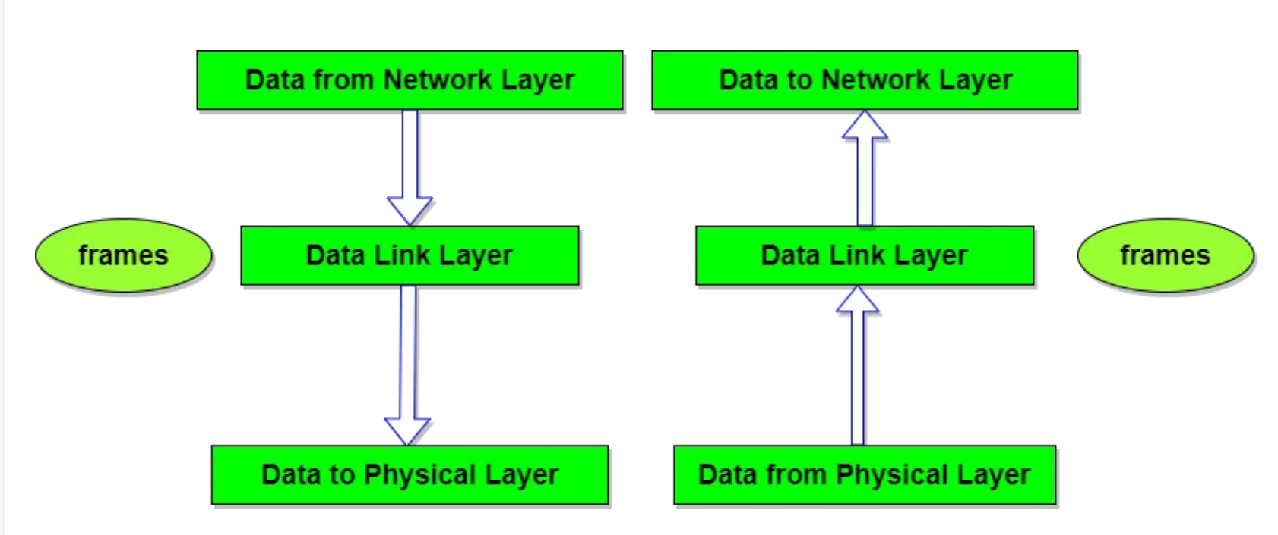

## Design Issues with Data Link Layer

* The issue that arises in the data link layer (and most of the higher layers as well) is how to keep a fast transmitter from drowning a slow receiver in data. Some traffic regulation mechanism is often needed to let the transmitter know how much buffer space the receiver has at the moment. Frequently, the flow regulation and the error handling are integrated.
* Broadcast networks have an additional issue in the data link layer: How to control access to the shared channel. A special sublayer of the data link layer, the medium access control (MAC) sublayer, deals with this problem.

Reiterated: The data link layer is the second layer of the seven-layer OSI model of computer networking. This layer is the protocol layer that transfers data between adjacent network nodes in a wide area network (WAN) or between nodes on the same local area network (LAN) segment. The data link layer provides the functional and procedural means to transfer data between network entities and might provide the means to detect and possibly correct error that may occur in the physical layer.

The data link layer is concerned with local delivery of frames between devices on the same LAN. Data-link frames, as these protocol data units are called, do not cross the boundaries of a local network. Inter-network routing and global addressing are higher-layer functions, allowing data link protocols to focus on local delivery, addressing and media arbitration. This way, the data link layer is analogous to a neighbourhood traffic cop; it endeavours to arbitrate between parties contending for access to a medium, without concern for their ultimate destination. When devices attempt to use a medium simultaneously, frame collisions occur. Data-link protocols specify how devices detect and recover from such collisions and may provide mechanisms to reduce or prevent them.

Example of data link protocols are Ethernet for local area networks (multi-node), the point-to-point protocol (PPP), HDLC and ADCCCP for point to point (dual node) connections. In the Internet Protocol Suite (TCP/IP), the data link layer functionality is contained within the link layer, the lowest layer of the descriptive model.

**Services**

* Encapsulation
* Frame synchronization
* Logical link control (Error & Flow control)
* Media access control (MAC, LAN switching, Physical addressing, QaS, VLAN)

## Some related terms

**WAN (wide area network)**

In its simplest form, a wide-area network (WAN) is a collection of local-area networks (LANs) or other networks that communicate with one another. A WAN is essentially a network of networks, with the Internet the worlds largest WAN.

The definition of what constitutes a WAN is fairly broad. Technically, any large network that spreads out over a wide geographic area is a WAN. The Internet itself is considered a WAN.

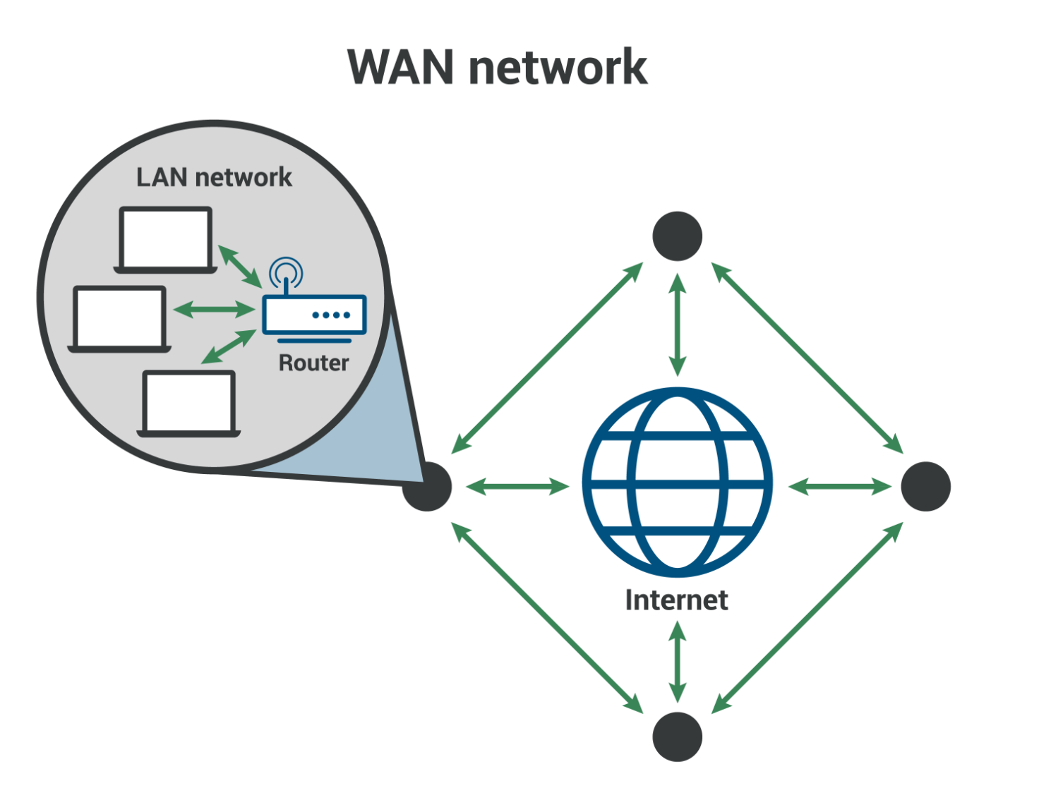

**LAN (local area network)**

A local area network (LAN) is a network confined to a small, localized area. Home WiFi networks and small business networks are common examples of LANs. Typically, whoever manages the LAN also manages the network equipment it uses. A small business for instance will manage the routers and switches involved in setting up the LAN.

**WAN vs LAN**

LANS typically exists in a contained area and usually share a single central point of Internet connection. WANs are designed to provide network connectivity over long distances. They are usually made up of several connected LANs. An organization that sets up its own WAN will almost always rely on network infrastructure that is outside their control: for example a company with an office in Paris and an office in New York will have to send data between these offices over undersea cables that cross the Atlantic Ocean.

Usually a WAN will include multiple routers and switches. A LAN only needs one router for connecting to the Internet or other LANs, although it may use switches as well.

**Packets, Frames and Fragments**

While communicating through networks its important to send and receive files and information. The basic unit of communication between a source and a destination in a network is a packet.

Data sent through the network is divided into packets, that are recombined by the destination devices. Dividing data into packets allows the network to manage different bandwidths, routes and multiple connected devices that share data and receive packets independently from each other.

It makes it easier to retransmit lost pieces of data or interrupted ones. Packets are data units within the network layer in the OSI model.

Each packet contains a header with both source and destination IP addresses, a field for the protocol specification, the data, a trailer, protocol version etc. The trailer field contains information about error corrections and other flags for the identification.

Let’s consider the example of an email. When the user clicks on the button ‘send’, the associated operation executes. The message will go through the OSI model layers until it reaches the network access layer where the packet should be created.

We format the data sent through an email into a packet, containing information about the used protocol, the error correction, IP addresses of the sender and the receiver (source and destination, respectively), as well as the email text:

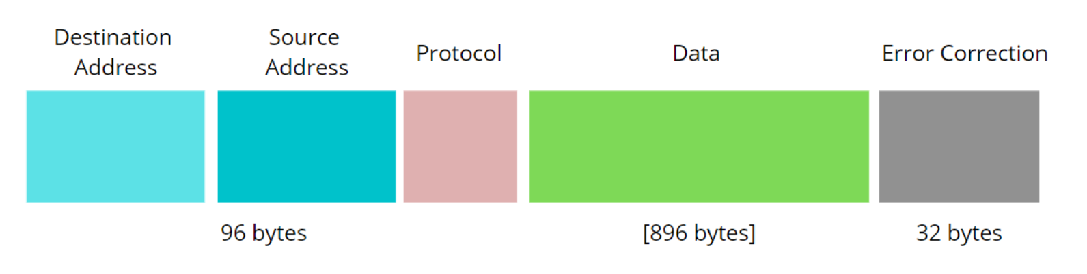

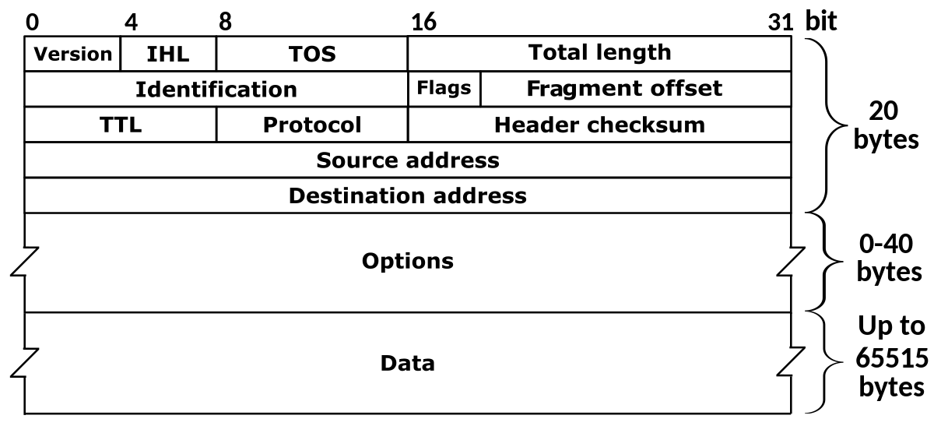

**Fragment**

In each network, there is a maximum size of the data to be transmitted called the MTU (Maximum Transmitted Unit). Packets can often be larger than the maximum size, so each packet is also divided into smaller pieces of data called fragments. The network layer is responsible for fragmentation.

Fragmentation of packets is necessary for the transmission since each network has its own MTU capacity. The receiver reassembles the IP fragments into the packets and forwards them to the higher layer.

When the network layer receives a packet, it checks the MTU of the packet. If the packet length is bigger than the MTU, the network layer checks the Don’t Fragment (DF) flag associated with the packet. If the DF flag is 1, we discard the packet. Otherwise, the network layer decides the size of the fragments, create the header, encapsulate the fragments within the header, and send them to the next layer:

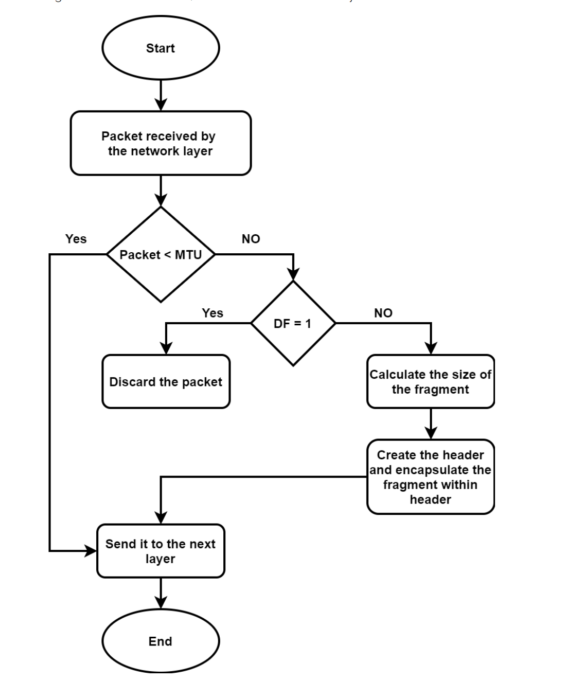

To carry on with the email example, let’s suppose the size of its packet is 1000 bytes, and the maximum size of the transmitted unit is equal to 300 bytes, the packet will be fragmented in this case into parts as follows:

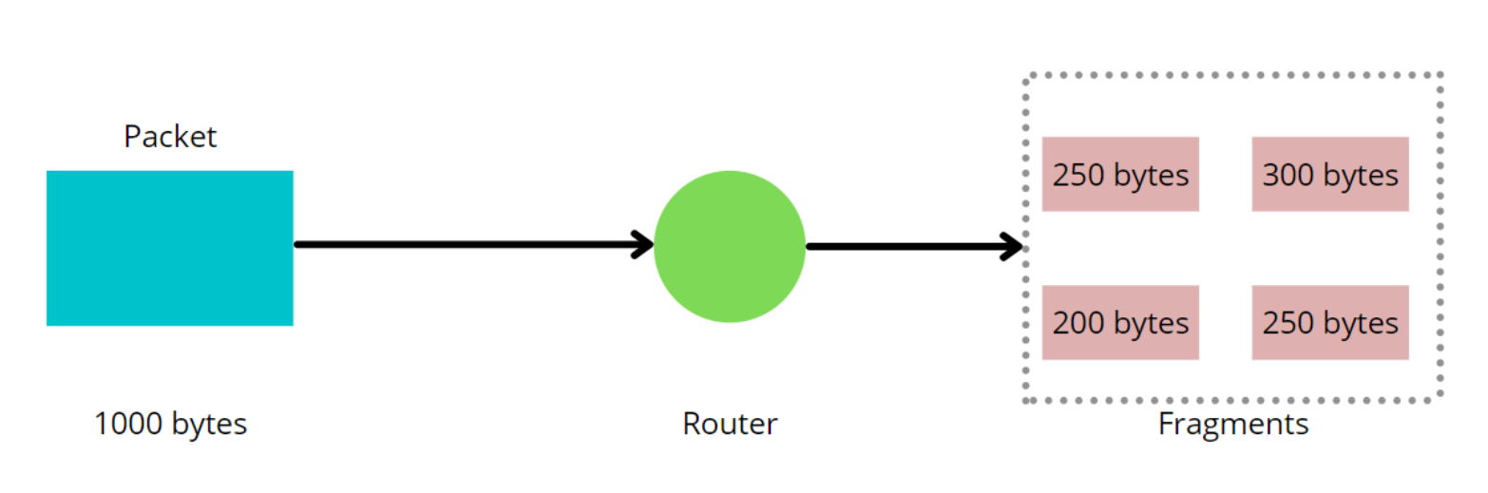

**Frame**

Just like packets, frames are small parts of a message in the network. It helps to identify data and determine the way it should be decoded and interpreted. The main difference between a packet and a frame is the association with the OSI layers.

While a packet is the unit of data used in the network layer, a frame is the unit of data used in the OSI models data link layer. A frame contains more information about the transmitted message than a packet.

In networking, there exists two types of frames: fixed length and variable length frames. In fixed length framing, the size of the frame works as the delimiter. Hence there is no need to set a boundary for the frame. In variable length framing, it’s difficult to determine the start and end of a frame. Hence it’s essential to define the start and end of a frame.

Frames are not much different from packets (each frame only contains one packet). They contain more information about the data. The process of framing consists of adding some extra bytes into the packet turning it into the frame:

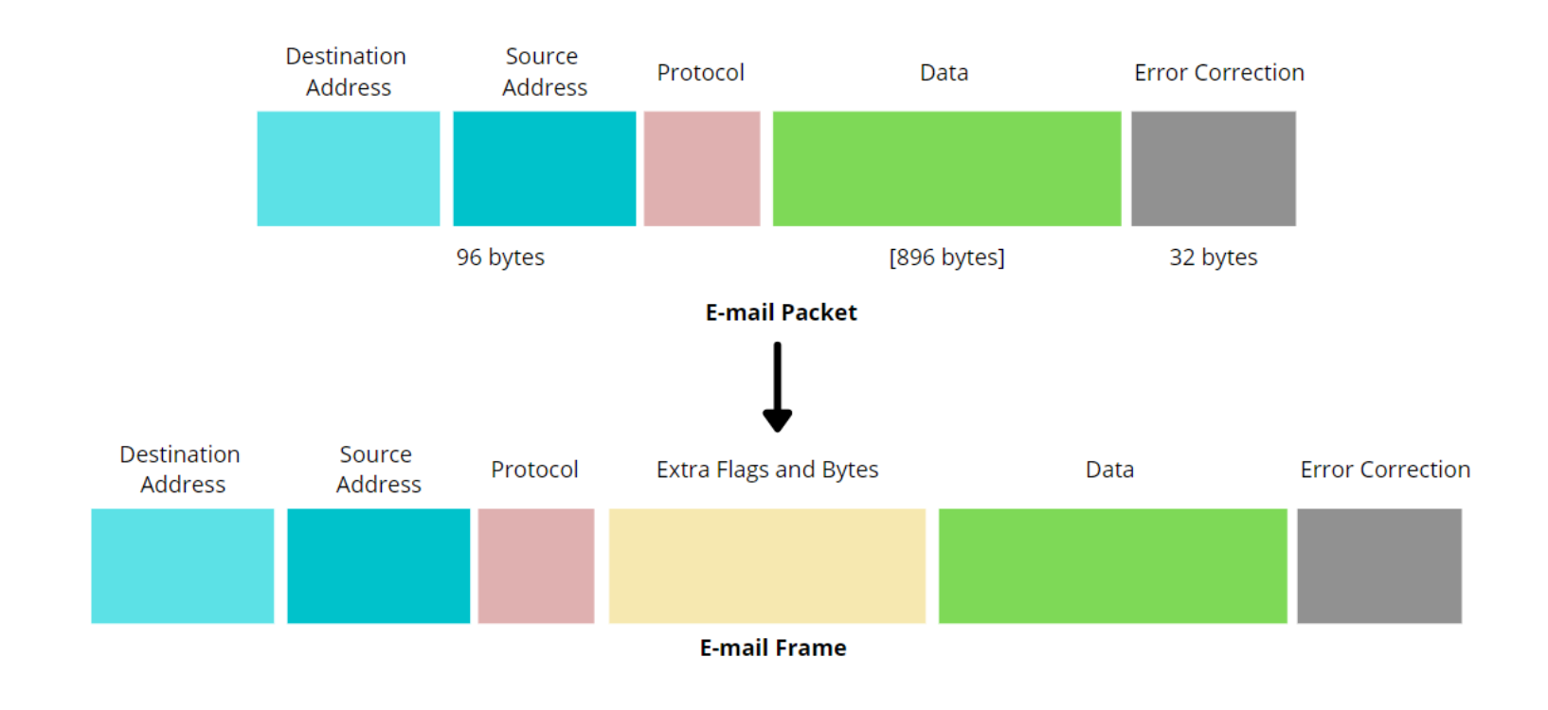

**What is MAC address vs IP address?**

A Media Access Control address (MAC address) is a hardware identifier that uniquely identifies each device on a network. Primarily, the manufacturer assigns it. They are often found on a devices network interface controller (NIC) card. A MAC address can also be referred to as a burned-in address. Ethernet hardware address, hardware address or physical address.

Meanwhile, an internet service provider (ISP) or network administrator assigns an internet protocol address (IP address). Associated with the TCP/IP protocol, an IP address helps identify a device connected to a network.

**Key differences (One is permanent, the other is dynamic)**

Because they are assigned to NICs or other hardware, MAC addresses never change on their own. (But many network interfaces support MAC address changes). On the other hand, many IP addresses are dynamic, changing periodically based on time or the particulars of a networking setup.

**Unique address structures**

A MAC address is a 48-but hexadecimal address. It’s usually six sets of two digits or characters separated by colons. An example MAC address would be 00:00:5e:00:53:af.

Many network card and other hardware manufacturers use a unique sequence at the beginning of their products MAC addresses. This called an organizationally unique identifier (OUI). The OUI is usually the first three bytes of digits or characters. The IEEE (Institute of electrical and electronics engineers) administers manufacturers OUI.

Meanwhile, an IPv4 address is a 32-bit integer expressed in hexadecimal notation. The more common format, known as dotted quad or dotted decimal x.x.x.x, where each x can be any value between 0 and 255. For example 192.0.2.146 is a valid IPv4 address.

**Residing in different layers in the OSI model**

A MAC address and IP address also sit in different layers of the open systems interconnection (OSI) model. The OSI model is a conceptual framework that uses seven abstraction layers to describe all the functions of a telecommunication system. In the OSI model, the MAC sublayer of the data link layer (layer 2) implements MAC addresses. Meanwhile, an IP address operates in the network layer (Layer 3) of the model.

**How a MAC address and IP address work together**

**The bridge between them: ARP**

While MAC and IP addresses have many differences, they are not islands unto themselves. The address Resolution Protocol (ARP) is the bridge that connects them. This protocol works between Layer 2 and Layer 3 on a local area network (LAN). It maps IPv4 addresses to network devices MAC address and vice versa.

(Note: IPv4 uses the ARP protocol. On newer IPv6 networks, the Neighbour discovery protocol provides equivalent functionality.)

A device wants to communicate with another device on the local network segment. It puts its request with both the source IP address and a destination IP address into an IP packet. An Ethernet frame then encapsulates the IP packet. The frame contains both a source and destination MAC address as well.

But sometimes the MAC address of the destination device is unknown, so ARP is required (address resolution protocol) which connects an ever-changing internal Protocol (IP) address to a fixed physical machine address, also known as a media access control (MAC) address, in a local area network (LAN).

**Computer A and computer B example**

Computer A wants to send an IP packet to computer B. But it does not know the MAC address of computer B. Computer A will then broadcast an ARP request received by all computers on the local network segment.

The request will essentially say. “This is my IP address. This is my MAC address, and I am looking for the MAC address associated with this IP address. If this IP address is yours, please response and give me your MAC address).”

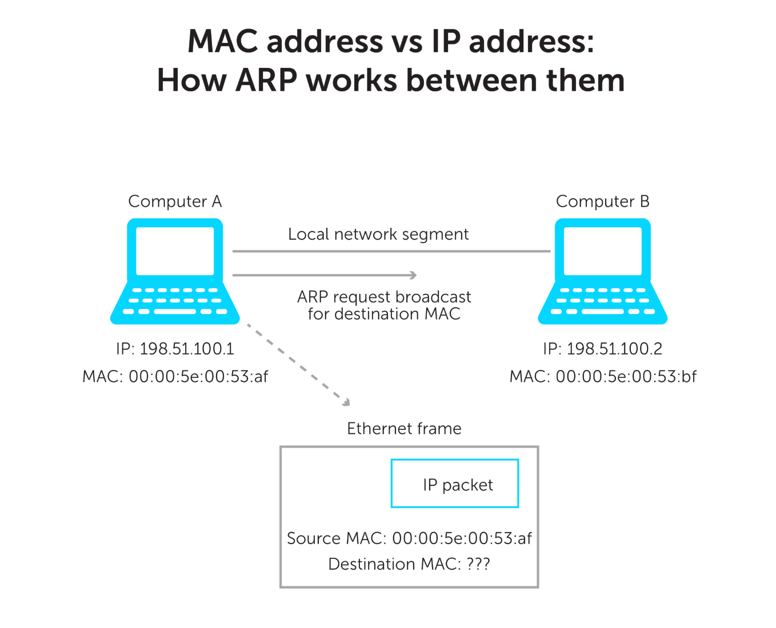

Computer B receives the ARP request and will do two things.

First every device has its own ARP table. Each time a computer wants to send a packet on the LAN, it will look in its ARP table first. If an entry for Computer does not already exist in computer Bs table. It will make one. It will add computer A’s MAC and IP addresses based on what is in the frame.

Then it will send an ARP reply with its IP address and MAC address. Computer A will receive the reply and add the info to its ARP table. With the right MAC address, Computer A can now send the Ethernet frame to Computer B.

It’s worth noting that, while an IP address is easy for anyone to look up, a MAC address can’t easily be found by others. Once an IP packet leaves you LAN and goes through a router, its header with the MAC address is stripped away. Therefore, anyone outside your LAN never sees your MAC in the IP packet (unless an application sends it as data.).

**IP Addresses**

**Understand TCP/IP addressing and subnetting basics**

**Glossary**

* Broadcast address – An IP address with a host option that is all ones.
* Host – A computer or another cdevice on a TCP/IP network
* Internet – The global collection of networks that are connected together and share a common range of IP addresses.
* InterNIC – The organization responsible for administration
* IP – The network protocol used for sending network packets over a TCP/IP network or the Internet.
* IP Address – A unique 32-bit address for a host on a TCP/IP network or internetwork.
* Network – There are two uses of the term network in this article. One is a group of computers on a single physical network segment. The other is an IP network address range that is allocated by a system administrator.
* Network address – An IP address with a host portion that is all zeros.
* Octet – An 8-bit number, 4 of which comprise a 32-bit IP address. They have a range of 00000000-11111111 that correspond to the decimal values 0-255.
* Packet – A unit of data passed over a TCP/IP network or wide area network.
* RFC (Request for Comment) – A document used to define standards on the Internet.
* Router – a device that passes network traffic between different IP networks.
* Subnet Mask – a 32 bit number used to distinguish the network and host portions of an IP address.
* Subnet or Subnetwork – a smaller network created by dividing larger network into equal parts.
* TCP/IP – used broadly, the net of protocols, standards, and utilities commonly used on the internet and large networks.
* Wide area network (WAN) – a large network that is a collection of smaller networks separated by routers. The Internet is an example of a large WAN.

**Summary**

When you configure the TCP/IP protocol on a windows computer, the TCP/IP configuration settings require:

* An IP address.
* A subnet mask.
* A default gateway.

To configure TCP/IP correctly, it’s necessary to understand how TCP/IP networks are addressed and divided into networks and subnetworks.

The success of TCP/IP as the network protocol of the internet is largely because of its ability to connect together networks of different sizes and systems of different types. These networks are arbitrarily defined into three main classes (along with a few others) that have predefined sizes. Each of them can be divided into smaller subnetworks by system administrators. A subnet mask is used to divide an IP address into two parts. One part identifies the host (computer), the other part identifies the network to which it belongs. To better understand how IP addresses and subnet masks work, look at an IP address and see how it’s organized.

**IP addresses: Networks and hosts**

An IP address is a 32 bit number. It uniquely identifies a host (computer or other device such as a printer or router) on a TCP/IP network.

IP addresses are normally expressed in dotted-decimal format, with four numbers separated by periods, such as 192.168.123.132. To understand how subnet masks are used to distinguish between hosts, networks, and subnetworks, examine an IP address in binary notation.

For example, the dotted decimal IP address 192.168.123.132 is (in binary notation) the 32 bit number 11000000101010000111101110000100. This number may be hard to make sense of, so divide it into four parts of eight binary digits.

These 8-bit sections are known as octets. The example IP address then becomes 11000000.10101000.01111011.10000100. This number only makes a little more sense, so for most uses, convert the binary address into dotted-decimal format 192.168.123.132. The decimal numbers separated by periods are the octets converted from binary to decimal notation.

For a TCP/IP wide area network (WAN) to work efficiently as a collection of networks, the routers that pass packets of data between networks don’t know the exact location of a host for which a packet of information is destined. Routers only know what network the host is a member of and use information stored in their route table to determine how to get the packet to the destination hosts network, the packet is delivered to the appropriate host.

For this process to work, an IP address has two parts. The first part of an IP address is used as a network address, the last part as a host address. If you take the example 192.168.123.132 and divide it into these two parts, you get:

* 192.168.123.0 – network address
* 0.0.0.132 – host address

**Subnet mask**

The second item, which is required for TCP/IP to work is the subnet mask. The subnet mask is used by the TCP/IP protocol to determine whether a host is on the local subnet or on a remote network.

In TCP/IP, the parts of the IP address that are used as the network and host addresses aren’t fixed. Unless you have more information, the network and host address above can’t be determined. This information is supplied.

## Exception Handling in ASP.NET Web API

**HttpResponseException**

What happens if a Web API controller throws an uncaught exception? By default, most exceptions are translated into an HTTP response with status code 500, Internal Server Error.

The **HttpResponseException** type is a special case. This exception returns any HTTP status code that you specify in the exception constructor. For example, the following method returns 404, Not Found of the id parameter is not valid.

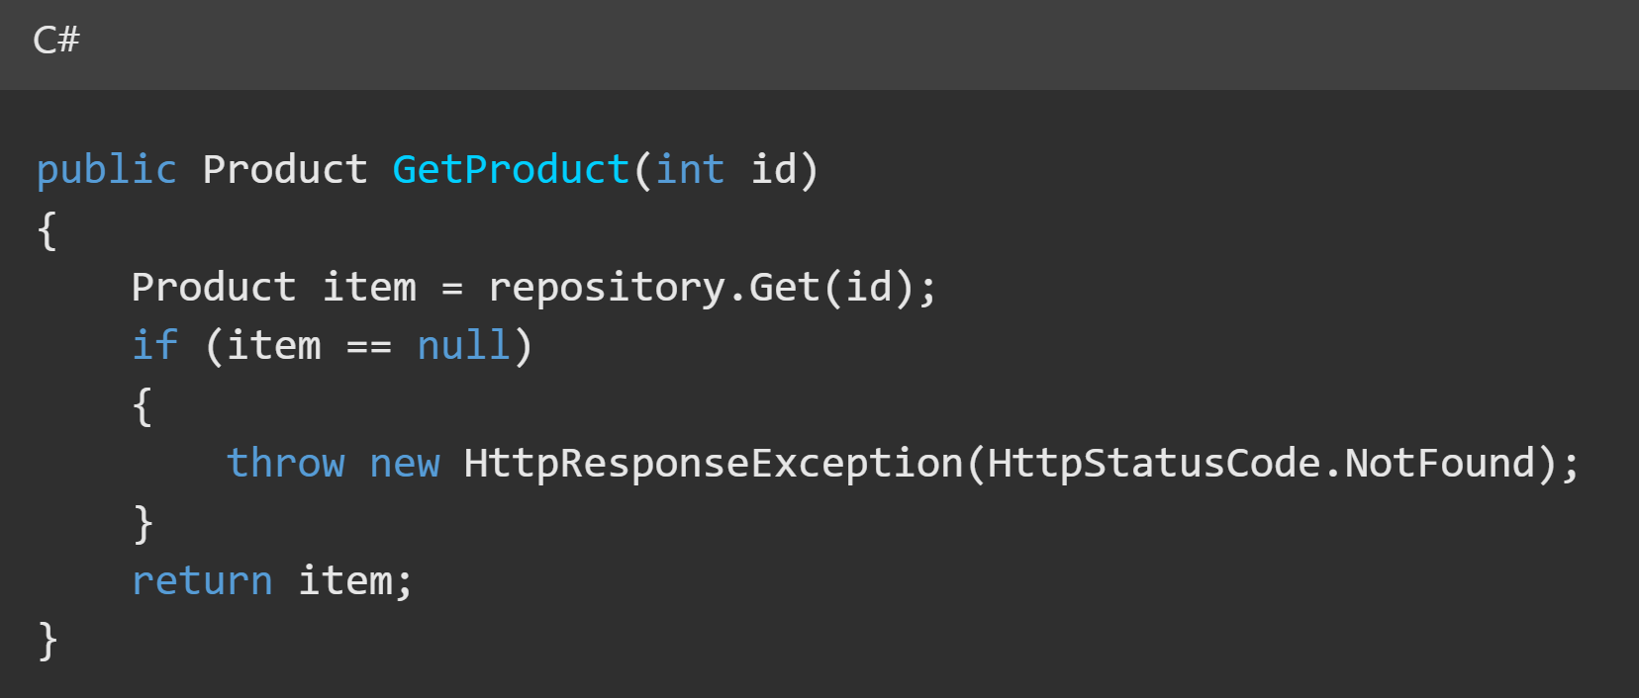

For more control over the response, you can also construct the entire response message and include it with the **HttpResponseException:**

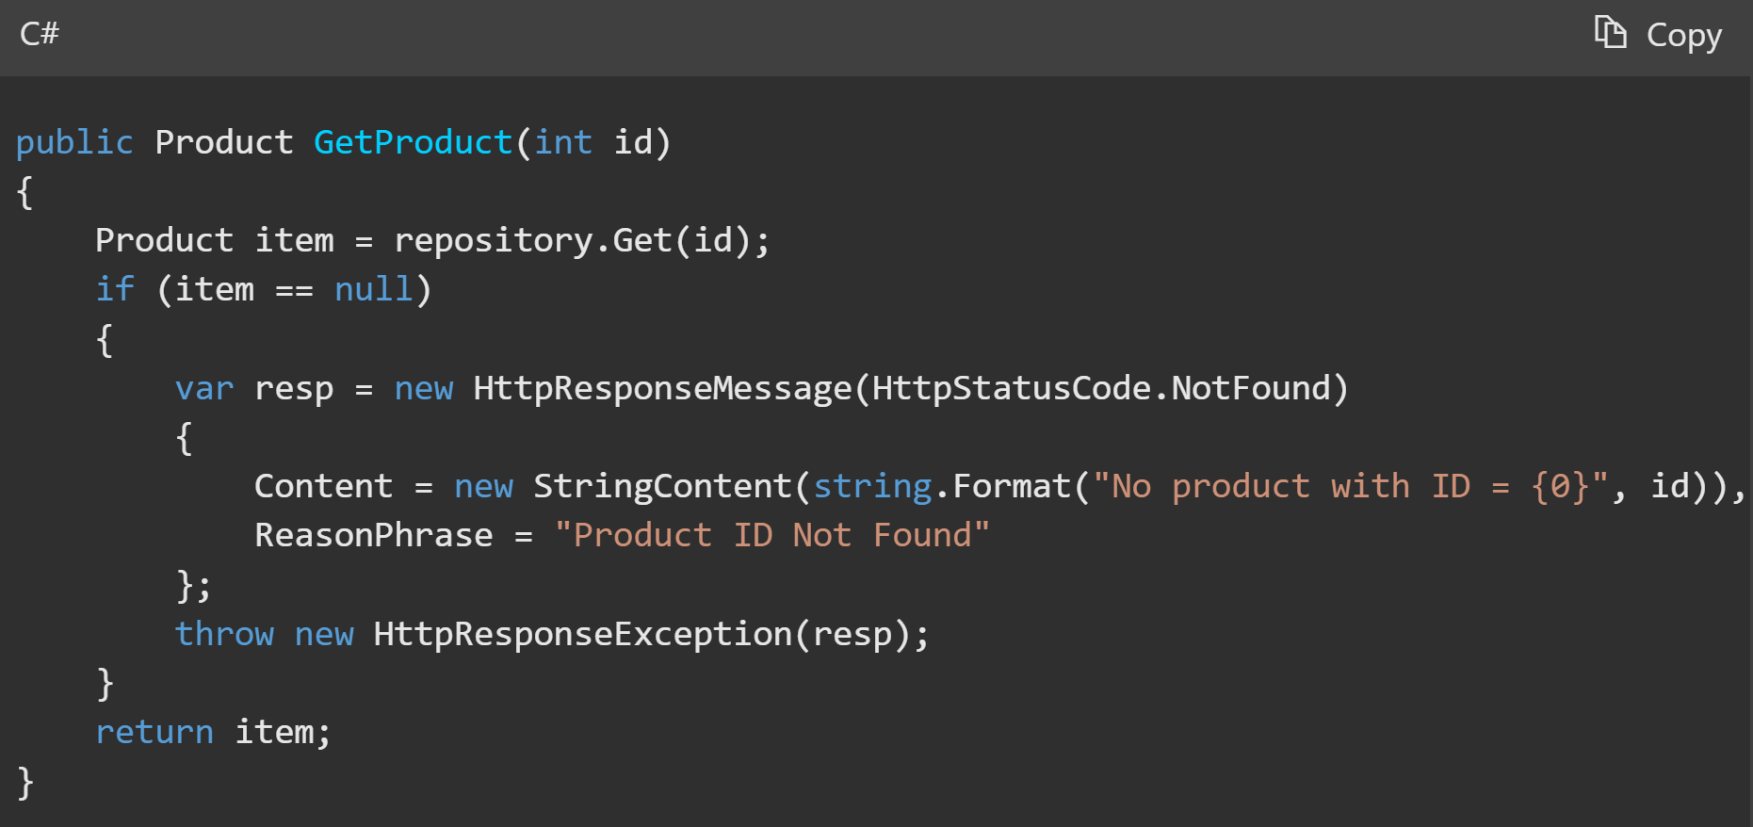

**Exception Filters**

You can customize how Web API handles exceptions by writing an exception filter. An exception filter is executed when a controller method throws any unhandled exception that is not an **HttpResponseException** exception. The **HttpResponseException** type is a special case because it is designed specifically for returning an HTTP response.

Exception filters implement the **System.Web.Http.Filters.IExceptionFilter** interface. The simplest way to write an exception filter is to derive from the **System.Web.Http.Filters.ExceptionFilterAttribute** class and override the **OnException** method.

Here is a filter that converts **NotImplementedException** exceptions into HTTP status code 501, Not Implemented:

­­ 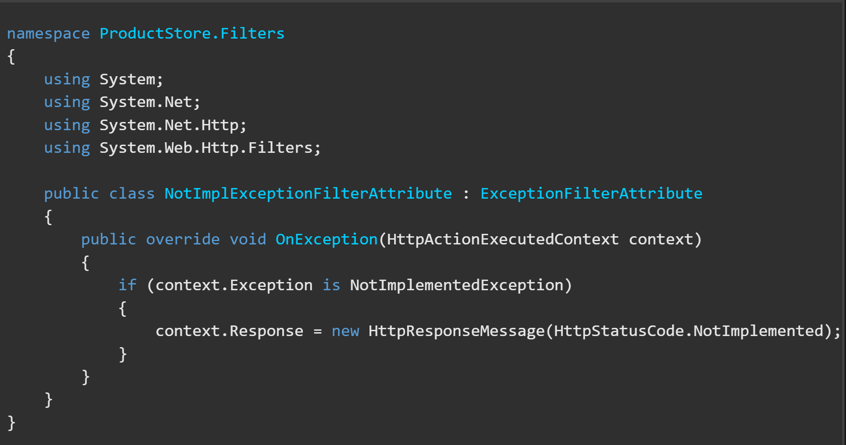

The **Response** property of the **HttpActionExecutedContext** object contains the HTTP response message that will be sent to the client.

**Registering Exception Filters**

There are several ways to register a Web API exception filter:

* By action
* By controller
* Globally

To apply the filter to a specific action, add the filter as an attribute to the action

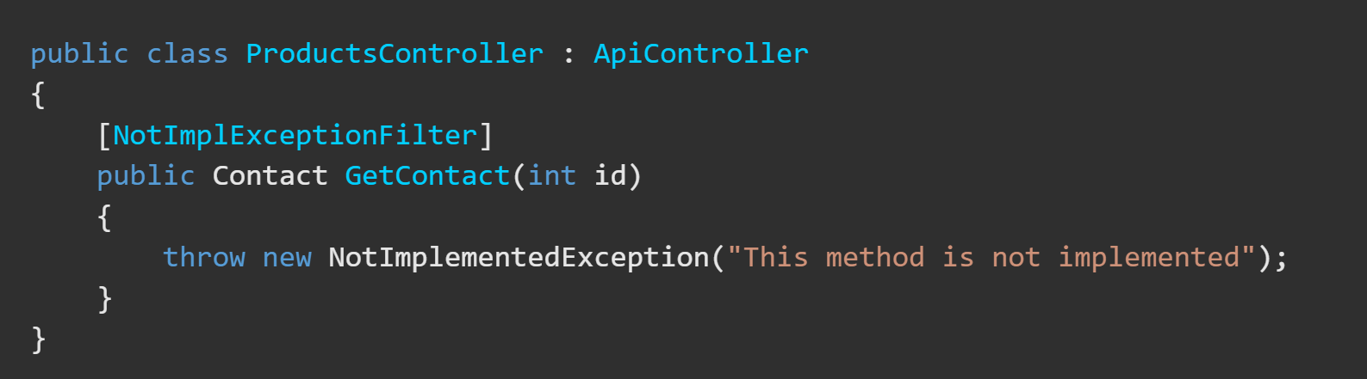

To apply the filter to all of the actions on a controller, add the filter as an attribute to the controller class:

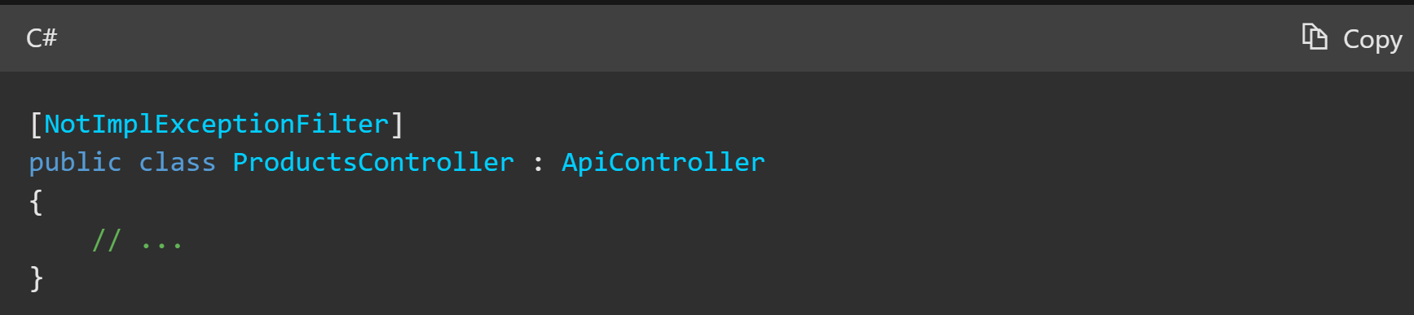

You can also apply the filter globally to all Web API controllers, add an instance of the filter to the **GlobalConfiguration.Configuration.Filters collection**. Exception filters in this collection apply to any Web API controller action.

## C# Testing

XUnit, Fluent Assertations and NSubstitute are three popular libraries in the .NET ecosystem that work well together for writing clean and expressive unit tests.

* **XUnit**
  + XUnit is a unit testing framework for .NET that provides a framework for writing and running unit tests.
  + It is used to define test methods, manage test lifecycle, and report test results.
* **NSubstitute**
  + NSubstitute is a mocking library for .NET. It allows you to create mock objects and define their behaviour for use in unit testing.
  + Mock objects are used to isolate the code you’re testing by replacing real dependencies with substitutes.
  + You can create substitutes for interfaces, abstract classes, or even non-sealed concrete classes.
* **Fluent Assertions**
  + Fluent Assertions is a library that enhances the readability and expressiveness of your unit tests by providing a fluent syntax for writing assertions.
  + It allows you to create clear and concise assertions in a natural language-like manner, making it easier to understand what your tests are checking.

Here’s how they can work together in a typical unit testing scenario:

1. Arrange:
   1. In your unit test, you set up the test scenario by arranging the necessary objects and data.
   2. You can use NSubstitute to create mock objects that mimic the behaviour of real dependencies.
   3. You can also create the object under test, which is the instance of the class or method you want to test.
2. Act:
   1. You perform the action you want to test. This is typically a method call on the object under test.
3. Assert:
   1. After the action is performed, you use Fluent Assertions to write clear and expressive assertions about the expected outcomes and behaviour.
   2. You can use NSubstitute to verify that specific methods were called on mock objects with the expected arguments.

## Exponential Backoff

Exponential backoff is a popular technique used to handle HTTP requests that fail due to network issues or server errors. When an Http request fails, the traditional approach is to simply retry the request after a certain interval of time. However, this can result in multiple failed requests and may even overload the server.

**Transient Failures**

Transient failures are the failures which occur while communicating to the external component or service and that external service is not available. But this unavailability or failure to connect is not due to any problem in the service but due to some reasons like network failure or server overload. Such issues are ephemeral (lasting a very short time). If we call the service again, changes are that our call will succeed. Such kind of failures are called transient failures.

Traditionally, we have been getting such errors in database connections and service calls. But in the new cloud world, the chances of getting such errors have increased since our application itself might also have some elements/components running in the cloud. So the failures like momentary loss of network, service unavailability and timeouts have become more prominent (comparatively).

These kinds of failures can easily be circumvented by simply calling the service after a delay.

**How to Handle Transient Faults using Retry Pattern**

Before we even start talking about how to handle the transient faults, the first task should be to identify the transient faults. The way to do that is to check if the fault is something that the target service is sending and actually has some context from the application perspective. If this is the case, then we know that this is not a transient fault since the service is sending us a fault. But if we are getting a fault that is not coming from the service and perhaps coming from some other reasons like infrastructure issues and the fault appears to be something that can be resolved by simply calling the service again, then we can classify it as a transient fault.

Once we have identified the fault as transient fault, we need to put some retry logic so that the issue will get resolved simply by calling the service again. The typical way to implement the retry is as follows:

1. Identify if the fault is a transient fault.
2. Define the maximum retry count.
3. Retry the service call and increment the retry count.
4. If the call succeeds, return the result to the caller.
5. If we are still getting the same fault, keep retrying until the maximum retry count is hit.
6. If the call is failing even after maximum retries, let the caller module known that the target service is unavailable.

**The Problem with Simple Retry**

The retry mechanism we discussed in the previous section is fairly straight forward and one would think why even discuss such a simple thing. Most of us use this retry mechanism in our applications. The reason we are discussing this is because there is a small problem in the mentioned retry mechanism.

To understand the problem, lets imagine a scenario where the transient fault is happening because the service is overloaded, or some throttling is implemented at service end. Thus, this service is rejecting new calls. This is a transient fault as if we call the service after some time, our call could succeed. But there could also be a possibility that our retry requests are further adding to the overload of the busy service. Which would mean that if there are multiple instances of our applications retrying for the same service, the service will be in the overloaded state longer and will take longer to recover from this state.

So, in a way, our requests are contributing further to the reason of the fault and ultimately, it’s our application only that is suffering due to the longer recovery time of the service. So how can we solve this problem.

**Exponential Backoff to the Rescue**

The idea behind using exponential backoff with retry is that instead of retrying after waiting for a fixed amount of time, we increase the waiting time between retries after each retry failure.

For example, when the request fails the first time, we retry after 1 second. If it fails for the second time, we wait for 2 seconds before next retry. If the second retry fails, we wait for 4 seconds before next retry. So, we are incrementally increasing the wait time between the consecutive retry requests after each failure. This gives the service some breathing time so that if the fault is due to service overload, it could get resolved faster.

**Note:** These wait durations are indicative only. Actual wait time should depend on application and service. In practical scenarios, no user will wait for more than 7 seconds for their request to process.

So, with exponential backoff, our retry algorithm will look like the following:

1. Identify if the fault is a transient fault.
2. Define the maximum retry count.
3. Retry the service call and increment the retry count.
4. If the call succeeds, return the result to the caller.
5. If we are still getting the same fault, increase the delay period for next retry.
6. Keep retrying and keep increasing the delay period until the maximum retry count is hit.
7. If the call is failing even after maximum retries, let the caller module know that the target service is unavailable.

**Example Usage of Retry with Exponential Backoff**

The best example for the implementation of this pattern is Entity Framework. Entity framework provides connection resiliency. Connection resiliency means that the entity framework is able to automatically re-establish the broken connections using the retry pattern.

Entity framework has an IDbExecutionStrategy interface which takes care of the connection retry mechanism. There are 4 implementations for this interface that comes with Entity Framework. DefaultExecutionStrategy, DefaultSqlExecutionStrategy, DbExecutionStrategy and SqlAzureExecutionStrategy. The first two strategies don’t retry at all in case of failure. The other two implement the retry with exponential backoff. In these strategies, the first retry happens immediately and if that fails, the next retry happens after a delay. This delay will increase exponentially until the maximum retry count is hit.

**How About Long-Lasting Transient Faults**

There is one more scenario we need to handle where the transient faults are long lasting. The first question that comes to mind is how a transient fault can be long lasting or how can we call a long-lasting fault a transient fault. One possible reason for the failure could be a network issue which is identified as transient fault by our application, but this connectivity issue is taking more than the usual time to recover from. In this case, our application thinks of the fault as transient fault, but the fault exists for a long time. The problem with long lasting transient faults is that our application will end up retrying, waiting, and retrying till the maximum retry count is hit and thus wasting resources. So we should mechanism to identify long last transient faults and let this retry mechanism not come in play when we have identified the fault as long lasting transient fault.

**Circuit Breaker Pattern**

The intent of the Circuit Breaker pattern is to handle the long-lasting transient faults. The idea behind this pattern is that we will wrap the service calls in a circuit breaker. If the number of retry failures reaches above a certain threshold value, we will make this circuit as OPEN which means the service is not available at the time. Once the circuit reaches the OPEN state, further calls to the service will immediately return failure to the caller instead of executing our retry logic.

The circuit breaker will have some timeout period after which it will move to HALF-OPEN state. In this state, it will allow a service call which will determine if the service has become available or not. If the service is not available, it goes back to OPEN state. If the service becomes available after this timeout, the circuit breaker moves to CLOSED state. The callers will be able to call the service and the usual retry mechanism will come in play again.

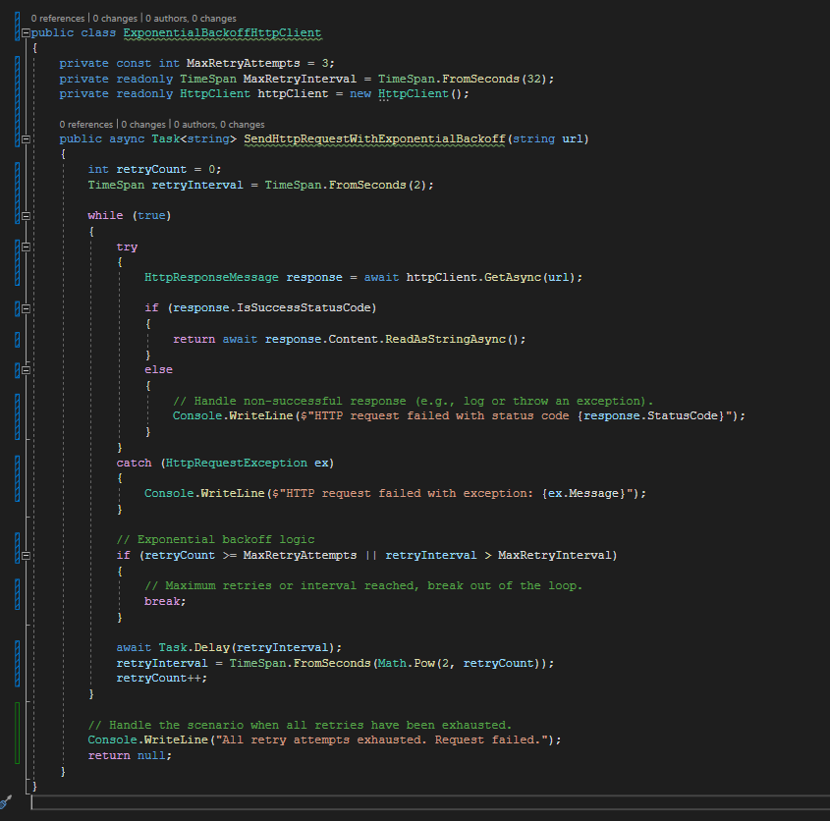

## Best practices for exceptions

A well-designed app handles exceptions and errors to prevent app crashes.

**Use try/catch/finally blocks to recover from errors or release resources.**

Use try/catch blocks around code that can potentially generate an exception, and your code can recover from that exception. In catch blocks, always order exceptions from the most derived to the least derived. All exceptions derive from the Exception class. More derived exceptions aren’t handled by a catch clause that’s preceded by a catch clause for a base exception class. When your code can’t recover from an exception, don’t catch that exception. Enable methods further up the call stack to recover if possible.

Clean up resources that are allocated with either *using* statements or *finally* blocks. Prefer *using* statements to automatically clean up resources when exceptions are thrown. Use *finally* blocks to clean up resources that don’t implement IDisposable. Code in a *finally* clause is almost always executed even when exceptions are thrown.

**Handle common conditions without throwing exceptions.**

For conditions that are likely to occur but might trigger an exception, consider handling them in a way that will avoid the exception. For example, if you try to close a connection that’s already closed, you’ll get an *InvalidOperationException.* You can avoid that by using an *if* statement to check the connection state before trying to close it.

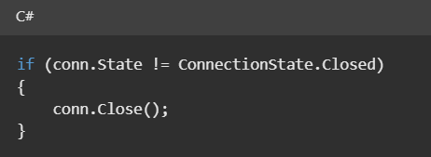

If you don’t check the connection state before closing, you can catch the *InvalidOperationException* exception.

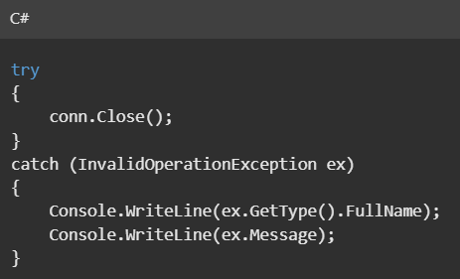

The method to choose depends on how often you expect the event to occur.

* Use exception handling if the event doesn’t occur often, that is, if the event is truly exceptional and indicates an error, such as an unexpected end-of-file. When you use exception handling, less code is executed in normal conditions.
* Check for error conditions in code if the event happens routinely and could be considered part of normal execution. When you check for common error conditions, less code is executed because you avoid exceptions.

**Throw exceptions instead of returning an error code.**

Exceptions ensure that failures don’t go unnoticed because the calling code didn’t check a return code.

**Use the predefined .NET exception types.**

Introduce a new exception class only when a predefined one doesn’t apply. For example:

* If a property set or method call isn’t appropriate given the object’s current state, throw an *InvalidOperationException* exception.
* If invalid parameters are passed, throw an *ArgumentException* exception or one of the predefined classes that derive from *ArgumentException.*

**End exception class names with the word *Exception***

When a custom exception is necessary, name it appropriately and derive it from the *Exception* class:

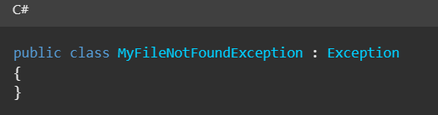

**Include three constructors in custom exception classes.**

Use at least the three common constructors when creating your own exception classes: the parameterless

## ASP.NET Core Middleware

Middleware is software that’s assembled into an app pipeline to handle requests and responses. Each component:

* Chooses whether to pass the request to the next component in the pipeline.
* Can perform work before and after the next component in the pipeline.

Request delegates are used to build the request pipeline. The request delegates handle each HTTP request.

Request delegates are configured using Run, Map and Use extension methods. An individual request delegate can be specified in-line as an anonymous method (called in-line middleware), or it can be defined in a reusable class. These reusable classes and in-line anonymous methods are *middleware,* also called *middleware components*. Each middleware component in the request pipeline is responsible for invoking the next component in the pipeline or short-circuiting the pipeline. When a middleware short-circuits, it’s called a *terminal middleware* because it prevents further middleware from processing the request.

**Create a middleware pipeline with *WebApplication***

The ASP.NET Core request pipeline consists of a sequence of request delegates, called one after the other . The following diagram demonstrates the concept. The thread of execution follows the black arrows.

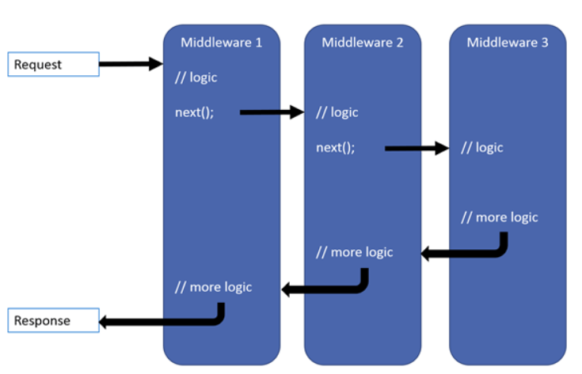

Each delegate can perform operations before and after the next delegate. Exception handling delegates should be called early in the pipeline, so they can catch exceptions that occur in later stages of the pipeline.

The simplest possible ASP.NET Core app sets up a single request delegate that handles all requests. This case doesn’t include an actual request pipeline. Instead, a single anonymous function is called in response to every HTTP request.

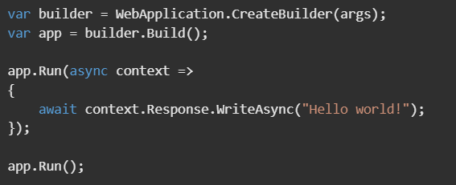

Chain multiple request delegates together with Use. The next parameter represents the next delegate in the pipeline. You can short-circuit the pipeline by not calling the next parameter. You can typically perform actions both before and after the *next* delegate, as the following example demonstrates:

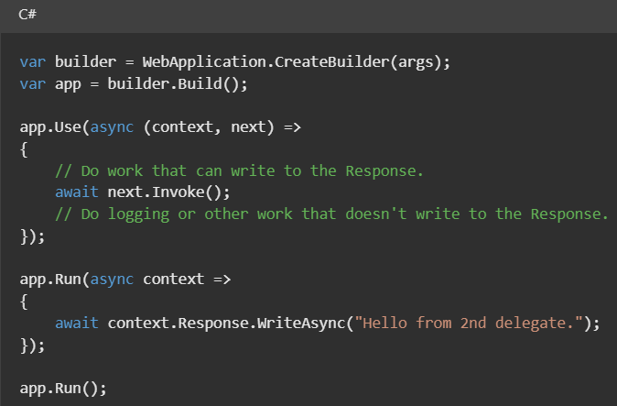

When a delegate doesn’t pass a request to the next delegate, it’s called short-circuiting the request pipeline. Short-circuiting is often desirable because it avoids unnecessary work. Middleware added to the pipeline before the middleware that terminates further processing still processes code after their next.Invoke statements.

**Run** delegates don’t receive a next parameter. The first Run delegate is always terminal and terminates the pipeline. Run is a convention. Some middleware components may expose Run[Middleware] methods that run at the end of the pipeline:

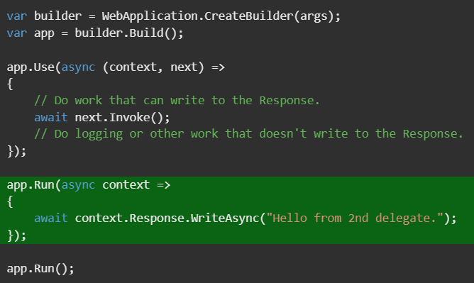

In the preceding example, the Run delegate writes “Hello from 2nd delegate.” To the response and then terminates the pipeline. If another Use or Run delegate is added after the Run delegate, it’s not called.

**Prefer app.Use overload that requires passing the context to next.**

The non-allocating app.Use extension method:

* Requires passing the context to *next*.
* Saves two internal per-request allocations that are required when using the other overload.

## Middleware order

The following diagram shows the complete request processing pipeline for ASP.NET Core MVC and Razor Pages apps. You can see how in a typical app, existing middleware’s are ordered and where custom middlewares are added. You have full control over how to reorder existing middlewares or inject new custom middlewares as necessary for your scenarios.

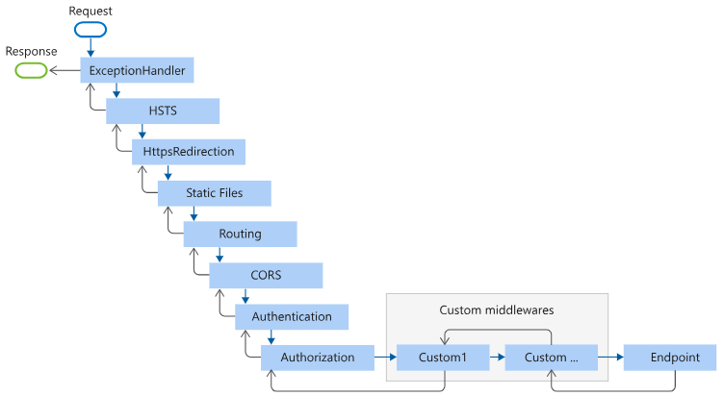

The **Endpoint** middleware in the preceding diagram executes the filter pipeline for the corresponding app type – MVC or Razor Pages.

The Routing middleware in the preceding diagram is shown following Static Files. This is the order that the project templates implement by explicitly calling app.UseRouting. If you don’t call app.UseRouting, the Routing middleware runs at the beginning of the pipeline by default.

The order that middleware components are added in the Program.cs file defines the order in which the middleware components are invoked on requests and the reverse order for the response. The order is critical for security, performance, and functionality.

The following highlighted code in Program.cs adds security-related middleware components in the typical recommended order:

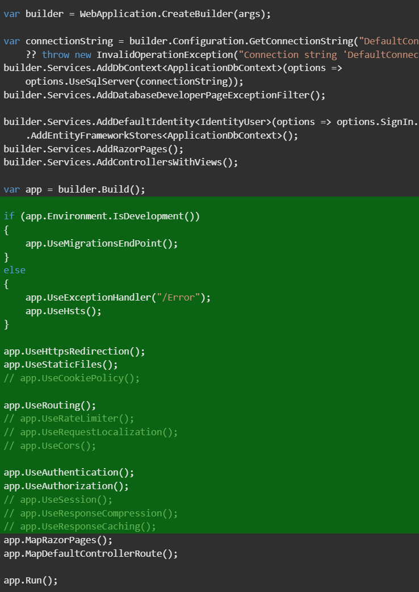

In the preceding code:

* Middleware that is not added when creating a new web app with individual users accounts is commented out.
* Not every middleware appears in this exact order, but many do. For example:
  + UseCors, UseAuthentication and UseAuthorization must appear in the order shown.
  + UseCors currently must appear before UseResponseCaching.
  + UseRequestLocalization must appear before any middleware that might check the request culture, for example, app.UseStaticFiles().
  + UseRateLimit must be called after UseRouting when rate limiting endpoint specific APIs are used. For example if the [EnableRateLimiting] attribute is used, UseRateLimiter can be called before UseRouting.

The following Program.cs code adds middleware components for common app scenarios:

1. Exception/error handling

* When the app runs in the Development environment:
  + Developer Exception Page Middleware reports app runtime errors
  + Database Error Page Middleware reports database runtime errors
* When the app runs in the Production environment:
  + Exception Handler Middleware catches exceptions thrown in the following middlewares.
  + HTTP Strict Transport Security Protocol (HSTS) Middleware (UseHstS) adds the Strict-Transport-Security header.

1. HTTPS Redirection Middleware (UseHttpsRedirection) redirects HTTP requests to HTTPS.
2. Static File Middleware (UseStaticFiles) returns static files and short circuits further request processing.
3. Cookie Policy Middleware (UseCookiePolicy) conforms the app to the EU General Data Protection Regulation (GDPR) regulations.
4. Routing Middleware (UseRouting) to route requests
5. Authentication Middleware (UseAuthentication) attempts to authenticate the user before they’re allowed access to secure resources.
6. Authorization Middleware (UseAuthorization) authorizes a user to access secure resources.
7. Session Middleware (Use Session) establishes and maintains session state. If the app uses session state, call Session Middleware after Cookie Policy Middleware and before MVC Middleware.
8. Endpoint Routing Middleware (UseEndpoints with MapRazorPages) to add Razor Pages endpoints to the request pipeline.

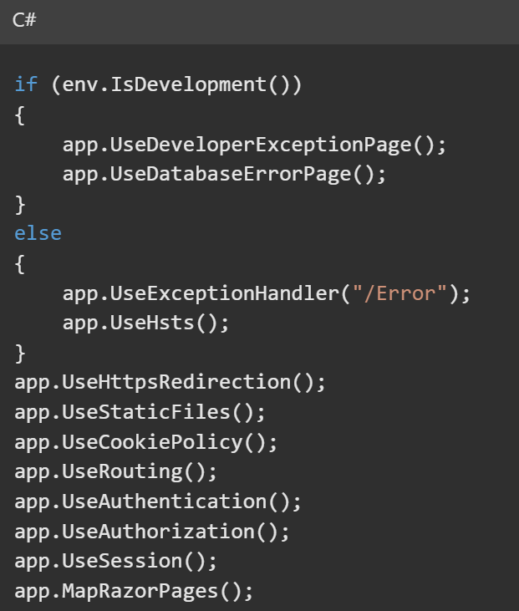

In the preceding example code, each middleware extension method is exposed on WebApplicationBuilder through the Microsoft.AspNetCore.Builder namespace.

UseExceptionHandler is the first middleware component added to the pipeline. Therefore, the Exception Handler Middleware catches any exceptions that occur in later calls.

**Built-in middleware**

ASP.NET Core ships with the following middleware components. The Order column provides notes on middleware placement in the request processing pipeline and under what conditions the middleware may terminate request processing. When a middleware short circuits the request processing pipeline and prevents further downstream middleware from processing a request, it’s called a terminal middleware.

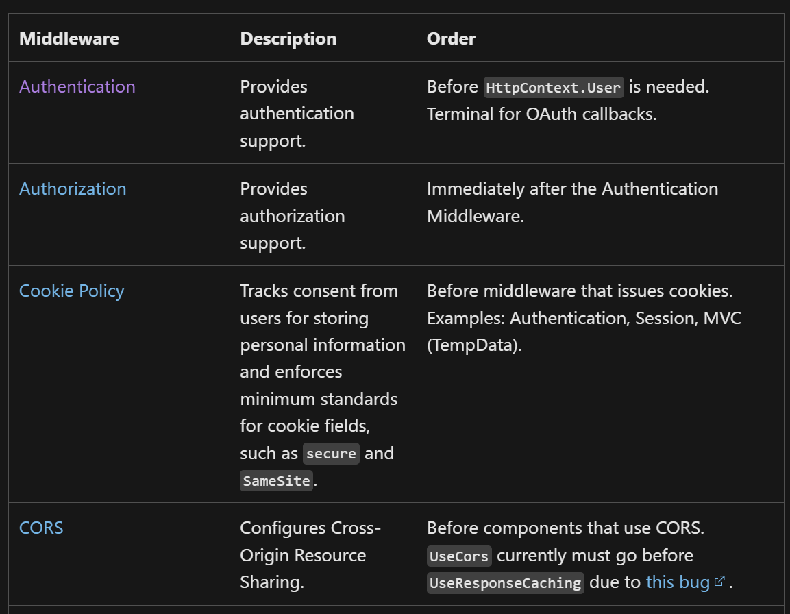

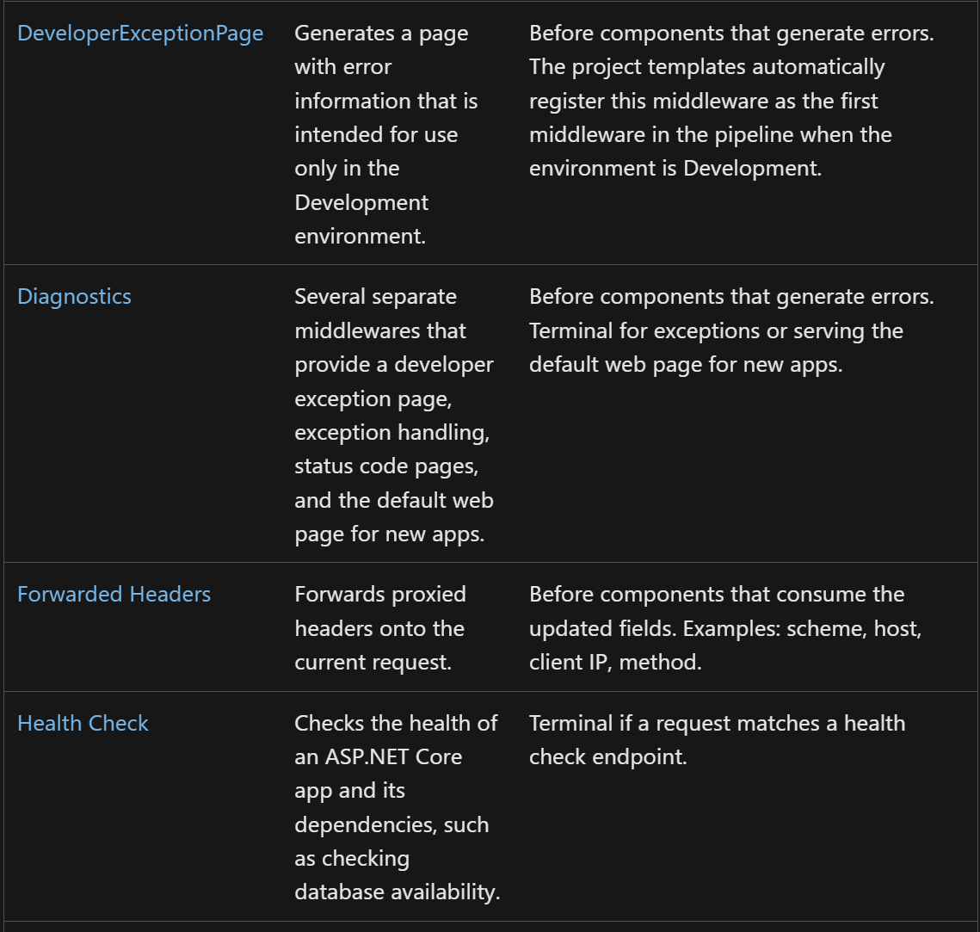

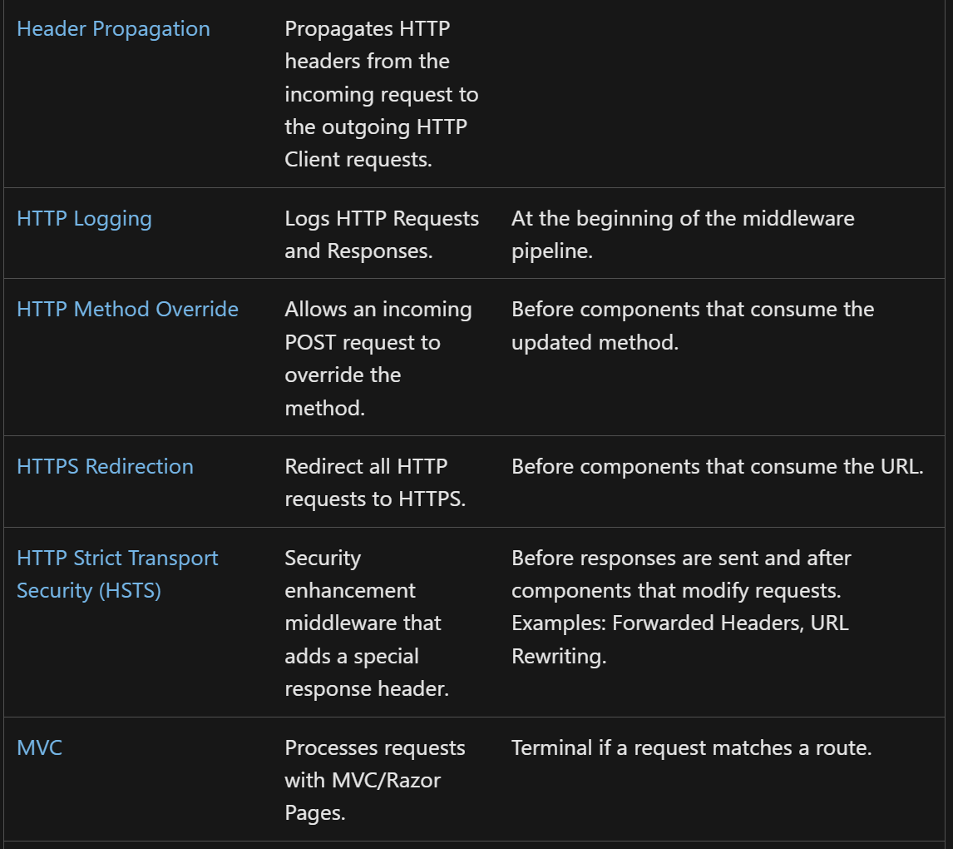

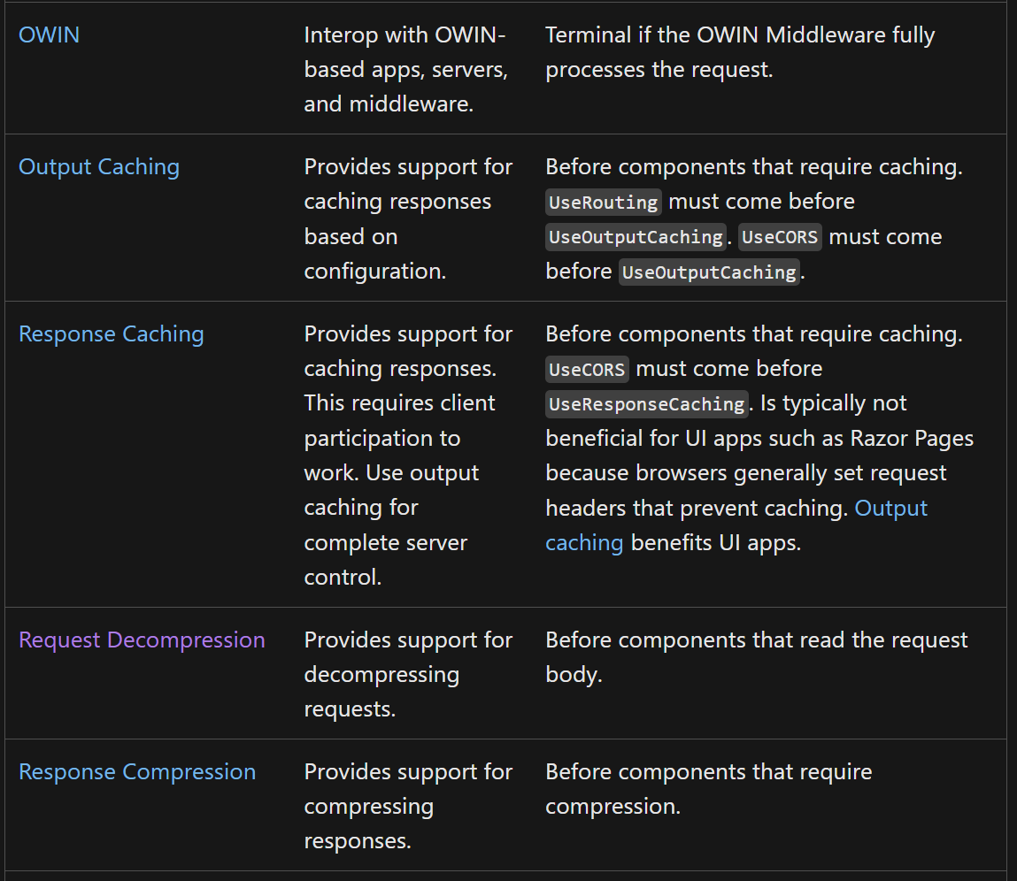

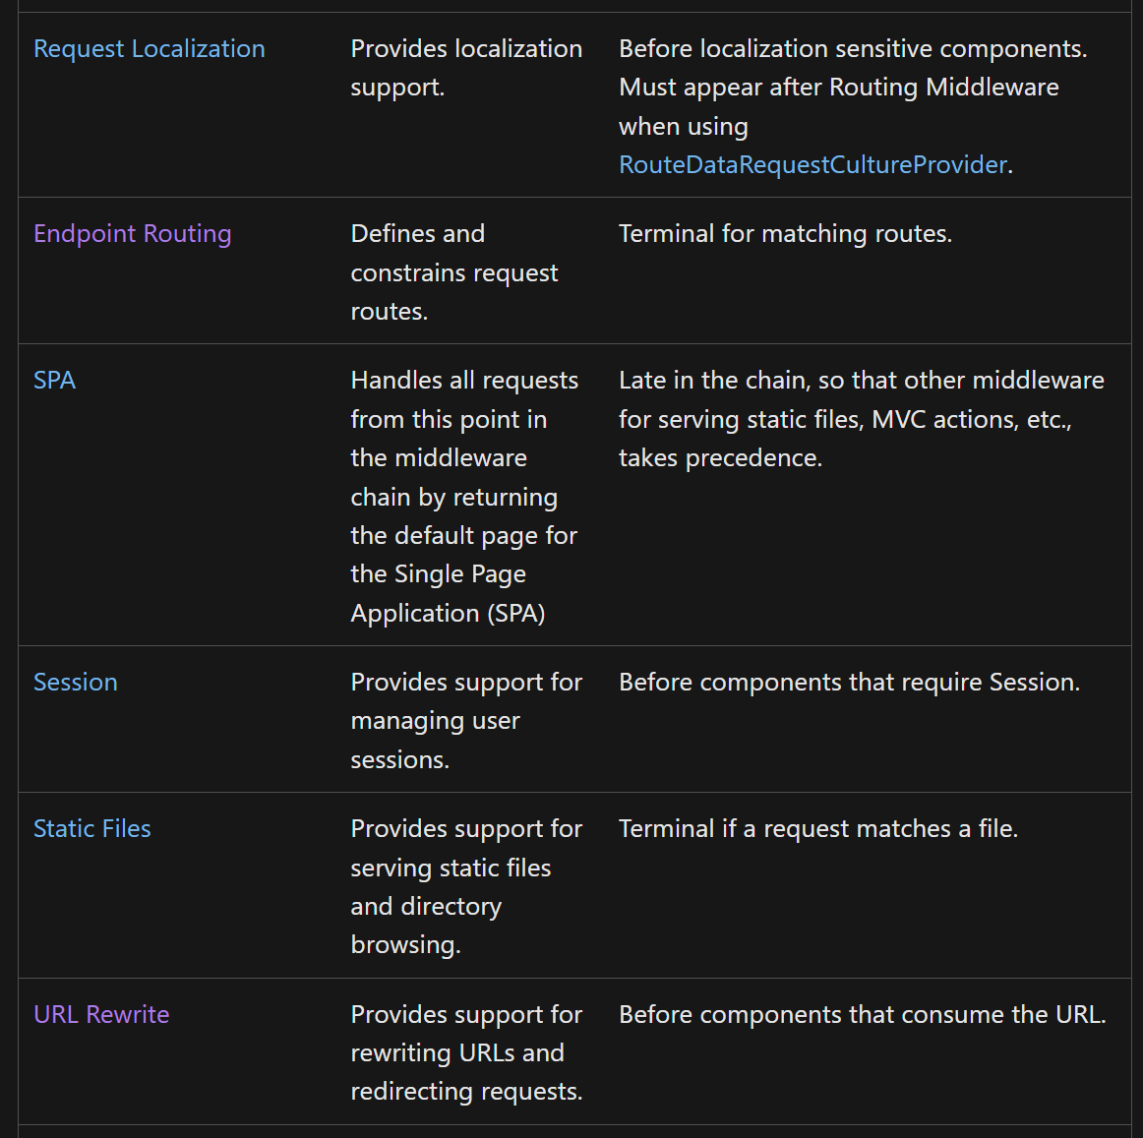

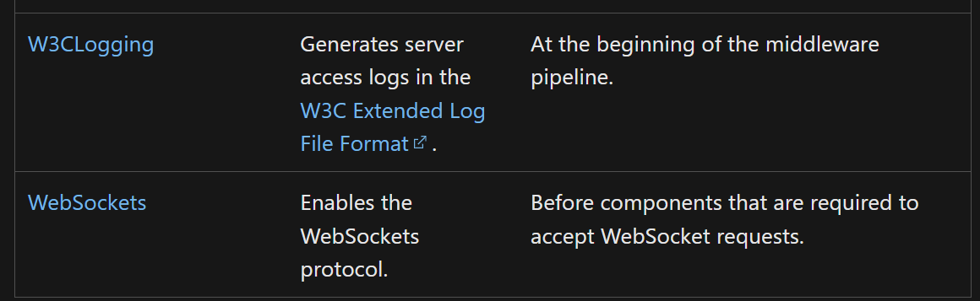

## Write custom ASP.NET Core middleware.

Middleware is software that’s assembled into an app pipeline to handle requests and responses. ASP.NET Core provides a rich set of built-in middleware components, but in some scenarios you might want to write a custom middleware.

This topic describes how to write convention-based middleware. For an approach that uses strong typing and per-request activation, see Factory-based middleware activation in ASP.NET Core.

**Middleware class**

Middleware is generally encapsulated in a class and exposed with an extension method. Consider the following inline middleware, which sets the culture for the current request from a query string:

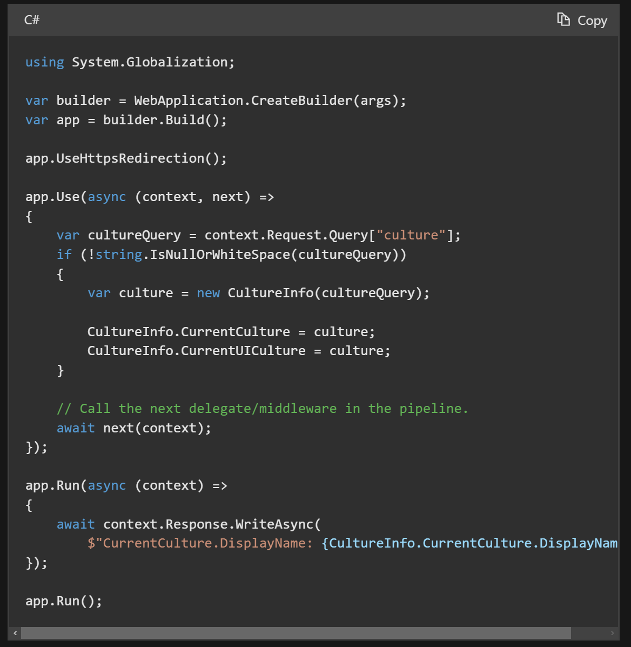

The preceding highlighted inline middleware is used to demonstrate creating a middleware component by calling Microsoft.AspNetCore.Builder.UseExtensions.Use. The preceding Use extension method adds a middleware delegate defined in-line to the applications request pipeline.

There are two overloads available for the Use extension:

* One takes HttpContext and a Func<Task>. Invoke the Func<Task> without any parameters.
* The other takes a HttpContext and a RequestDelegate. Invoke the RequestDelegate by passing the HttpContext.

Prefer using the later overload as it saves two internal per-request allocations that are required when using the other overload.

The following code moves the middleware delegate to a class:

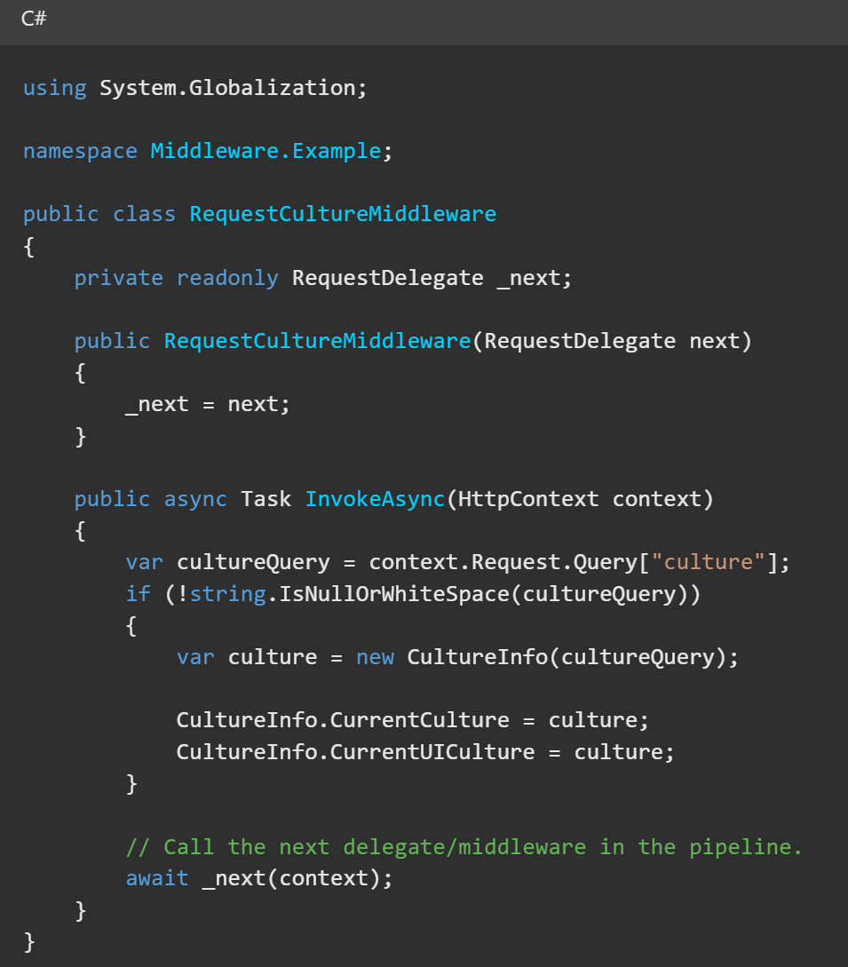

The middleware class must include:

* A public constructor with a parameter of type RequestDelegate.
* A public method named Invoke or InvokeAsync. This method must:
  + Return a Task
  + Accept a first parameter of type HttpContext.

Additional parameters for the constructor and Invoke/InvokeAsync are populated by dependency injection (DI).

Typically, an extension method is created to expose the middleware through IApplicationBuilder:

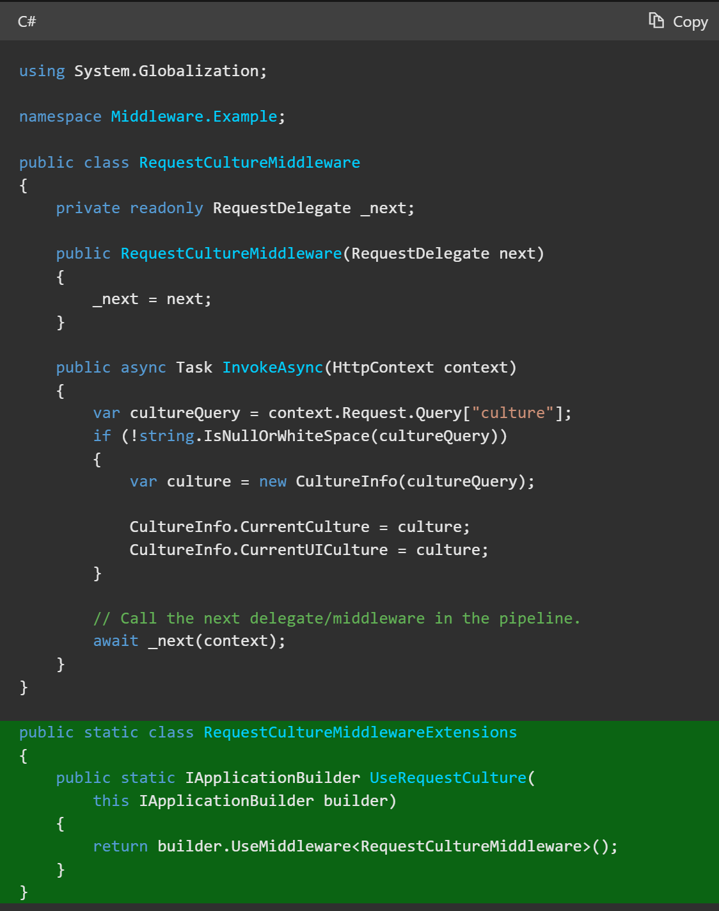

The following code calls the middleware from Program.cs:

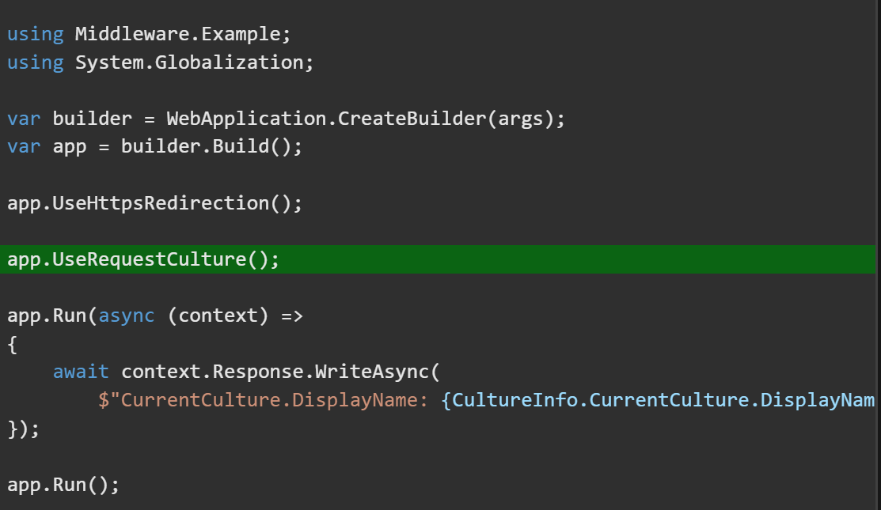

**Middleware dependencies**

Middleware should follow the explicit dependencies principle by exposing its dependencies in its constructor. Middleware is constructed once per application lifetime.

Middleware components can resolve their dependencies from dependency injection (DI) through constructor parameters. UseMiddleware can also accept additional parameters directly.

**Per-request middleware dependencies**

Middleware is constructed at app startup and therefore has application lifetime. Scoped lifetime services used by middleware constructors aren’t shared with other dependency-injected types during each request. To share a scoped service between middleware and other types, add these services to the InvokeAsync method’s signature. The InvokeAsync method can accept additional parameters that are populated by DI:

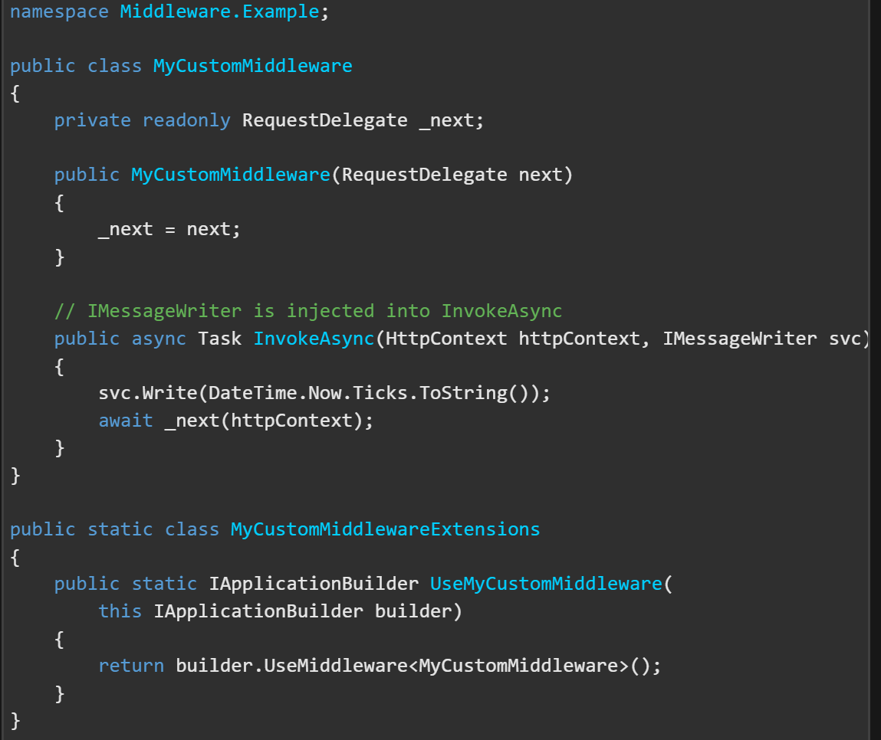

Lifetime and registration options contains a complete sample of middleware with scoped lifetime services.

The following code is used to test the preceding middleware:

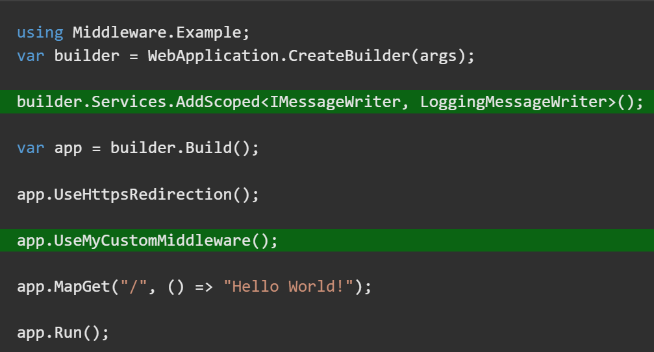

The IMessageWriter interface and implementation:

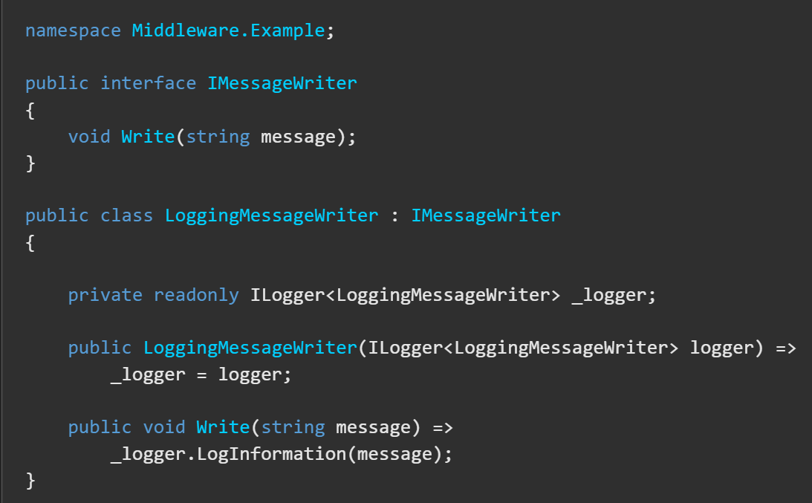

## CORS

Cross-Origin Resource Sharing (CORS) is an HTTP-header based mechanism that allows a server to indicate any origins (domain, scheme, or port) other than its own from which a browser should permit loading resources. CORS also relies on a mechanism by which browsers make a “preflight” request to the server hosting the cross-origin resource, in order to check that the server will permit the actual request In that preflight, the browser sends headers that indicate the HTTP method and headers that will be used in the actual request.

An example of a cross-origin request: the front-end JavaScript code served from <https://domain-a.com> uses XMLHttpRequest to make a request for <https://domain-b.com/data.json>.

For security reason, browsers restrict cross-origin HTTP request initiated from scripts. For example, XMLHttpRequest and the Fetch API follow the same-origin policy. This means that a web application using those APIs can only request resources from the same origin the application was loaded from unless the responses from the same origin the application was loaded from unless the response from other origins includes the right CORS headers.

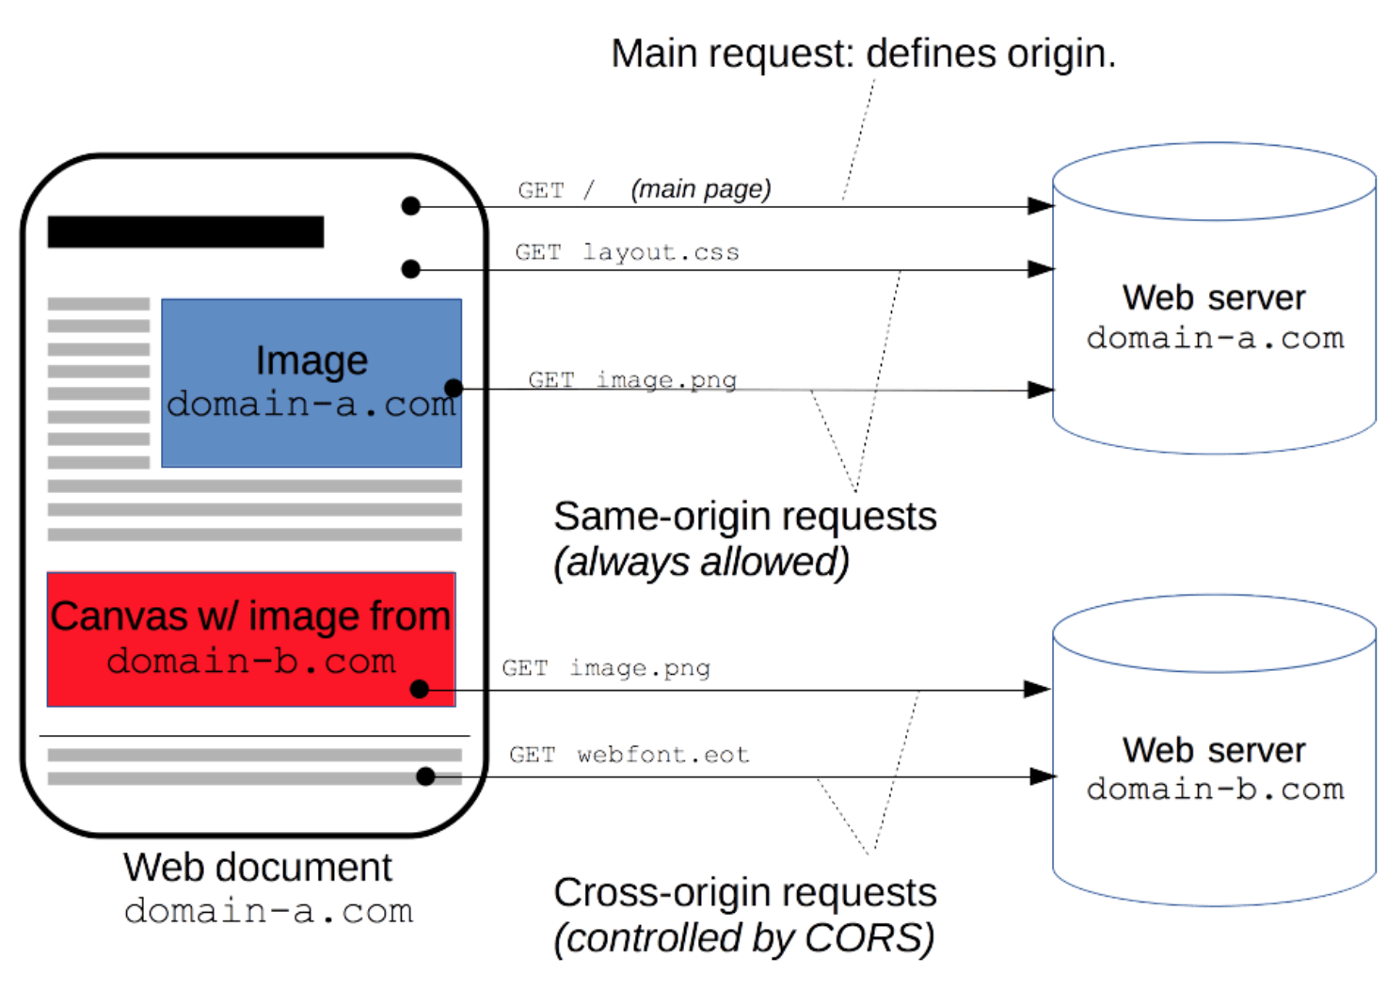

The CORS mechanism supports secure cross-origin requests and data transfers between browsers and servers. Modern browsers use CORS in APIs XMLHttpRequest or Fetch to mitigate the risks of cross-origin HTTP requests.

**Functional overview**

The Cross-Origin Resource sharing standard works by adding new HTTP headers that let servers describe which origins are permitted to read that information from a web browser. Additionally, for HTTP request methods that can cause side-effects on server data (in particular, HTTP methods other than GET, or POST with certain MIME types), the specification mandates that browsers “preflight” the request, soliciting supported methods from the server with the HTTP OPTIONS request method, and then, upon “approval” from the server, sending the actual request. Servers can also inform clients whether “credentials” (such as Cookies and HTTP Authentication) should be sent with requests.

CORS failures result in errors but for security reasons, specifics about the error are not available to JavaScript. All the code knows is that an error occurred. The only way to determine what specifically went wrong is to look at the browsers console for details.

Subsequent sections discuss scenarios, as well as provide a breakdown of the HTTP headers used.

**Examples of access control scenarios**

We present three scenarios that demonstrate how cross-origin resource sharing works. All these examples use XMLHttpRequest, which can make cross origin requests in any supporting browser.

**Simple requests**

Some requests don’t trigger a CORS preflight. Those are called simple requests from the obsolete CORS spec, though the Fetch spec (which now defines CORS) doesn’t use that term.

The motivation is that the <form> element from HTML 4.0 (which predates cross-site XMLHttpRequest and fetch) can submit simple requests to any origin, so anyone writing a server must already be protecting against cross-site request forgery (CSRF). Under this assumption, the server doesn’t have to opt-in (by responding to a preflight request) to receive any request that looks like a form submission, since the threat of CSRF is no worse than that of form submission, since the threat of CSRF is no worse than that of form submission. However, the server still must opt-in using Access-Control-Allow-Origin to share the response with the script.

A simple request is one that meets all the following conditions:

* One of the allowed methods:
  + GET
  + HEAD
  + POST
* Apart from the headers automatically set by the user agent (for example, Connection, User-Agent), the only headers which are allowed to be manually set are those which the Fetch spec defines as a CORS-safe listed request-header, which are:
  + Accept
  + Accept-Language
  + Content-Language
  + Content-Type
  + Range
* The only type/subtype combinations allowed for the media type specified in the Content-Type header are:
  + Application/x-www-form-urlencoded
  + Multipart/form-data
  + Text/plain
* If the request made using an XMLHttpRequest object, no event listeners are registered on the object returned by the XMLHttpRequest.upload property used in the request; that is given an XMLHttpRequest instance xhr, no code has called xhr.upload.addEventListener() to add an event listener to monitor the upload.
* No Readable object is used in the request.

For example, suppose web content at <https://foo.example> wishes to involve content on domain <https://bar.other>. Code of this sort might be used in Javascript deployed on foo.example:

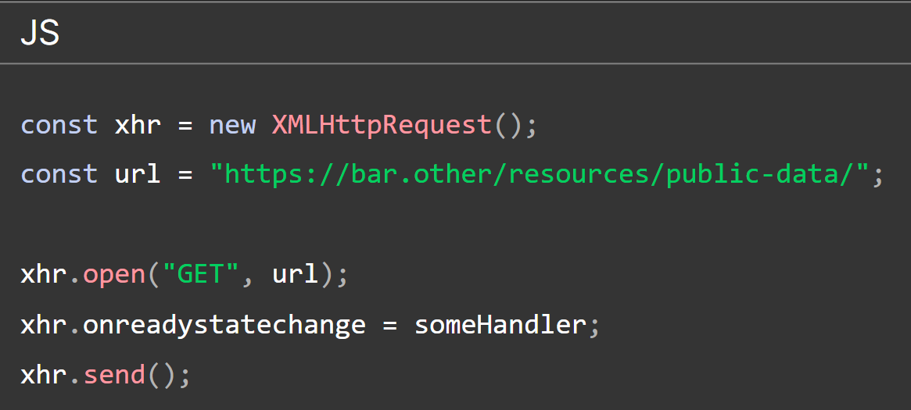

This operation performs a simple exchange between the client and the server, using CORS headers to handle the privileges:

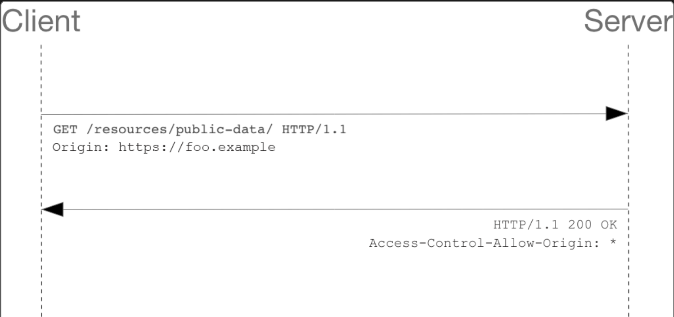

Let’s look at what the browser will send to the server in this case:

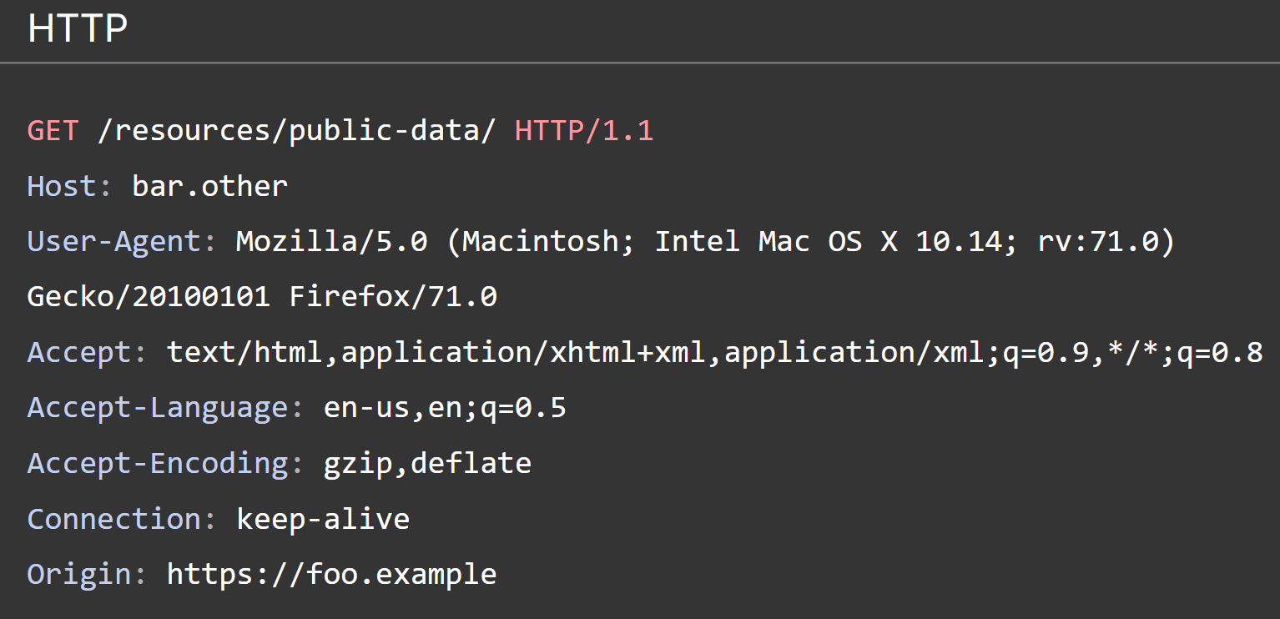

The request header of note is Origin, which shows that invocation is coming from <https://foo.example>.

Now lets see how the server responds:

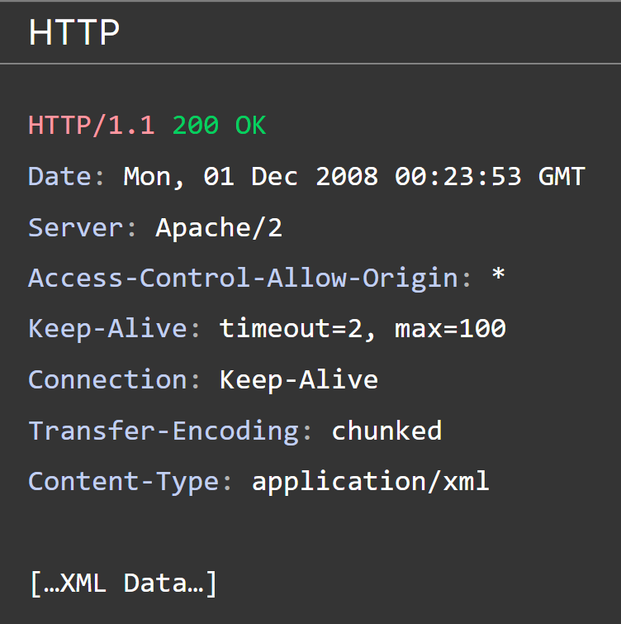

In response, the server returns an Access-Control-Allow-Origin header with Access-Control-Allow-Origin: *, which means that the resource can be accessed by any origin.

This pattern of the Origin and Access-Control-Allow-Origin headers is the simplest use of the access control protocol. If the resource owners at <https://bar.other> wished to restrict access to the resource to requests only from https://foo.example (i.e. no domain other than <https://foo.example> can access the resource in a cross-origin manner), they would send:

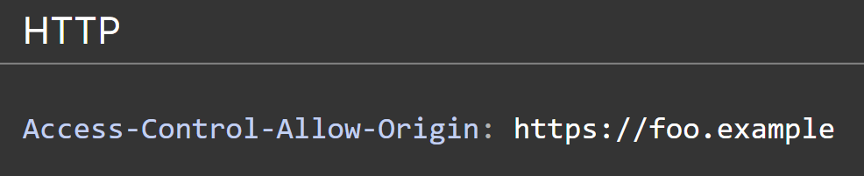

**Preflighted requests**

Unlike simple requests, for “Preflighted” requests the browser first sends an HTTP request using the OPTIONS method to the resource on the other origin, in order to determine if the actual request is safe to send. Such cross-origin requests are Preflighted since they may have implications for user data.

The following is an example of a request that will be Preflighted:

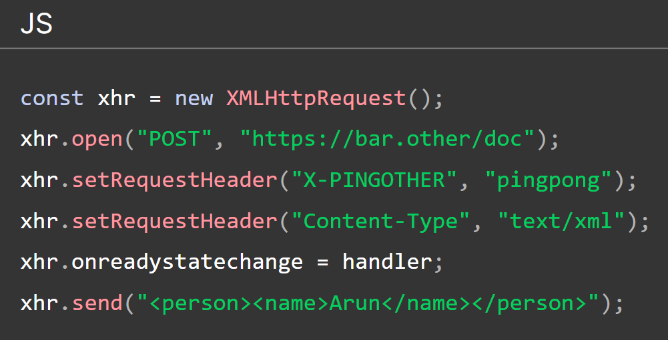

The example above creates an XML body to send with the POST request. Also, a non-standard HTTP X-PINGOTHER request header is set. Such headers are not part of HTTP/1.1 but are generally useful to web applications.

## Browsers

A web browser is software that enables users to access and view content on the World Wide Web. It’s primary function is to locate and retrieve web pages, images, videos, documents and other files from servers and display them on the users device.

For instance, imagine you want to visit a website. Here’s where the browser comes in. When you type the website’s URL into the browser’s address bar and hit enter, your browser sends a request to the server where the websites files are stored. This communication happens over protocols such as HTTPS (Hypertext Transfer Protocol Secure) or HTTP (Hypertext Transfer Protocol).

On receiving your request, the server sends back the websites files. These files are often written in languages like HTML, CSS and Javascript. Your browsers job is to interpret this code and render it into the web page you see.

In essence, the browser acts as a bridge between you and the website, sending your requests to the server and translating the servers response into a format you can easily interact with on your device. Without a browser, navigating the vast ocean of internet content would be nearly impossible.

**Functions of a browser**

A web browser serves a multitude of functions to enhance your browsing experience. Let’s explore some of the key features and functions of a browser:

1. **Web Page Rendering**: When you visit a website, the browser retrieves the website’s HTML, CSS and Javascript files from the server. It then interprets and processes this code to construct the web page you see on your device. The HTML defines the structure and content of the page, CSS styles the page’s appearance, and Javascript adds interactivity and dynamic elements.
2. **Navigation**: Browsers provide an intuitive interface for navigating the internet. You can enter a websites address (URL) directly into the address bar, and the browser will take you to that specific webpage. Additionally, you can click on hyperlinks within web pages to navigate to other related pages. Browsers also support bookmarks, which allow you to save and organize frequently visited websites for quick access.
3. **Tabled Browsing**: Tabs revolutionized web browsing by allowing you to open multiple web pages within a single browser window. Instead of opening separate browser instances for each webpage, you can open new tabs, each representing a different webpage. This feature facilitates multitasking and makes it easy to switch between different websites without cluttering your screen.

## Components of a Browser

A browser has two elements: **front-end** and **back-end.** The complex back end facilitates the core functioning of the browser, and the front end interacts with the user.

* **Front-end:** The front-end of a browser refers to the user-facing part that you interact with. It includes the graphical user interface (GUI) elements, such as the address bar, navigation buttons, bookmarks and tabs. The front-end also handles the rendering of web pages, displaying the content, images and interactive elements on your devices screen.
* **Back-end:** The back end of a browser encompasses the complex processes that occur behind the scenes. It handles the communication between the browser and web servers, fetching and managing web page resources, and processing the code that makes up the web pages. The back-end interprets HTML, CSS and Javascript files, ensuring that web pages are rendered correctly. It manages network connections, supports various protocols like HTTP and HTTPS, and handles security measures such as encryption and certificate verification..

The front-end and backend components of a browser work together seamlessly to provide a rich and interactive browsing experience.

When you interact with the front-end by typing a URL, clicking on links, or using browser features, the front-end communicates with the back-end to fetch the necessary web page resources.

The back-end processes these resources and sends the rendered content back to the front-end for display on your device. This collaboration between the front-end and back-end enables you to navigate the internet, access websites, and interact with online content smoothly.

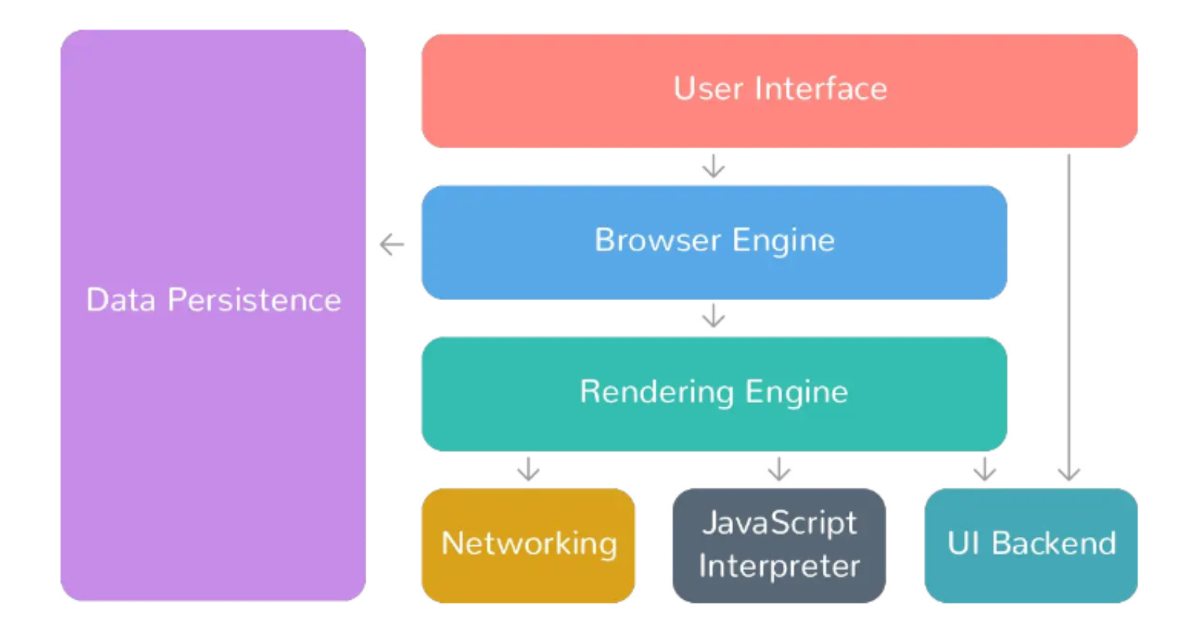

* **User Interface:** The user interface is the space where users interact with the browser. It encompasses elements such as bookmarks, an address bar for entering website URLs, back and forward buttons for navigation, tabs for multitasking and menus for accessing various browser features and settings. The user interface provides a visually intuitive way for users to control and navigate the browser.
* **Browser Engine:** The browser engine acts as the core of the browser, handling user interactions, rendering web pages, and facilitating communication with other components. It coordinates the flow of information between the user interface, rendering engine and other browser components. The browser engine ensures that user actions, such as clicking a link or entering a URL, are properly processed and trigger the appropriate actions within the browser.
* **Rendering Engine:** The rendering engine is responsible for displaying the content of web pages within the browser. It takes the HTML, CSS and Javascript code of a web page and converts it into a visual display that users can see. The rendering engine interprets the HTML structure, applies the CSS styles to determine the pages layout and appearance and executes any Javascript code to add interactivity and dynamic elements to the web page.
* **Javascript Interpreter:** The Javascript interpreter is a component within the browser that executes Javascript code found on web pages. Javascript is a programming language commonly used for adding interactivity and dynamic functionality to websites. The interpreter ensures that Javascript code is properly executed, allowing web pages to respond to user actions, update content dynamically and interact with APIs and other web technologies.
* **Networking:** The networking component of a browser handles various aspects of network communication. It is responsible for resolving website URLs into IP addresses, sending HTTP requests to web servers, establishing network connections, and receiving and processing the responses. The networking component plays a crucial role in fetching web page resources such as HTML, CSS, images and other files, from servers and delivering them to the rendering engine for display.

Each browser component is important and they work together.

**How does a Browser Work?**

Browsers are responsible for retrieving and displaying web content to users. When a user enters a URL or clicks on a link, the browser initiates a complex series of actions to retrieve the web content from a server and display it on the users device.

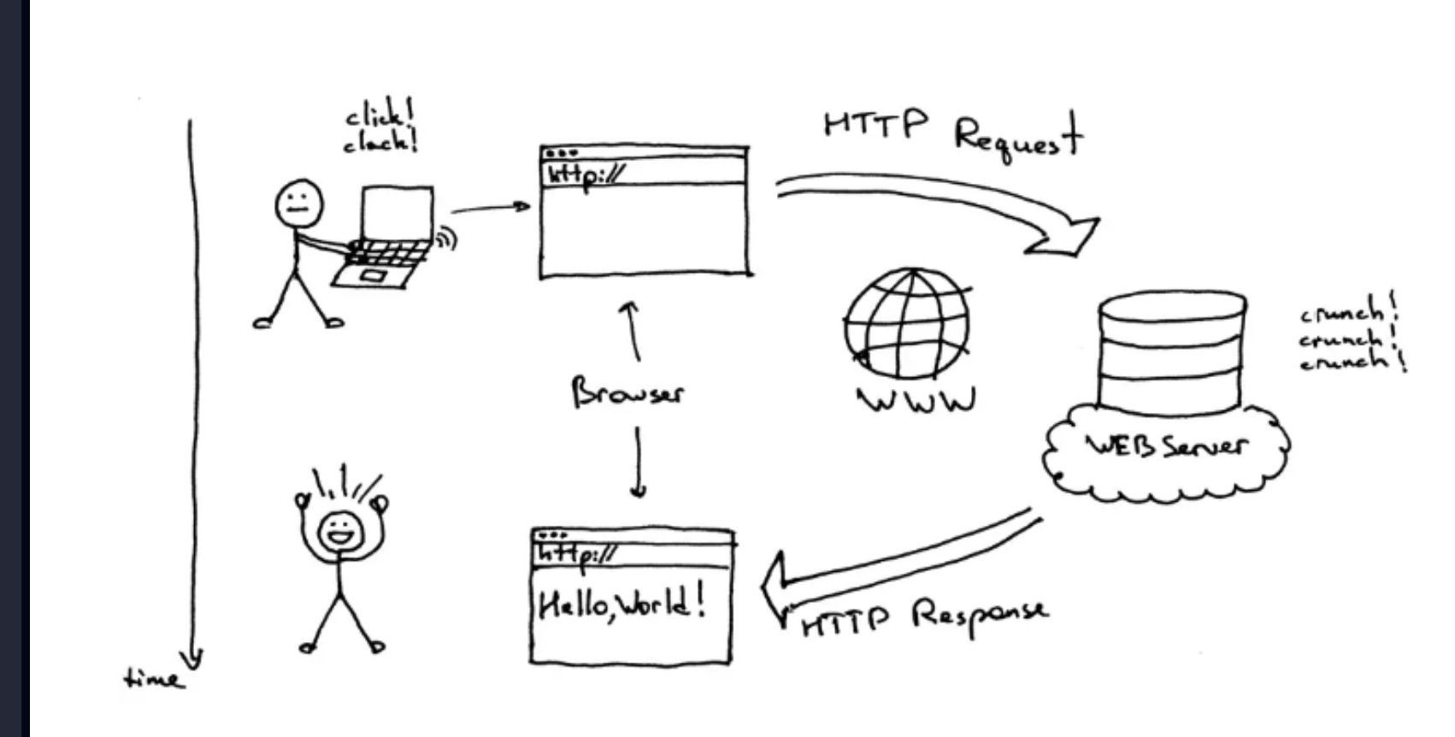

The process begins with Domain Name System (DNS) resolution, where the browser translates the domain name into an IP address to locate the server where the web page is stored.

* The browser then sends an HTTP request to the server, specifying the path and parameters of the requested resource.
* Once the server receives the request, it sends an HTTP response to the browser containing the requested resource in HTML, CSS and Javascript code.
* The browsers rendering engine interprets and renders the code to display the web page on the users device.
* The CSS stylesheets are applied to format the web pages content, including fonts, colours and layout.
* The browser may also execute Javascript code on the web page to add interactivity and dynamic behaviour.

As new content is loaded or changes are made to the web page, the browser updates the display accordingly.

**Commonly used Jargons in Browser**

* **URL:** The universal resource locator (URL) addresses a unique resource on the web.
* **HTML:** Hypertext markup language (HTML) is used for creating web applications and pages.
* **HTTPS:** Hypertext Transfer protocol (HTTPS) works as HTTP but with encryption for a secure server communication.
* **IP Address:** It spots the location of a specific server connected to the internet.
* **DNS:** Domain Name System is a database containing domain records.
* **Cookies:** Cookies are small text files that are stored on the users device by a website. When a user visits a website, the website may create a cookie to track information about the users activity on the site or to remember the users preferences or login information.

## Sockets and ports

A socket uniquely identifies the endpoint of a communication link between two application ports.

A port represents an application process on a TCP/IP host, but the port number itself does not indicate the protocol being used: TCP, UDP or IP. The application process might use the same port number for TCP or UDP protocols. To uniquely identify the destination of an IP packet arriving over the network, you have to extend the port principle with information about the protocol used and the IP address of the network interface; this information is called a socket. A socket has three parts: protocol, local address, local port.

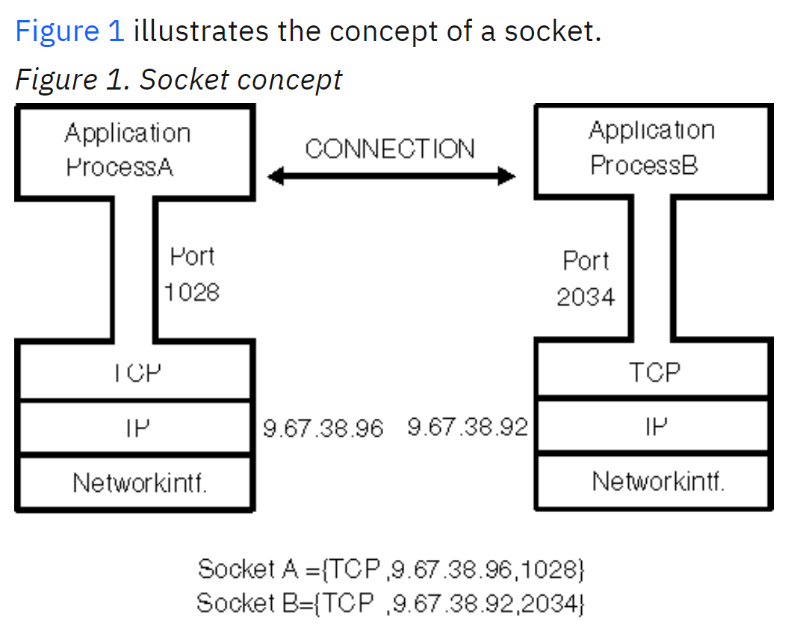

The term association is used to specify completely the two processes that comprise a connection: (protocol, local-address, local-port, foreign-address, foreign-port). The terms socket and port are sometimes used as synonyms, but note that terms port number and socket address are not like one another. A port number is one of the three parts of a socket address, and can be represented by a single number (for example 1028) while a socket address can be represented by tcp, myhostname, 1028). A socket descriptor (sometimes referred to as a socket number) is a binary integer that acts as an index to a table of sockets; the sockets are currently allocated to a given process. A socket descriptor represents the socket, but is not the socket itself.

## Difference between a Port and a Socket

Port is a part of the transport layer and helps in network communication. A port is a logical identifier assigned to a process in order to identify that process uniquely in a network system. When two network devices communicate, they do so by sending packets to each other. Each packet received by a receiver device contains a port number that uniquely identifies the process where the packet needs to be sent.

Not all the network protocol uses a port for communication. For example, ICMP doesn’t use a port. On the other hand, protocols like TCP, UDP, HTTP utilize a port for communication. Let’s look at an example: A client computer is requesting the server for a virtual connection with the port number 23. Telnet is a well known protocol for establishing a remote connection over a TCP/IP and it uses port 23. Hence the server acknowledges the request from the client and starts a telnet connection:

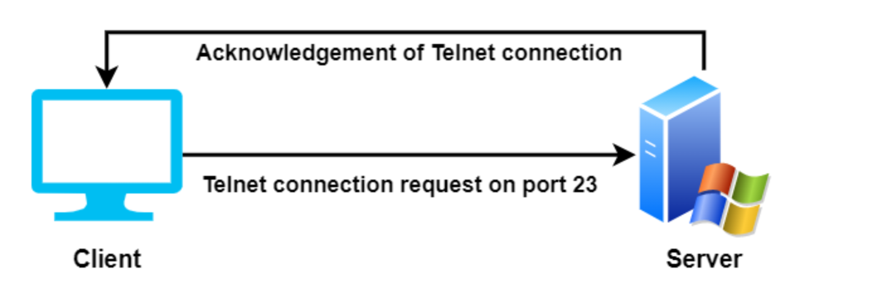

**What is a Socket?**

Two processes that are running on a computer or running on two different systems can communicate via a socket. A socket works as an inter-process communicator and seen as the endpoint of the process communication. For communication, the socket uses a file descriptor and is mainly employed in client-server applications.

A socket consists of the IP address of a system and the port number of a program within the system. The IP address corresponds to the system and the port number corresponds to the program where the data needs to be sent:

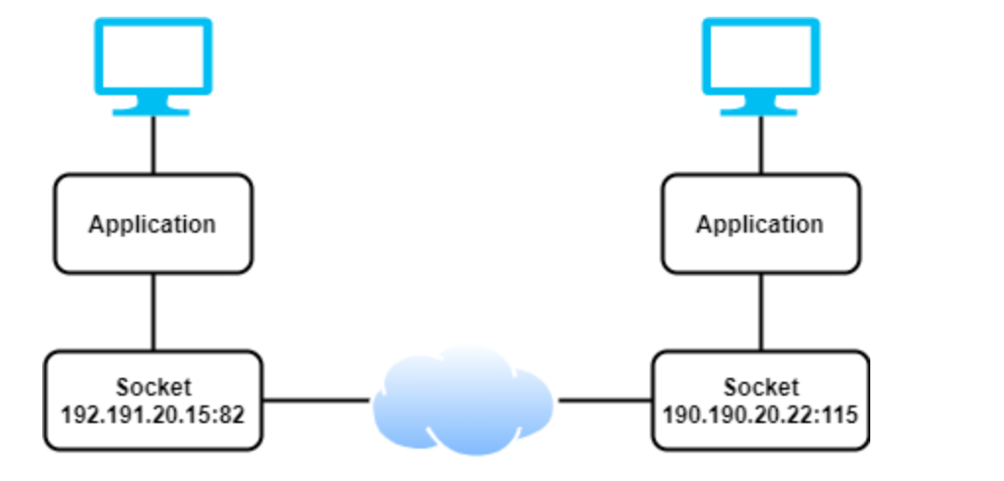

**Socket can be classified into three categories: stream, datagram and raw socket.**

Stream sockets use connection oriented network point to send and receive data. This type of sockets generally utilizes TCP to permit processes to communicate with each other.

Datagram sockets use connectionless network protocols like UDP to allow process communication. Raw sockets are datagram oriented and allow the processes to use ICMP for communication purpose.

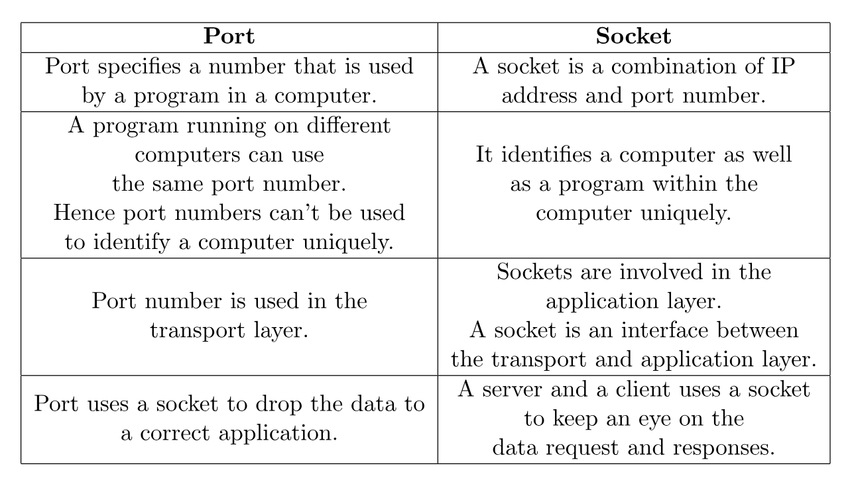

## WebSockets

WebSocket is a real time technology that enables bidirectional, full-duplex communication between client and server over a persistent, single-socket connection. The WebSocket connection is kept alive for as long as needed (in theory, it can last forever), allowing the server and the client to send data at will, with minimal overhead.

The WebSocket technology consists of two core building blocks:

* The WebSocket protocol.
* The WebSocket API.

**What is the WebSocket protocol?**

The WebSocket protocol enables ongoing, full duplex, bidirectional communication between a web client and a web server over and underlying TCP connection. The protocol is designed to allow clients and servers to communicate in real time, allowing for efficient and responsive data transfers in web applications.

In December 2011, the Internet Engineering Task Force (IETC) standardized the WebSocket protocol through RFC 6355. In coordination with IETF, the Internet Assigned Numbers Authority (IANA) maintains the WebSocket Protocol Registries, which define many of the codes and parameter identifiers used by the protocol.

**What is the WebSocket API?**

Included in the HTML Living Standard, the WebSocket API is a programming interface for creating WebSocket connections and managing the data exchange between a client and da server in a web app. It provides a simple and standardized way for developers to use the WebSocket protocol in their applications.

Nowadays, almost all modern browsers support the WebSocket API. Additionally, there are plenty of frameworks and libraries – both open source and commercial solutions that implement WebSocket APIs.

**How do WebSockets work?**

In a nutshell, working with WebSockets involves three main steps:

* **Opening a WebSocket connection**. The process of establishing a WebSocket connection is known as the opening handshake and consists of an HTTP request/response exchange between the client and the server.
* **Data transmission over WebSockets**. After a successful WebSocket handshake, the client and server can exchange messages (frames) over the persistent WebSocket connection. WebSocket messages may contain string (plain text) or binary data.
* **Closing a WebSocket connection.** Once the persistent WebSocket connection has served its purposes, it can be terminated; both the client and the server can initiate the closing handshake by sending a close message.

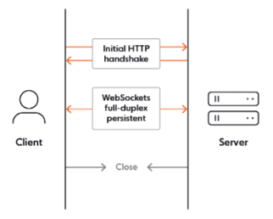

**What are the pros and cons of WebSockets?**

The advantages of WebSockets are that they enable real time communication between the client and server without the need for frequent HTTP requests/responses. This brings benefits such as reduced latency, and improved performance and responsiveness web apps.

Due to its persistent and bidirectional nature, the WebSocket protocol is more flexible that HTTP when building real time apps that require frequent data exchanges. WebSockets are also more efficient, as they allow data to be transmitted without the need for repetitive HTTP headers and handshakes. This can reduce bandwidth usage and server load.

While WebSockets have plenty of advantages, they also come with some disadvantages. Here are the main ones:

* WebSockets are not optimized for streaming audio and video data.|
* WebSockets don’t automatically recover when connections are terminated.
* Some environments (such as corporate networks with proxy servers) will block WebSocket connections.
* WebSockets are stateful, which makes them hard to use in large scale systems.

**Are WebSockets scalable?**

Yes, WebSockets are scalable. Slack uses WebSockets for instant messaging between chat users. Scaling WebSockets is non-trivial, and involves numerous engineering decisions and technical trade-offs:

* Should you use vertical or horizontal scaling?
* How do you deal with unpredictable loads?
* How do you manage WebSocket connections at scale/
* How much bandwidth is being used overall, and how is it impacting your budget?
* Do you have to deal with traffic spikes, and if so, what is the performance impact on the server layer?
* How will you automatically add additional server capacity if and when it’s needed?
* How do you ensure data integrity (guaranteed message ordering and delivery) at scale?

## Introduction to SignalR

ASP.NET SignalR is a library for ASP.NET developers that simplifies the process of adding real-time web functionality to applications. Real-time web functionality is the ability to have server code push content to connected clients instantly as it becomes available, rather than having the server wait for a client to request new data.

SignalR can be used to add any sort of “real-time” web functionality to your ASP.NET application. While chat is often used as an example, you can do a whole lot more. Any time a user refreshes a web page to see new data, or the page implements long polling to retrieve new data, it is a candidate for using SignalR. Examples include dashboards and monitoring applications, collaborative applications (such as simultaneous editing of documents), job progress updates, and real-time forms.

SignalR also enables completely new types of web applications that require high frequency updates from the server, for example, real-time gaming.

SignalR also enables completely new types of web applications that require high frequency updates from the server, for example real-time gaming.

SignalR provides a simple API for creating server-to-client remote procedure calls (RPC) that call Javascript functions in client browsers (and other client platforms) from server-side .NET code. SignalR also includes API for connection management (for instance, connect and disconnect events), and grouping connections.

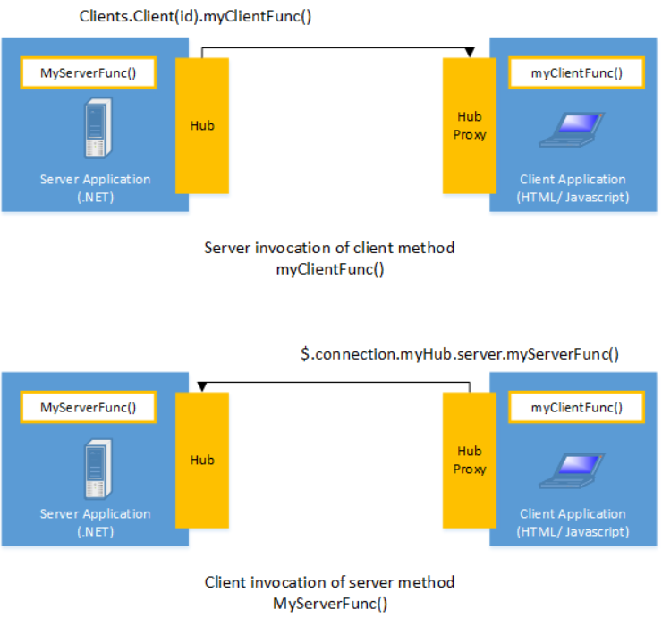

Signal R handles connection management automatically, and lets you broadcast messages to all connected clients simultaneously, like a chat room. You can also send messages to specific clients. The connection between the client and server is persistent, unlike a classic HTTP connection, which is re-established for each communication.

SignalR supports “server push” functionality, in which server code can call out to client code in the browser using Remote Procedure Calls (RPC), rather than the request-response model common on the web today.

SignalR applications can scale out to thousands of clients using built-in, and third party scale-out providers.

**SignalR and WebSocket**

SignalR uses the new WebSocket transport where available and falls back to older transports where necessary. While you could certainly write your app using WebSocket directly, using SignalR means that a lot of the extra functionality you would need to implement is already done for you. Most importantly this means that you can code your app to take advantage of WebSocket without having to worry about creating a separate code path for older clients. SignalR is updated to support changes in the underlying transport, providing your application a consistent interface across versions of WebSocket.

**Transports and fallbacks**

SignalR is an abstraction over some of the transports that are required to do real time work between client and server. SignalR first attempts to establish a WebSocket connection if possible. WebSocket is the optimal transport for SignalR because it has:

* The most efficient use of server memory.
* The lowest latency.
* The most underlying features, such as full duplex communication between client and server.

If these requirements are not met, SignalR attempts to use other transports to make its connections.

## Amazon SNS

Amazon simple notification service (Amazon SNS) is a managed service that provides message delivery from publishers to subscribers (also known as producers and consumers). Publishers communicate asynchronously with subscribers by sending messages to a topic, which is a logical access point and communication channel. Clients can subscribe to the SNS topic and receive published messages using a supported endpoint type, such as Amazon Kinesis Data Firehose, Amazon SQS, AWS Lambda, HTTP, email, mobile push notifications and mobile text messages (SMS)

## Amazon SQS

**Distributed queues**

There are three main parts in a distributed messaging system: the components of your distributed system, your queue (distributed on Amazon SQS servers) and the messages in the queue.

In the following scenario, your system has several producers (components that send messages to the queue) and consumers (components that receive messages from the queue). The queue (which holds messages A through E) redundantly stores the messages across multiple Amazon SQS servers.

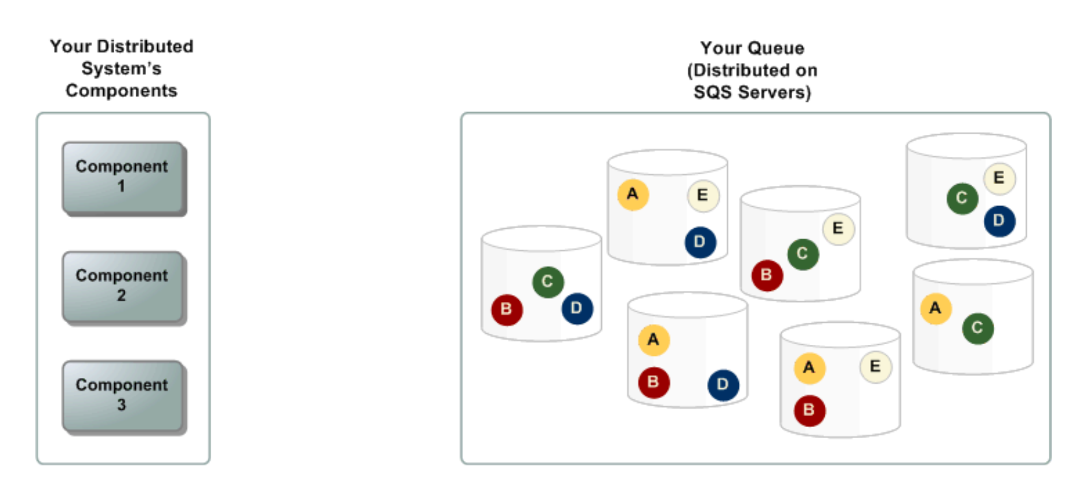

**Message lifecycle**

The following scenario describes the lifecycle of an Amazon SQS message in a queue, from creation to deletion.

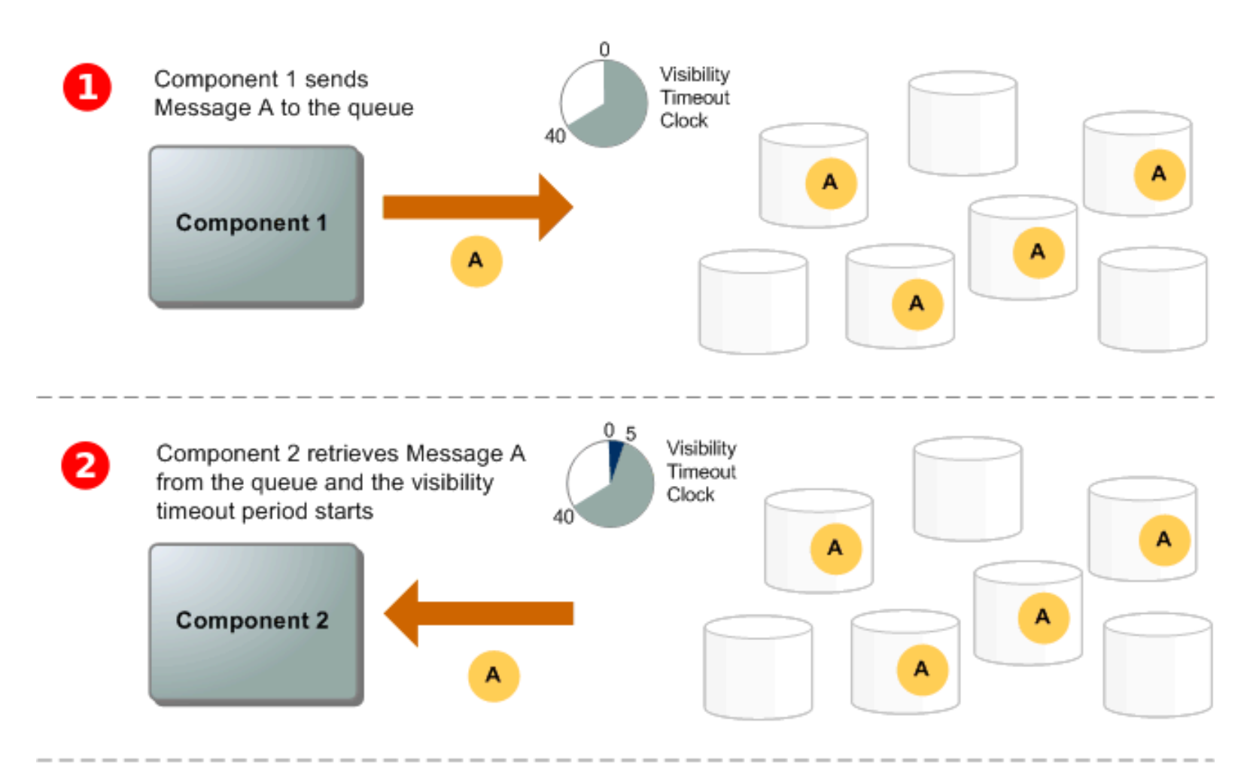

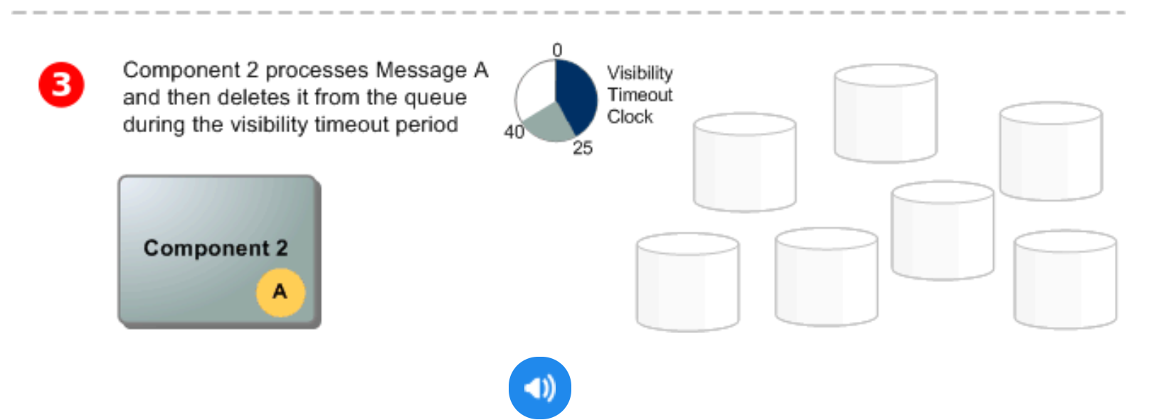

1. A producer (component 1) sends a message A to a queue, and the message is distributed across the Amazon SQS servers redundantly.
2. When a consumer (component 2) is ready to process messages, it consumes messages from the queue, and message A is returned. While message A is being processed, it remains in the queue and isn’t returned to subsequent receive requests for the duration of the visibility timeout.
3. The consumer (component 2) deletes message A from the queue to prevent the message from being received and processed again when the visibility timeout expires.

**Note:**

Amazon SQS automatically deletes messages that have been a queue for more than the maximum message retention period. The default message retention period is 4 days. However, you can set the message retention period to a value from 60 seconds to 14 days.

**Differences between Amazon SQS and Amazon SNS**

**Amazon SQS** offers hosted queues that integrate and decouple distributed software systems and components. Amazon SQS provides a generic web services API that you can access using any programming language supported by AWS SDK. Messages in the queue are typically processed by a single subscriber. Amazon SQS and Amazon SNS are often used together to create a fanout messaging application.

**Amazon SNS** is a publish-subscribe service that provides message delivery from publishers (also known as producers) to multiple subscriber endpoints (also known as consumers). Publishers communicate asynchronously with subscribers by sending messages to a topic, which is a logical access point and communication channel. Subscribers can subscribe to an amazon SNS topic and receive published messages using a supported endpoint type, such as Amazon SQS, Lamda, HTTP, email, SMS. Amazon SNS acts as a message router and delivers messages to subscribers in real time. If a subscriber is not available at the time of message publication, the message is not stored for later retrieval.

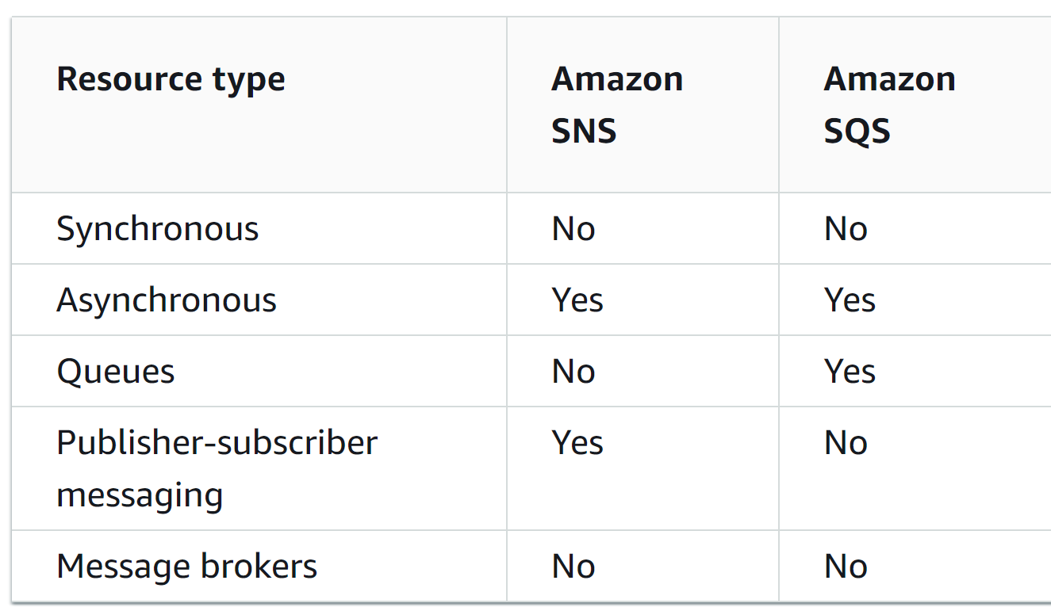

Under the hood, the subscription process typically involves the following steps:

1. Creation of Topic: First a topic needs to be created in Amazon SNS. This topic acts as a channel through which messages are sent.
2. Subscription request: an entity such as another AWS service, an application or an endpoint, initiates a subscription request to the SNS topic. This entity can subscribe to the topic by specifying its protocol (e.g. HTTP, HTTPS, email, SMS etc) and endpoint (URL, email address, phone number).
3. Confirmation: After the subscription request is initiated, SNS sends a confirmation message to the provided endpoint. The confirmation is required to verify that the endpoint or the subscriber is willing to receive messages from the SNS topic.
4. Confirmation response: the endpoint needs to confirm the subscription by responding to the confirmation message sent by Amazon SNS. This confirmation message sent by Amazon SNS. This confirmation typically involves a token or a unique identifier provided by the SNS service.
5. Subscription confirmation: once the endpoint confirms the subscription amazon SNS acknowledges the subscription request and marks it as active.
6. Receiving messages: from that point forward, when a message is published to the subscribed SNS topic, the SNS service sends a copy of that message to all the active subscribers (endpoints) associated with that topic.

The process ensures that the entity subscribing to the SNS topic has control over whether it wants to receive messages from that particular topic. Additionally, this mechanism helps prevent unauthorized subscriptions to topics.

Behind the scenes, Amazon SNS manages the routing of messages and ensures that messages are reliably delivered to the subscribed endpoints based on their specified protocols.

**Capitalization Architecture**

**Introduction**

Capitalization structure is intended to be a semi-standalone micro application which integrates with software solutions products to give a standard experience for users reviewing private credit structures and to provide customizable aggregations on top of this structure to which platform specific data has been transposed.

The initial integration of this system is with iLevel with a long-term vision to be integrated with other products under the atlas umbrella.

**High level architecture**

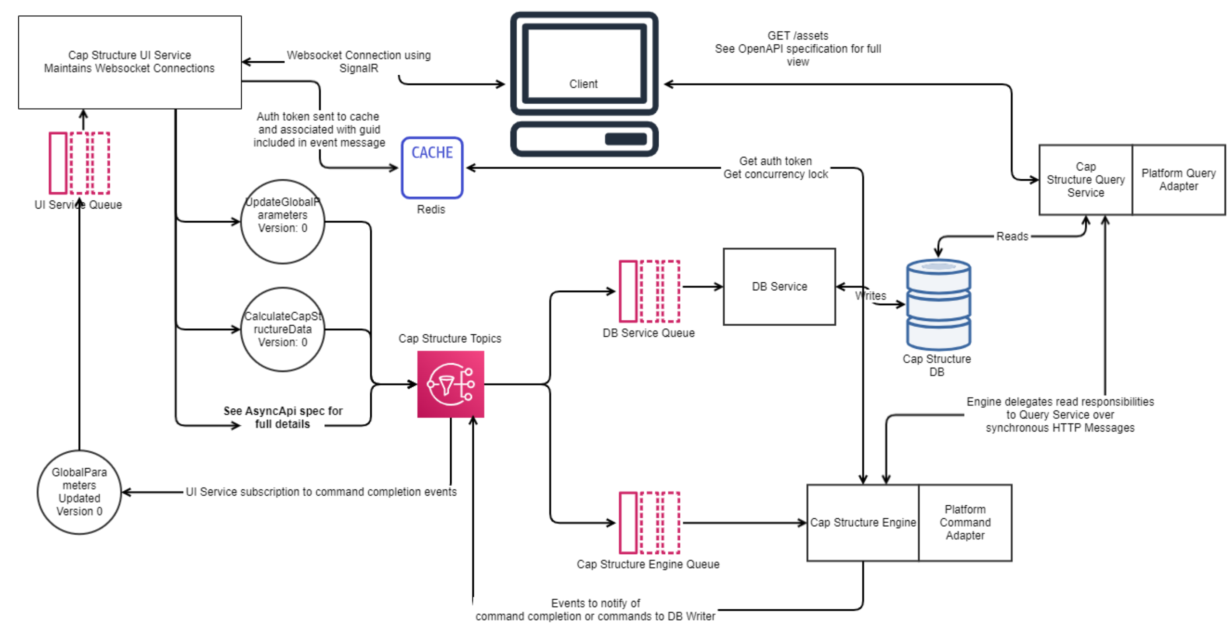

**Components Summary**

**Client**: A react client app for cap structure embedded into a platform web app. Subscribes to the UI service SignalR hub for commands/events. Uses the query service for synchronous retrieval of simple data and config over HTTP.

**Cap Structure UI Service:** A service that handles the SignalR connections to the client. Adds events to Cap Structure Topic.

**Cap Structure Query Service:** A service that processes Cap structure queries. Exposes REST API endpoints.

**Platform Queries Adaptor:** A library within the Cap Structure Query Service that translates Cap structure domain queries to platform domain queries.

**Cap Structure Topics:** SNS Topics for the Cap Structure domain events.

**UI Service Queue:** An SQS queue that subscribes to a cap structure topic. It is long polled by the UI Service.

**Cap Structure Engine Queue:** An SQS queue that subscribes to the Cap Structure Topic. It is long polled by the Cap Structure Engine.

**DB Service Queue:** An SQS queue that subscribes to the Cap Structure Topic. It is long polled by the DB Service.

**Cap Structure Engine:** An engine that processes Cap Structure commands. It handles calculations for the domain logic.

**Platform command adaptor:** A library within the Cap Structure engine service that translates cap structure domain commands to platform domain commands.

**DB Service:** A microservice for processing write requests to the Cap Structure DB.

**CAP Structure DB:** A PostgreSQL DB used both for reads and writes.

**Redis Cache:** Is populated by Cap structure UI Service with auth tokens. A GUID will be passed in the event from the UI service that will reference the user token in the Redis cache. The Redis cache will be accessed by the Cap Structure Engine to receive tokens and handle concurrency locks.

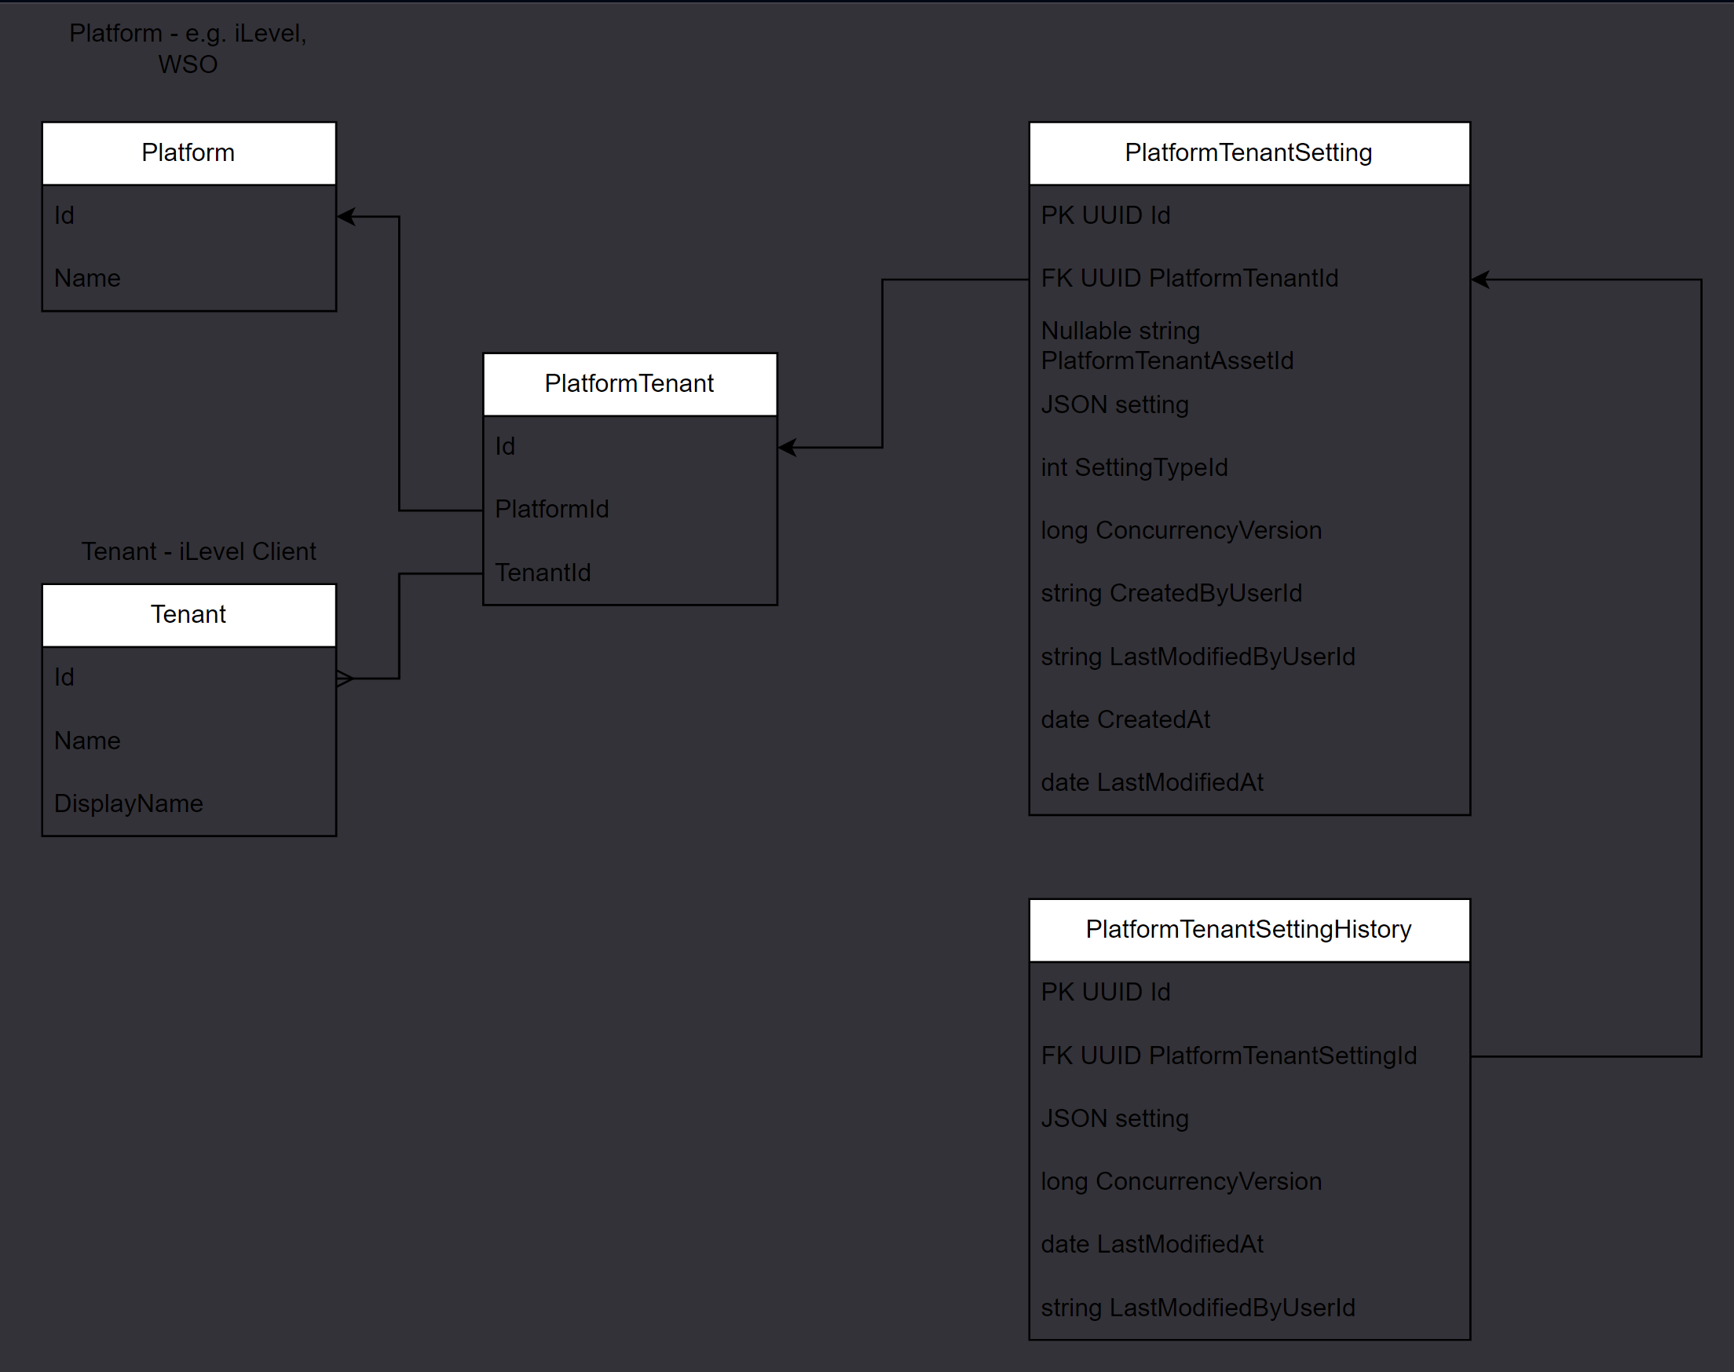

**Entities and descriptions:**

**Platform**: a representation of a target platform e.g., iLevel, WSO.

**Tenant**: a representation of a tenant i.e. an iLevel client.

**Platform Tenant:** A relationship between a platform and a tenant.

**Platform Tenant Setting:** Contains records for storing each instance of different setting types and asset/global level configs.

**Platform Tenant Setting History:** A history table for Platform Tenant Setting.

**Data Overrides:** Stores Cap Structure specific overrides of data not managed by the target platform.

**Data Overrides History:** A history table for Data Overrides.

## Technologies

**Messaging**

Messages are sent/received from the UI using a WebSocket connection setup by SignalR, a library available for C# and Javascript which safely wraps WebSockets. In addition, data which does not require calculation or aggregation (e.g. retrieving a view of data stored in the capitalization structure database, static data required to drive the UI and structure information of capitalization from the target platform (e.g. assets/issuers, securities, deals/positions)). Likewise, any data or config submission or calculation/aggregation requests will be handled through SignalR methods which will be assumed to have a non-linear mapping of commands to events by design, meaning a single calculation request could result in multiple events returned with no particular order, to be rendered by the UI as and when they are received.

Regarding SignalR connection failures, either through some networking issues, deployment related activities or otherwise, it is our intention that the UI will re-establish a connection after not receiving the heartbeat from the SignalR hub. In this time, it is possible messages will be lost and the data/config in the UI will become stale. In this case, the UI will be triggered to reload the data and config on the page.

AWS SNS (Simple Notification Service) and SQS (Simple Queue Service) are used together to send messages between services. An SQS Queue can subscribe to an SNS Topic and messages will be put on the queue depending on SNS subscription filter policy. Items in the queue are received by services using long polling.

**Amazon SQS short and long polling**

Amazon SQS provides short polling and long polling to receive messages from a queue. By default, queues use short polling.

With *short polling* the ReceiveMessage requests queries only a subset of the servers (based on a weighted random distribution) to find messages that are available to include in the response. Amazon SQS sends the response right away, even if the query found no messages.

With *long polling* the ReceiveMessage request queries all of the servers for messages. Amazon SQS sends a response after it collects at least one available message, up to the maximum number of messages specified in the request. Amazon SQS sends an empty response only if the polling wait time expires.

**Consuming messages using short polling**

When you consume messages from a queue using short polling, Amazon SQS samples a subset of its servers (based on a weighted random distribution) and returns messages from only those servers. Thus, a particular ReceiveMessage request might not return all of your messages. However if you have fewer that 1000 messages in your queue, a subsequent request will return your messages. If you keep consuming from your queues, Amazon SQS samples all of its servers and you receive all of your messages.

The following diagram shows the short-polling behaviour of messages returned from a standard queue after one of your system components makes a receive request. Amazon SQS samples several of its servers and returns messages A, C, D and B from these servers. Message E isn’t returned for this request, but is returned for a subsequent request.

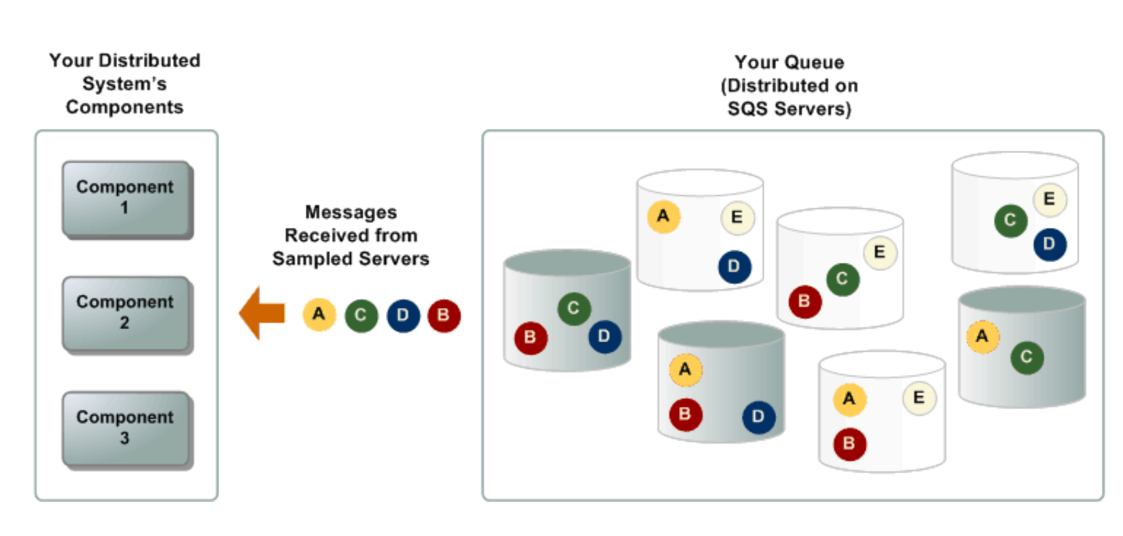

**Consuming messages using long polling**

When the wait time for the ReceiveMessage API action is greater that 0, long polling is in effect. The maximum long polling wait time is 20 seconds. Long polling helps reduce the cost of using SQS by eliminating the number of empty responses (when there are no messages available for a ReceiveMessage request) and false empty responses (when messages are available but aren’t included in a response).

**Long polling offers the following benefits:**

* Reduce empty responses by allowing amazon SQS to wait until a message is available in a queue before sending a response. Unless the connection times out, the response to the ReceiveMessage request contains at least one of the available messages, up to the maximum number of messages specified in the ReceiveMessage action. In rare cases, you might receive empty responses even when a queue still contains messages, especially if you specify a low value for the ReceiveMessageWaitTimeSeconds parameter.
* Reduce false empty responses by querying all – rather than a subset of – Amazon SQS servers
* Return messages as soon as they become available.

**SNS message filtering**

By default, an Amazon SNS topic subscriber receives every message that’s published to the topic. To receive only a subset of the messages, a subscriber must assign a filter policy to the topic subscription.

A filter policy is a JSON object containing properties that define which messages the subscriber receives. Amazon SNS supports policies that act on the message attributes or on the message body, according to the filter policy scope that you set for the subscription. Filter policies for the message body assume that the message payload is a well-formed JSON object.

If a subscription doesn’t have a filter policy, the subscriber receives every message published to its topic. When you publish a message to a topic with a filter policy in place, Amazon SNS compares the message attributes or the message body to the properties in the filter policy for each of the topics subscriptions. If any of the message attributes or message body properties match, Amazon SNS sends the message to the subscriber. Otherwise, Amazon SNS doesn’t send the message to that subscriber.

**Backend**

The backend services (Query Service, UI-Service, Engine and DB-Writer) will be implemented in C# with the ASP.NET Core runtime, built on top of iLevels .Net service template.

Together, these services aim to implement the CQRS pattern, chosen to align with the architecture guild recommendations, as well as to enable fine grained control over optimization and scaling of areas of the system. Initially, we will employ a shared postgres database used by both the query service and the DB writer due to the simplicity of our data model, through a potential future scope will be to segregate read and write optimized data storage, should there be enough demand and increased data complexity to justify added complexity here.

* Query Service
  + Requesting data from a target platform.
  + Requesting configuration data as stored in our data store.
  + The SwS architecture guild recommends usage of GraphQL at this stage, however we have elected not to use it in this case due to the simplicity of the data we have direct control over (i.e. just configuration and mappings, not financial data or heavily relational data)
* UI Service
  + SignalR hub and maintaining connections with browser SignalR clients.
  + Translation layer between SignalR messages and backend message bus.
* Engine
  + Provides an implementation of the domain model for
    - Calculations and aggregations as per client configuration.
    - Business logic and validation tasks.
* Platform Adapter
  + An abstraction layer intended to provide decoupling of the capitalization domain and the domain entities and specifics of a target platform. It will provide a set of operations for reading and writing data from target platforms in an interface defined in capitalization domain concepts; the corresponding platform specific implementations will handle transposition of the capitalization domain and the target platform domain and vice versa.
* DB Writer
  + Provides a service to control writing of data to the data store in a fully asynchronous and non-blocking manner. However, business logic will not live here – it is intended to simply control how domain entities are stored in the write store.
* Postgres DB
  + In the initial design, this will implement a schema as-per the ERD with no further read or write optimization (beyond indexing if it identified during testing to optimize performance issues).
  + Access from the .NET applications will utilize the Entity Framework ORM, which will provide easy to use migrations and data access at the cost of fine-grained control and better encapsulation ORMs such as Dapper.NET provide. Due to the simplicity of the data model here, and the effective encapsulation provided by separation of the domain layer and repository layers into separate application services, the issues with entity framework are somewhat mitigated.
  + Entity Framework has been chosen to aid with the expediency of the project – later, it would be preferable to migrate to Dapper with an open source migration tool, but this would break from the current iLevel deployment pipelines for databases and migrations management, which would add to project timelines with little immediate value for the clients.

**UI**

The UI will be implemented in a manner whereby minimal definition of labels and options corresponding to labels live here, they will be exposed by the query service in order to provide a single source of truth for these behaviours and allow minimal development effort to integrate with other platforms that the initial target of iLevel.

**Logging**

Splunk is used for logging. To track messages as they flow through the system, a GUID can be generated by the creator of the initial message (most likely UI service). This GUID can be used in logging for the lifetime of the event providing an east way to follow an event through the system.

Jaeger is used to enable distributed tracing.

**Concurrency Handling**

The system will need to be able to handle concurrent writes in a manner which will protect against data loss and/or invalid states being reached.

The approach to avoid this will be using ConcurrencyVersion identifiers which will be passed around in messages, which represents state at a point in time of when that state was last persisted. It will be required to send this ID along with update commands, conceptually it represents the state version to which the user applied changes. If the identifier does not match what is currently associated with the entity-to-update, it is assumed that a concurrent write request happened, causing the context the user applied the changes to, to be invalid. In this scenario, the command will be rejected and follow an error flow back up to the source of the command.

* We will use Redis to track concurrency versions for entities.
* The engine will check Redis to:
  + Ensure the latest version was sent with the command.
  + Ensure a new latest version is created in a Redis transaction and added to Redis and sent downstream for writing into the entity table and the corresponding history table.
  + On Error in the DB Writer, a failure message will be published and subscribed to in the engine, where reverting the Redis value to the last successfully stored version will be handled.
  + If concurrent writes are received, Redis should handle locking by allowing the first received request to continue and rejecting subsequent requests.
  + On failure to acquire a lock, we will initially reject the command but later can handle retrying.
  + On success, a success event will be sent, bubbling back up the stack to UIs.

Additional safety will be added to check concurrency versioning in the database query/transaction.

**History Tracking**

* The DB Writer service is responsible for maintaining history for each entity it writes.
* It will insert the entity into the corresponding history table (which references the identity of the corresponding record in the main table) and update the record in the main table in a single transaction.
* The intention of performing this work in a single transaction is to ensure the integrity of the history table.

**Cancellation Events**

**Problem**

It has been identified that a scenario is possible, whereby commands are in flight and the corresponding events are no longer required.

For example, this would happen when a user is on all assets screen, which sends a *CalculateAssetsCapitalizationData* command per page of assets received for display in the grid. When a user changes the search parameters, the commands previously sent will be requiring calculations for assets which may no longer be displayed on the grid. This would yield a significant amount of wated load on the Cap Structure engine which is avoidable by application of cancellation events.

**Solution**

* Each command sent by the UI will contain a message identifier (GUID), the UI-Service will generate a corresponding cancellation token on-receipt of the command and send the token back to the UI.
* When the UI receives the cancellation token event over SignalR, it will store it in application state and send a cancellation command when required.
* The UI-Service will enrich the downstream message with the generated cancellation token before publishing the command to SQS.
* The UI-Service will populate a Redis cache with cancellation tokens and a status which can be one of (proceed, cancel) with a TTL of e.g. 1 hour (the actual value should depend on the SQS re-drive policy to ensure re-driven messages cannot outlive the cached cancellation token).
* On a receipt of a cancel command, the UI Service will:
  + If there’s a token in the cache, update status to cancel.
  + If no token is found, do nothing.
* Downstream services which subscribe to this message will check the Redis cache prior to processing the message.
* On process of a cancelled command, the handler will short circuit processing and delete the message from the queue.
* On process of a command in “proceed” status, processing continues.
* A command handler receiving a cancellable event will consume the Redis cache entry (i.e. on checking the value, the entry should be removed).
  + If no token is found, proceed anyway.
  + If a token is in proceed status, proceed.
  + If a token is in cancel status, don’t proceed (and ensure removal of the message from the SQS queue).
  + To handle debugging of production issues, all touch points with Redis will log information about the current state.

## HTTP vs HTTPS

HTTPS is HTTP with encryption and verification. The only difference between the two protocols is that HTTPS uses TLS (SSL) to encrypt normal HTTP requests and responses, and to digitally sign those requests and responses. As a result, HTTPS is far more secure than HTTP. A website that uses HTTP has http:// in its URL, while a website that uses HTTPS has https://.

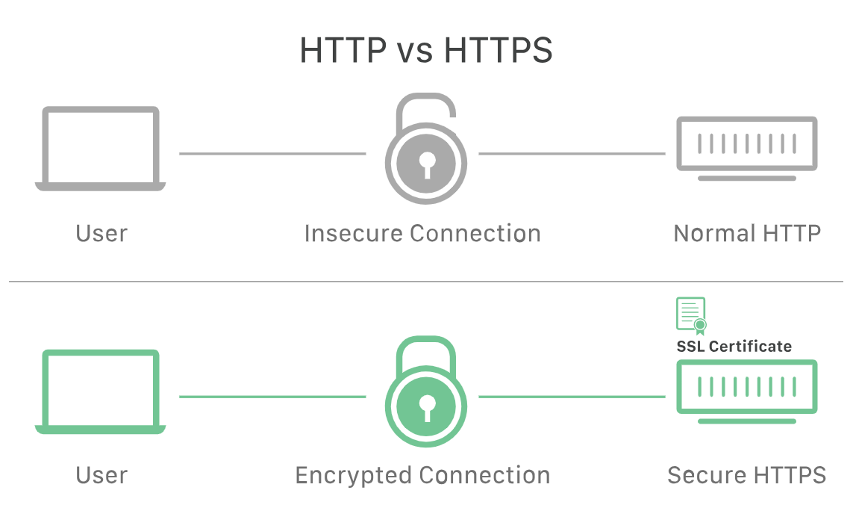

**What is HTTP?**

HTTP stands for Hypertext Transfer Protocol, and it is a protocol – or a prescribed order and syntax for presenting information – used for transferring data over a network. Most information that is sent over the internet, including website content and API calls, uses the HTTP protocol. There are two main kinds of HTTP messages: requests and responses. In the OSI model, HTTP is a layer 7 protocol.

**What is an HTTP request? What is an HTTP response?**

HTTP requests are generated by a user’s browser as the user interacts with web properties. For example, if a user clicks on a hyperlink, the browser will send a series of “HTTP GET” requests for the content that appears on that page. If someone googles “What is HTTP?” and this article shows up in the search results, when they click on the link, their browser will create and send a series of HTTP requests in order to get the information necessary to render the page.

These HTTP requests all go to either an origin server or a proxy caching server, and that server will generate an HTTP response. HTTP responses are answers to HTTP requests.

**What does a typical HTTP request look like?**

An HTTP request is just a series of lines of text that follow the HTTP protocol. A GET request might look like this:

GET /hello.txt HTTP/1.1

User-Agent: curl/7.63.0 libcurl/7.63.0 OpenSSL/1.1.l zlib/1.2.11

Host: www.example.com

Accept-Language: en

This section of text, generated by the users browser, gets sent across the Internet. The problem is, it’s sent just like this, in plaintext that anyone monitoring the connection can read.

This is especially an issue when users submit sensitive data via a website or a web application. This could be a password, a credit card number, or any other data entered into a form, and in HTTP all this data is sent in plaintext for anyone to read. (When a user submits a form, the browser translates this into an HTTP POST request instead of an HTTP GET request.)

When an origin server receives an HTTP request, it sends an HTTP response which is similar:

HTTP/1.1 200 OK

Date: Wed, 30 Jan 2019 12:14:39 GMT

Server: Apache

Last-Modified: Mon, 28 Jan 2019 11:17:01 GMT

Accept-Ranges: bytes

Content-Length: 12

Vary: Accept-Encoding

Content-Type: text/plain

Hello World!

If a website uses HTTP instead of HTTPS, all requests and responses can be read by anyone who is monitoring the session. Essentially, a malicious actor can just read the text in the request or the response and know exactly what information someone is asking for, sending or receiving.

**What is HTTPS?**

The S in HTTPS stands for secure. HTTPS uses TLS (or SSL) to encrypt HTTP requests and responses, so in the example above, instead of the text, an attacker would see a bunch of seemingly random characters.

**In HTTPS, how does TLS/SSL encrypt HTTP requests and responses?**

TLS uses a technology called public key cryptography: there are two keys, a public key and a private key, and the public key is shared with client devices via the servers SSL certificate. When a client opens a connection with a server, the two devices use the public and private key to agree on new keys, called session keys, to encrypt further communications between them.

All HTTP requests and responses are then encrypted with these session keys, so that anyone who intercepts communications can only see a random string of characters, not the plaintext.

**How does HTTPS help authenticate web servers?**

Authentication means verifying that a person or machine is who they claim to be. In HTTP, there is no verification of identity – its based on a principle of trust. The architects of HTTP didn’t necessarily plan to implicitly trust all web servers; they simply had priorities other than security at the time. But on the modern Internet, authentication is essential.

Just like an ID card confirms a person’s identity, a private key confirms server identity. When a client opens a channel with an origin server (e.g. when a user navigates to a website), possession of the private key that matches with the public key in a websites SSL certificate proves that the server is actually the legitimate host of the website. This prevents or helps block a number of attacks that are possible when there is no authentication, such as:

* On-path attacks
* DNS hijacking
* BGP hijacking
* Domain spoofing

In addition, the SSL certificate is digitally signed by the certificate authority that issued it. This provides confirmation that the server is who it claims to be.

**What is encryption?**

Encryption is a way of scrambling data so that only authorized parties can understand the information. In technical terms, it is the process of converting human readable plaintext to incomprehensible text, also known as ciphertext. In simpler terms, encryption takes readable data and alters it so that it appears random. Encryption requires the user of a cryptographic key: a set of mathematical values that both the sender and recipient of an encrypted message agree on.

**How does encryption work?**

Encryption is a mathematical process that alters data using an encryption algorithm and a key. Imagine if Alice sends the message “Hello” to Bob, but she replaces each letter in her message with the letter that comes two places later in the alphabet. Instead of “Hello”, her message now reads “Jgnnq.” Fortunately, Bob knows that the key is “2” and can decrypt her message back to “Hello”.

Alice used an extremely simple encryption algorithm to encode her message to Bob. More complicated encryption algorithms can further scramble the message:

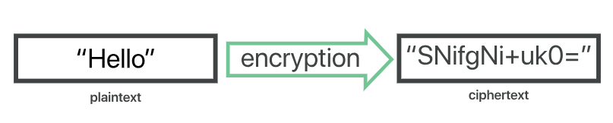

Although encrypted data appears random, encryption proceeds in a logical, predictable way, allowing a party that receives the encrypted data and possesses the right key to decrypt the data, turning it back into plaintext. Truly secure encryption will use keys complex enough that a third party is highly unlikely to decrypt or break the cyphertext by brute force – in other words, by guessing the key.

Data can be encrypted “at rest” when it is stored, or “in transit” while it is being transmitted somewhere else.

**What is a key in cryptography?**

A cryptographic key is a string of characters used within an encryption algorithm for altering data so that it appears random. Like a physical key, it locks (encrypts) data so that only someone with the right key can unlock (decrypt) it.

**What are the different types of encryptions?**

The two main kinds of encryption are symmetric and asymmetric encryption. Asymmetric encryption is also known as public key encryption.

In symmetric encryption, there is only one key, and all communicating parties use the same (secret) key for both encryption and decryption. In asymmetric, or public key, encryption there are two keys: one key is used for encryption, and a different key is used for decryption. The decryption key is kept private (hence the “private key” name), while the encryption key is shared publicly, for anyone to use (hence the “public key” name). Asymmetric encryption is a foundational technology for TLS (often called SSL).

**Public Key Cryptography**

* Encryption requires Alice and Bob to share a key, and to make sure only they know that key.
  + Prior exchange
  + Trusted third-party
  + What is they never met and they don’t trust anyone?

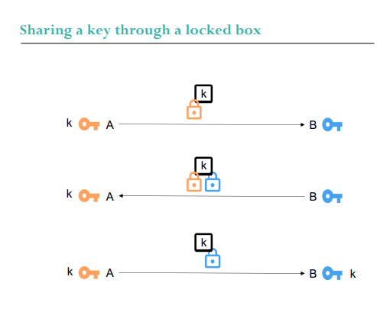

**Key Exchange:**

* The example of the padlock works because the order with which we lock the padlocks can be different to the order with which we unlock them.

**Public Key Cryptography**

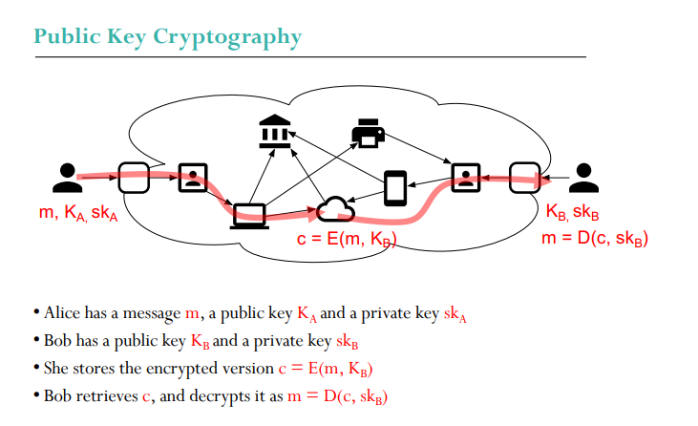

* Diffie-Hellman relies on the Discrete Logarithm problem, which is easy to compute, but hard to solve. RSA relies on the Factorisation problem, also easy to compute but hard to solve.
* On the contrary of Diffie-Hellman, each user in RSA has its own Public Key, which is supposed to be known by anybody who wants to send messages.
* RSA works on the principle that, given the public/private keys KB, skB for Bob:
  + m = D(E(m, KB), skB)
* It turns out that we also have m = D(E(m, skB), KB)
* If Bob takes a message m and encrypts with its private key c =E(m, skB), anybody with his public key can check that m = D(c, KB).
* It is recommended to use a different pair of public/private keys for signature and for encryption.

Complete example

* Alice wants to send a message m to Bob.
* She creates a hash h = H(m) and encrypts it with her private key s = E(h, skA).
* She encrypts m and s with Bob’s public key c=E(m;s, KB)
* Bob receives c, decrypts it with his private key m;s=D(c, skB)
* Bob decrypts s with Alice public key and checks H(m)=D(s,KA)
* We assume that Eve cannot:
  + Decrypts m;s, because only skB can do that (brute force, key leakage?)
  + Create s, because only skA can do that (brute force, collision?)
  + Find out skA and skB from KA and KB (difficulty of the problem)

**SSL/TLS handshake process simplified.**

As it goes with all handshakes, the SSL/TLS Handshake is where it all starts. The SSL/TLS handshake involves a series of steps through which both the parties – client and server, validate each other and start communicating through the secure SSL/TLS tunnel.

**SSL Handshake Explained**

The reason it’s called a handshake is that it’s when two parties – client and server come across each other for the first time. The handshake involves a number of steps that start from validating the identity of the other party and concludes with the generation of a common key – secret key.

A TLS handshake marks the onset of TLS communication between the client and the server. During a TLS handshake, both the parties exchange messages to verify the identity, agree on cipher suite and TLS version to be used in communication and finally establish the sessions keys.

Fundamentally, the SSL handshake is nothing but a conversation between two parties (client and server) wanting to accomplish the same purpose – securing the communication with help of symmetric encryption.

**Imagine this SSL Handshake Process as a dialog between the two.**

**Client:** “Hello, I want to establish secure communication between the two of us. Here are my cipher suites and compatible SSL/TLS version.”.

**Server:** “Hello Client, I have checked your cipher suites and SSL/TLS version. I think we are good to go ahead. Here is my certificate file and my public key. Check them out.

**Client:** “Let me verify your certificate. (After a while) Okay, it seems fine, but I need to verify your private key. What I’ll do is, I will generate and encrypt a pre-master (shared secret key) key using your public key. Decrypt it using your private key and we’ll use thing master key to encrypt and decrypt the information”

**Server:** “Done.”

*[Now that both the parties know who they’re talking to, the information transferred between them will be secured using the master-key. Keep in mind that once the verification part is over, the encryption takes place through the master-key only. This is symmetric encryption.]*

**Client:** “I’m sending you this sample message to verify that our master-key works. Send me the decrypted version of this message. If it works, our data is in safe hands.”

**Server:** “Yeah, it works. I think we’ve accomplished what we were looking for.”

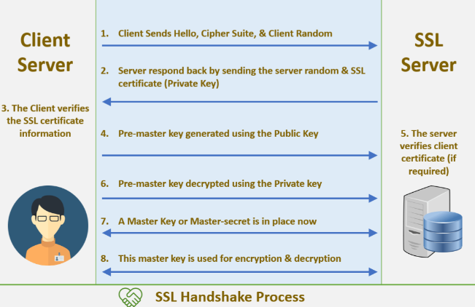

From now on, every bit of data transmitted back and forth between client and server will be encrypted. This is called the SSL/TLS handshake process.

**This is how Asymmetric Encryption is used in SSL/TLS certificates.**

In SSL/TLS and other digital certificates, both methods – Symmetric and Asymmetric are employed. Now you might be wondering, “Why both? Shouldn’t Asymmetric cryptography be used as its more secure?” Granted, it is more secure, but it comes with a pitfall. A major drawback when it comes to Public Key Cryptography is the computational time. As the verification and functions are applied from both the sides, it slows down the process significantly. That’s where symmetric encryption comes and saves the day.

First, when two parties (browser and server in the case of SSL) come across each other, they validate each others private and public key through Asymmetric Encryption. Once the verification is successful and both know whom they’re talking to, the encryption of the data starts – through Symmetric Encryption. Thereby saving significant time and serving the purposes of confidentiality and data-protection. This entire process is called an SSL/TLS handshake.

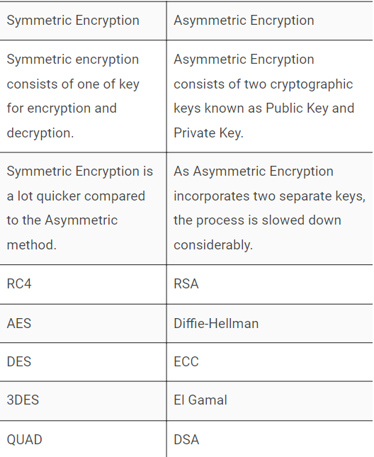

**You’re using Asymmetric Encryption without even realizing it.**

When you visit any HTTPS website/webpage, your browser establishes Asymmetrically encrypted connection with that website. Your browser automatically derives the public key of the SSL/TLS certificate installed on the website (that’s why its called ‘Public Key’). Do you want to see what it looks like? Click the green padlock you see in front of the URL and go to certificate details:

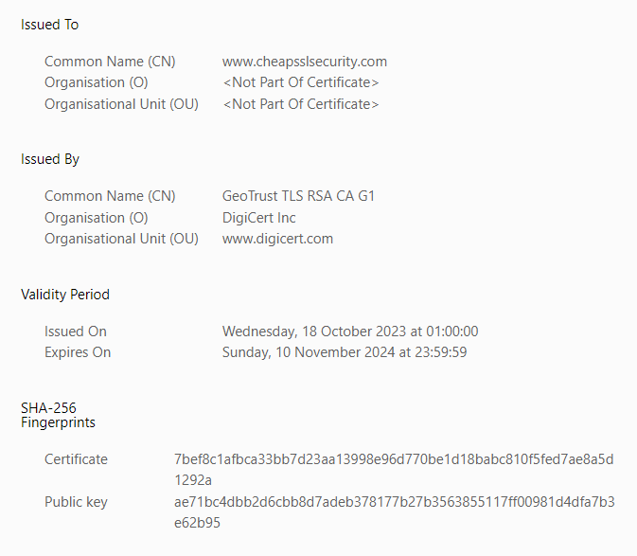

So the key encrypts any information you send to the website during the initial handshake, and their private key will decrypt it.

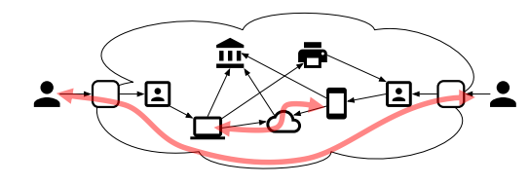

* Network security focuses on the security of information exchanged between two different entities
  + Confidentiality: no observer can know the content of the exchange
  + Integrity: no outsider can modify the communication
  + Availability: entities can always communicate between each other.

**Main problem**

* Alice (A) wants to send a message m to Bob (B)
* She has to go through a network she does not control, and for which she does not know the topology.
* Eve (E) is a potential threat to Alice and Bob
* What could go wrong?
* Spoofing: E can pretend to be A to B, or B to A.
* Tampering: E can modify m to another message
* Repudiation: A can pretend she never sent m
* E can read the content of m
* Denial of service: E can prevent B from receiving m.
* Escalation of privileges: not really applicable here.